Volume One
Vibrational Fascia Release Technique™
3-Day Intensive Class Manual
Name:
©2019 New Earth Healing Center LLC Ver6 (9/18)
All Rights Reserved: Do not copy without permission

Disclaimer:
Practitioners, owners, and authors of New Earth Healing Center LLC and NEHC Academy are not medical professionals and shall not be held liable for results based on information provided in this document. The information provided within these pages are suggested techniques and opinions based on knowledge and experience gained from sound healing with singing bowls. Information provided in this document is not backed by research-based information or peer-reviewed science. Consult with a medical professional and use professional judgement before attempting any action suggested within this document and for treatments where using singing bowls or tuning forks on the body is contraindicated.
New Earth Healing Center LLC and its training division NEHC Academy operate within the State of Michigan in the United States. Techniques suggested within this document may not apply to all local, state, and national laws for performing sound healing or placing hands on a client. Check with your own rules and regulations prior to attempting these techniques with any client.
Do Not Reproduce:
This document is provided as a workbook for an NEHC Academy training course, and receipt of this document assumes the owner will print pages for personal or professional use. However, reproduction in any format for re-sale is prohibited. Do not share information from this document in a public forum.

Table of Contents:
What Is Vibrational Fascia Release Technique™ | 5
Introduction to the 10 Core Skills | 8
Core Skill: Grip | 10
Core Skill: Strike | 12
What is Fascia? | 14
What are the Fluids? | 17
Problems with our Fascia and Fluids | 20
Re-defining Edema | 21
Problems with Fascia Fibers | 22
Core Skill: Palpation | 23
Core Skill: Pressure | 25
Core Skill: Placement | 27
Core Skill: Feedback | 29
Core Skill: Healer Logic | 31
Core Skill: Press and Push (Hands) | 35
Core Skill: Gem Foot Slide (Tuning Fork) | 36
Core Skill: Resolution and Accountability | 37
Head and Neck Protocols | 38
Abdominal Pain and Digestion Protocols | 50
Lower Back and Hip Pain Protocols | 53
Join Pain and Range of Motion Protocols | 61
Foot and Leg Pain Protocols | 72
Anti-aging Protocols | 80
Fat Burning Protocols | 84

Purpose of this class manual:
This manual is to be used in conjunction with a live 3-day Intensive VFRT Certification Course. The content found within this manual may follow the workflow for the course. However, the instructor may also change the workflow based on the needs of the class.
The content is structured in a bullet format in some areas with adequate space for writing notes. This manual is not designed to be an all-encompassing document with all of the material presented within the course. Additional resources have been provided in electronic format within our NEHC Academy Learning Management System.

What is Vibrational Fascia Release Technique™?
VFRT uses the 128hz weighted tuning fork together with distinct core skills of palpation, grip, strike, placement, and pressure against the skin for rapid relief of pain and restoration of mobility throughout the body.
At NEHC Academy, we have established specific protocol groups designed to encompass patterns of conditions based primarily on medical diagnosis, location in the body, and unique aspects of a condition specific to the type of tissue and restrictions involved. Each protocol group includes a step-by-step starting process, healer logic, and application of core skills to relieve most conditions within a single session. Some protocol groups may only include using healer logic and knowledge gained within the other protocol groups to work directly on the area of pain and restriction.
VFRT focuses mainly on the soft “connective” tissue of the body where pain and restriction is a result of collagen fascia fibers and pressurized fluids working together to press against pain receptors, pinch or compress nerve bundles, reduce blood flow, and prevent the lymphatic system from removing fluids from these enclosed “interstitial” spaces. We use a combination of vibration and compression from the tuning fork to directly affect the collagen fascia fibers and compressed fluids where the restriction either “releases” or “resolves” completely to return a restricted area back to normal function.
With VFRT, we use our hands to feel or palpate the skin to identify exact locations to place the tuning fork with each strike, and we continue to monitor the status of each placement with our feedback hand. The combination of vibration and compression of the fascia provides immediate changes which can be felt by both the therapist and client. Through training and experience, our VFRT Therapists use their 10 Core Skills and established methods and protocols to bring about immediate changes sometimes not possible with typical hand-based bodywork and manual manipulation. Recent Fascia Research studies have determined the need for both stretching and vibrating the cells of the body to cause a change to the current operating condition. Tuning forks provide both properties of change, and VFRT combines skill and knowledge for a new way of thinking when it comes to healing the body through fascia and fluids.
What is not a part of VFRT?
Since we use a form of vibration to affect fascia and fluids, VFRT bridges a gap across multiple healing modalities. The sound healing community uses various weighted and un-weighted tuning forks either in the air or pressed against the body for a specific healing purpose. Sound healer methods range from only sounds emitted into the air by vibrating instruments to a combination of unweighted tuning forks and techniques used off the body in the energy field. Energy healers use a hands-on or hands-off method to work with electro-magnetic energy through various methods to heal the body with the energy system of meridians and chakras. Some sound and energy healing modalities focus on healing a person’s emotions which is thought to be connected to a physical ailment.
Bodyworkers focus on using hands and various devices to change the structure of fascia in multiple layers from the superficial layer down to deep fascia surrounding the muscle layers. Bodyworkers learn about musculo-skeletal systems and use specific methods to increase range of motion across joints and within muscle groups. Most chiropractors focus on moving the bones back into alignment using established protocols and methods.
In VFRT, we primarily focus on the superficial fascia layer just underneath the skin. This area is sometimes referenced as the “dermis” layer between the outer epidermis and the musculo-skeletal layer. It is within this superficial layer where we find the greatest restrictions and pressurization of the interstitial plasma fluids coming from the cardiovascular system. Although some fluid pressure and fascial restrictions can reside within the muscle groups, we have found success with most resolved conditions within the outer superficial layer. Through our method of moving interstitial fluids out of a pressurized space with hands or tuning forks, these fluids move across known muscle groups indicating a more global location in the superficial fascia layer stretching across the entire body.
We only use the weighted tuning fork for the purpose of providing physical vibration to the cells and tissue of the body. VFRT focuses on the physical vibration aspect instead of on the energy and emotion approach to healing. Tuning fork vibration is a form of mechanical energy which follows the laws of physics separate from the laws of other types of energy such as electro-magnetic or electrical (electron) flow. We work on areas of the body where we feel for specific tissue properties underneath the skin. Our therapists can identify patterns in tissue density to recognize normal fascia without pressurized fluid pockets. VFRT Therapists are trained to identify placement locations established through known patterns or identified through palpation. We do not work on the body’s energy system or on established meridians and acu-points.
We do not work directly on the bones as an established standard for VFRT. The weighted 128hz tuning fork has been named the OTTO 128 by practitioners and tuning fork suppliers throughout the sound healing community. The term OTTO stands for “Osteophonic” meaning to focus on the vibration within the bone structure. The underlying concept of osteophonics is due to the physics of vibration travel specific to the dense nature of a bone. However, physics of sound also states the dynamics of vibration will remain inside of the bone since the soft tissue outside the bone differs greatly in density. Since VFRT focuses on the soft tissue, we place our tuning fork directly on the fascia layer so the vibration does not get trapped within the density of the bone structure.
Our VFRT methods are very specific to physical ailments, so we do not focus on conditions based on mental health diagnoses and stress-related disorders. However, certain protocols and methods might have an affect on the overall health and condition of a client where the resolution of a physical ailment can aid in resolving a mental health condition.
VFRT is performed in a traditional massage-style bed, but our clients are fully clothed and receive treatments from a sitting position or laying down (face down or up). Our sessions do not focus on relaxation as the main goal, so our clients are fully awake and participate in the feedback process as we identify and release the restrictions associated with pain and mobility.

Introduction to the 10 Core Skills:
Introduction: The Vibrational Fascia Release Technique™ and associated protocols presented within this course are successful in providing rapid pain relief and resolution of mobility restrictions primarily because of the therapist’s core skills. Mastery of these core skills is crucial to becoming an efficient therapist and each skill is equally critical to success while performing VFRT on a client.
The overall flow of the 10 Core Skills is not designed to be follow in order, but you will find a natural flow from one skill to another. In class, we will focus on each Core Skill in an order appropriate to a logical learning sequence. Each single Core Skill has a relationship with other skills, and you will find yourself returning back to certain skills throughout each placement, protocol, and session.
Here are the 10 Core Skills:
- Grip
- Strike
- Palpation
- Pressure
- Placement
- Feedback
- Healer Logic
- Press and Push (Hands)
- Gem Foot Slide (Tuning Fork)
- Resolution and Accountability

We are going to start practice our Core Skills with learning HOW we use the tuning fork in VFRT. Then we will discuss the knowledge of fascia and fluids followed by an understanding of when and where the place the tuning forks based on the skill of palpation.
- Anatomy of a Weighted Tuning Fork

In the image to the left, we can see the yolk is a U-shaped section where the tines merge and transition into the stem. Weighted tuning forks have thinner tines than unweighted tuning forks, and the thin construction of the tines and addition of the weights focus the vibrations downward into the base instead of outward into the air. However, the story of vibration does not stop there.

The bigger story is told in the weight distribution of the tuning fork and the unbalanced physics dynamics across the entire length of the tuning fork.

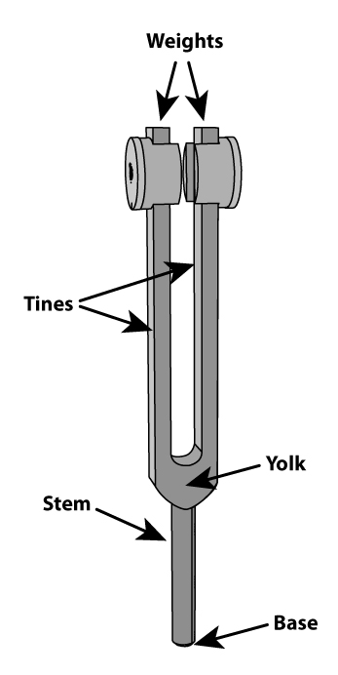
A weighted tuning fork is designed with an unbalanced fulcrum with the weights at the end of the tine forcing the vibrations down the tines, through the yolk, and into the stem. By placing the base of the tuning fork against the skin, we not only benefit from the downward travel of the vibrations created as the tines swing or oscillate back and forth, we also receive a much stronger effect of the stem vibrating in many directions just due to the physics of an unbalanced device.
In other words:
“It’s all about the Fork Torque”

Core Skill: Grip
Once the placement location has been established using the Palpation Core Skill, it’s time to strike the tuning fork in preparation for placement. The Grip Core Skill is vital for both a proper strike and ability to provide the grip strength for the necessary pressure required for a vibrational fascia release.
We will discuss the primary categories of tuning fork grip. In the

Striking Grip, we focus on holding the tuning fork for striking against a surface such as the hand or knee. Grips for striking are designed to prevent or reduce repetitive injury of the therapist while also providing a more effective grasping area on the yolk of the tuning fork instead of the stem where other practitioners tend to strike and hold the tuning fork.

- Striking Grips:
 | - Standard Grip: for striking to efficiently transition to placement grip with proper pressure and angle
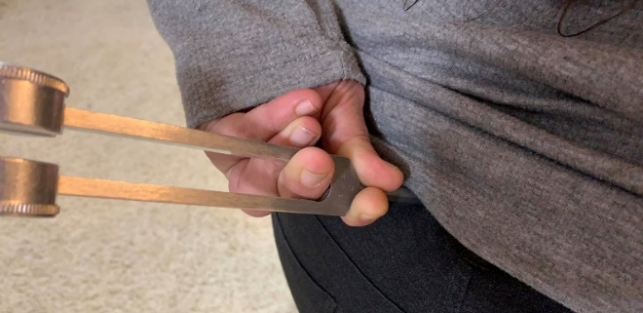 | - Reverse Grip: for self-care, under chin, lymph nodes, sore throat

- Holding Grips:
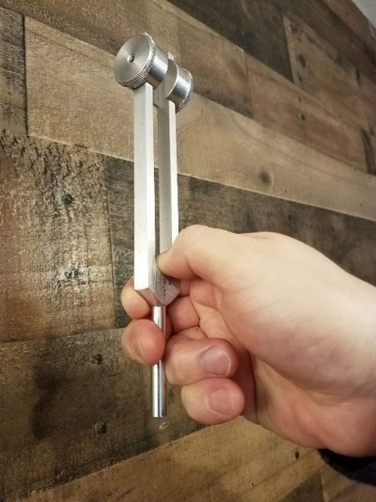 | - Finger Assist Grip: need for sensing hand. Can be used to reduce grip fatigue.
  - Butterfly Grip: max pressure with less grip: Remember: Sometimes you do not need maximum pressure. Designed to reduce repetitive stress, but it is used for increased pressure. Do not use in areas where maximum pressure is not required. Reduces feedback from opposite hand.
“Don’t rely on the Butterfly!”

 | - Modified Standard Strike Grip: Rotate hand to maximize hand weight

- Reducing Hand Exhaustion:
Don’t maintain standard grip for repetitive, sustained, or increased pressure areas: No extra force or pressure is needed if you use the right grip. Consider changing the angle after each placement. Use the weight of your hand to increase overall downward pressure. Vary your grip often to reduce hand exhaustion.
Core Skill: Strike
The Strike Core Skill is important because the quality of a strike will affect the length and strength of the vibration for each placement. In vibrational fascia release, the release point for the cells and tissue might be at the trailing end of one specific strike that fell below the breakpoint.
Fascia collagen fibers and supporting cells require both pressure (stretch) and vibration to cause a change, and sometimes the change is the destruction (apoptosis) of the cells involved in the restriction or the release of the necessary substances to dissolve the collagen fibers responsible for the adhesion.
After our own testing and thousands of strikes, we believe that the best quality striking surface is our own body in two primary locations; the hand and knee. Body strike locations are efficient because we do not have to hold onto another object like an activator. Therefore, we can use the strike hand solely for sensing and feedback.
A mastered Striking Core Skill should not hurt the therapist or leave marks. A properly executed strike has a distinct sound and feel. The key to a proper strike is the follow through of the hand holding the tuning fork. Focus a few inches beyond the point of impact so the hand continues to follow through after striking. With a proper follow-through, the weight of the tuning fork will “bounce” off the striking surface instead of controlling the exact moment of impact. In other words, it’s more of a bounce than a strike.

- Hand Strike:

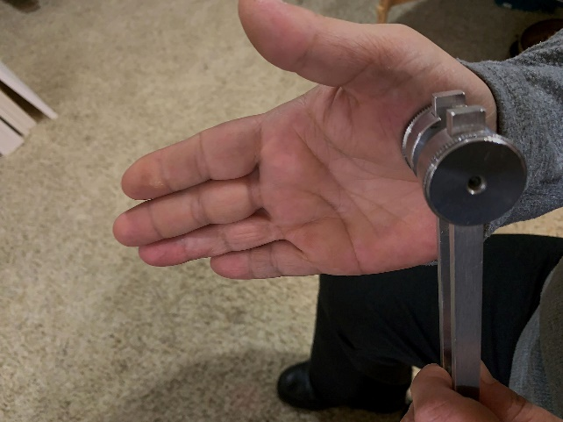 | - Strike on the meaty part at the base of the palm  - Only the striking hand moves  - Strike the flat surface of the weight  - Aim for a spot beyond the striking surface  - Distinct “thump” sound  - A “tink” is okay, but a “ping” is too hard  - If you torque the fork, you might ping the thing
- Knee Strike:
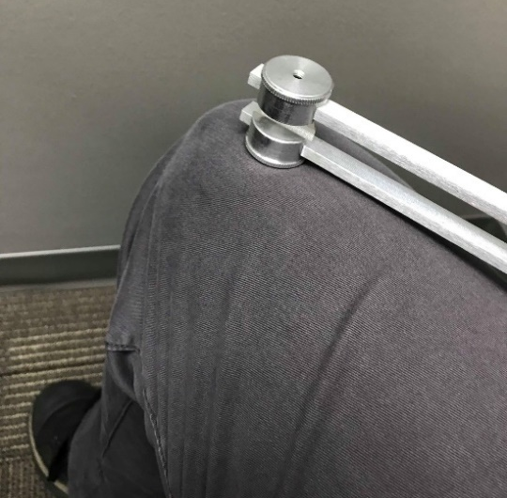 | - Efficient in a sitting position  - Used when sensing hand marks a placement location  - Strike against meaty area closer to the inside of the leg where muscle is thicker  - Bend knee to tighten muscle on striking surface  - Avoid kneecap or bones

Activity: Practice proper grip and strike. Review and provide feedback of student experience.
What is Fascia?
Structures on the outside of our muscles and skeletal system were traditionally referenced as “connective tissue” since this material was thought to connect layers and parts of the body together. Early anatomists used cutting techniques of a butcher to cut across layers of tissue to study muscles and bones through dissection.
Study and research of this connective tissue has created a new understanding of the collagen-based substances throughout our body known as fascia. Modern diagnostic and research methods now show the solid structures of fascia at the cellular level and within the living body so we can identify the various roles fascia plays throughout the body.
Researchers have identified most of the structure within the body made from different combinations and types of fascia. Each role fascia provides depends on the demand for structure from a dense bone to a very tight and flexible tendon or aponeurosis (IT Band or plantar fascia). Fascia can vary in its elasticity through the substances within the fiber strands or through the alignment of fibers.
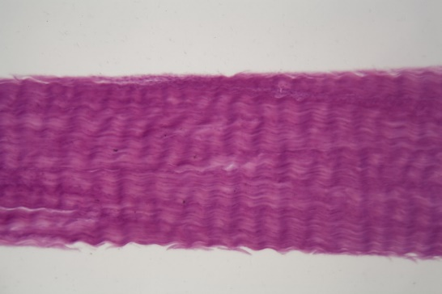 | A tendon has very organized fibers oriented in the same direction for additional strength.

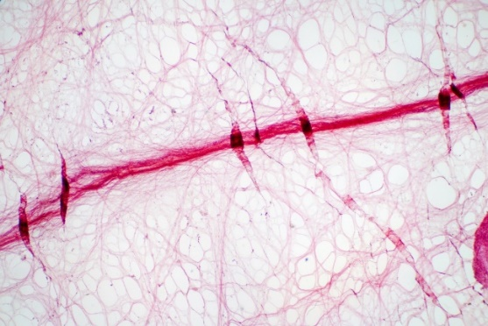 | Some fascia fibers are organized in a manner to allow for more flexibility like the superficial fascia layer just underneath our skin.

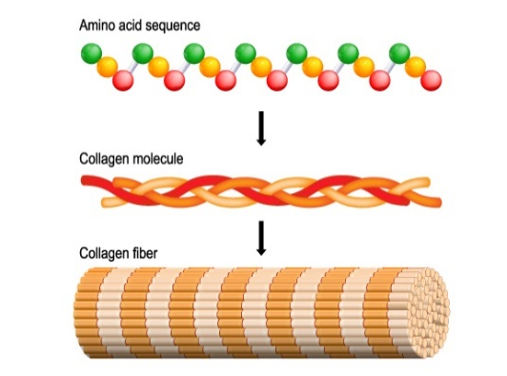 | The structure of a fascia fiber begins with the collagen substances of amino acids arranging themselves in a triple-helix rope or fibril, and several fibrils will band together to for a collagen “fascia” fiber.

These collagen fascia structures are created or extruded from cells called fibroblasts. These cells are responsible for creating most of the structures of your body using collagen as the primary building block.
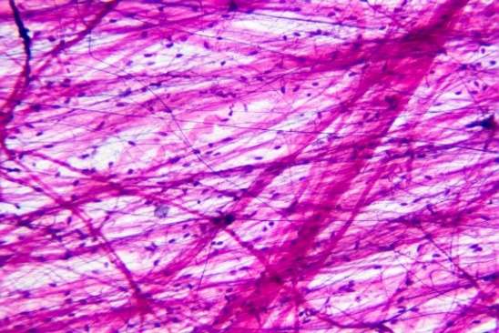 | Fibroblast cells are mobile and can react to the needs of localized area and larger regions through several communication channels. In the image to the left, the dots are fibroblasts responsible for creating the structures around them.
Fibroblasts also create other substances like hyaluronic acid to hydrate the fascia fibers and provide a better sliding surface between different layers of fascia structures. Hyaluronic acid is sometimes referenced as “water”, and lack of this substance can tighten the tension of a fiber. We might recognize the results of dehydration in our body tissue, but the act of forcing water out of the fascia fibers is a natural part of the body’s movement function. The movement of a muscle group to pull on a tendon will force out the water within the fibers causing the tendon to increase tension at the end of a movement. Once a tendon is returned to its resting position, the water in each fiber is returned and re-hydrated.
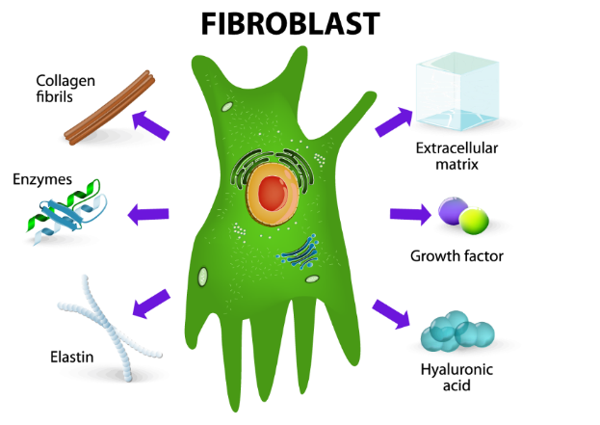 | Fibroblasts use collagen fibers to create most of the structures in the body from our organs to the vessels (nerves, arteries, veins, lymphatic) running throughout our body. Movement structures like bones, muscles, tendons, and ligaments are either made entirely from fascia or are surrounded by fascia like a muscle group.
The superficial fascia (dermis) layer is also created by a collagen fascia structure, and the purpose of this layer is to create necessary space for the traversing vessels and nerves, fluid flow, transfer and maintenance of tension, and sliding of layers during movement. Since the superficial fascia layer resides outside of the cells, we also call this layer the “extra-cellular matrix” to house all our systems and additional cells like adipose (fat). We consider this superficial layer to provide several protective functions from shock absorption to the control of temperature and fluid flow.
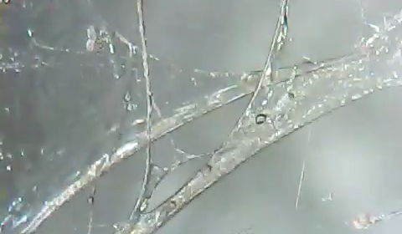 | Fibroblasts also create a thick, gel-like substance called proteoglycan. This gel is a vital part of the structure function of fascia by producing a way to slow down the flow of interstitial fluid and create natural barriers and channels for directed fluid flow.
Recent fascia studies have determined the channels or “vessels” created with the interstitial spaces are considered the largest organ of the body since fluid can flow over long distances for transport and communication.
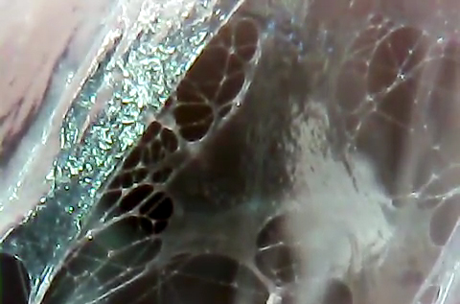 | The proteoglycan gel can also create un-necessary fluid pockets where interstitial fluid can pressurize and create pain and mobility restrictions. VFRT focuses on the fascia fibers and pressurized fluids within the interstitial spaces.
What are the Fluids?
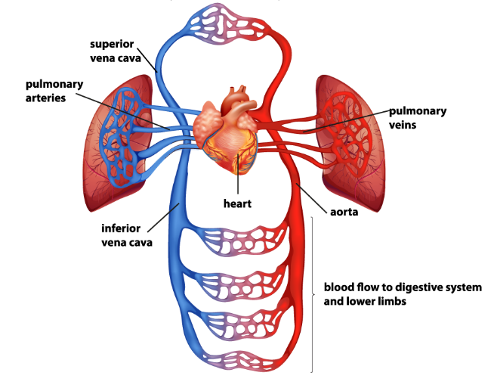 | Fluid within the interstitial spaces come directly from the cardiovascular system. The heart pumps blood through the arteries for distribution throughout the body. Arteries branch into different areas of our head, abdomen, and extremities.

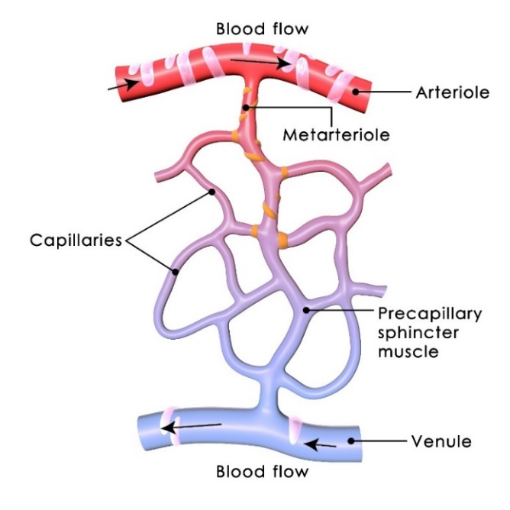 | Arteries continue to branch into smaller diameter until they are at the cellular level. Blood flows through a series of valves based on the need of the immediate cells, and the fluid part of blood (plasma) is forced out of capillaries while the red blood cells remain inside the blood stream. Once plasma is outside of the arteries it is called “interstitial fluid”. Veins pick up some of the fluids from this space and return it to the heart.

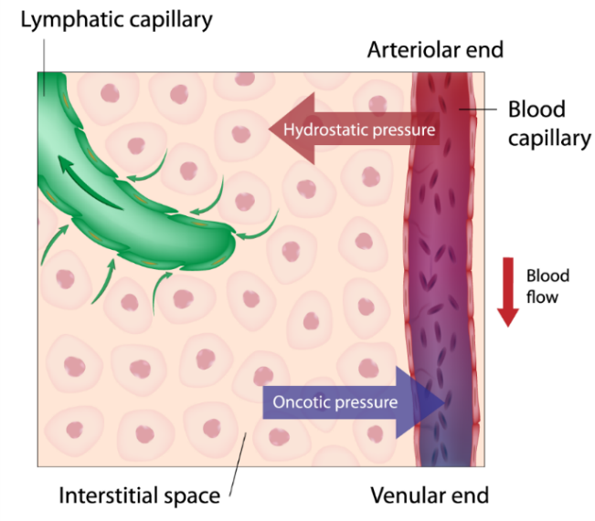 | As plasma is pushed out of the capillaries into the extra-cellular (outside of cell) space, the interstitial fluid slowly passes through the gel and across the surface of the cells to provide nourishment and supplies. Fluid not used by the cells are picked up by either the veins or the lymphatic vessels if the fluid pressure is adequate to allow passage through intake capillaries.

The lymph vessels and nodes work together to remove fluids from the interstitial spaces of the extra-cellular matrix for cleaning, recycling, and removal. The lymphatic system has many tasks along the return route of the lymphatic system to the cardiovascular system, but we are mainly concerned with the ability for the lymphatic vessels and nodes to work properly within the confines of the extra-cellular matrix.

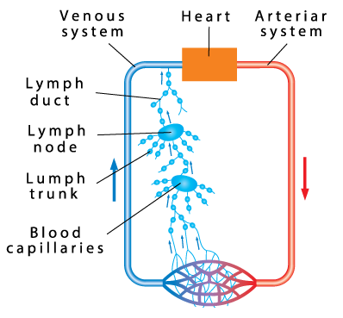 | Unlike the cardiovascular system, the lymphatic system has no internal “pump” like the heart to force fluid flow inside a closed network. The flow of fluid towards the heart requires movement from the body otherwise the fluid flow reduces during periods of inactivity. Lymphatic vessels have special valves designed to keep the fluids from moving backwards due to gravity.

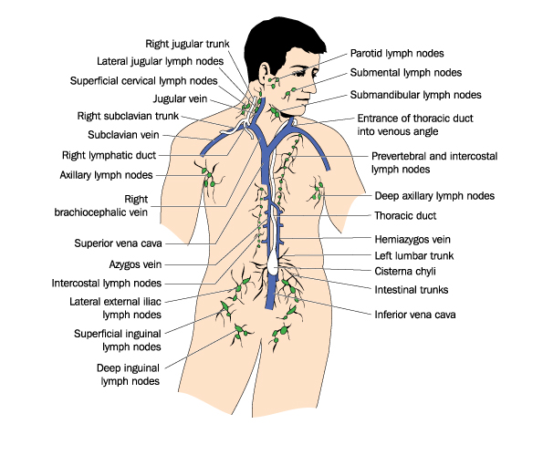 |  | We find lymph nodes near areas of the body where injury is likely to occur, and these nodes can support the healing process. The largest gathering of lymph nodes are found in joints like the behind the knees, at the groin leg crease, and arm pits. They are also found in great numbers throughout the face, neck, upper chest, and deep inside of the abdomen.
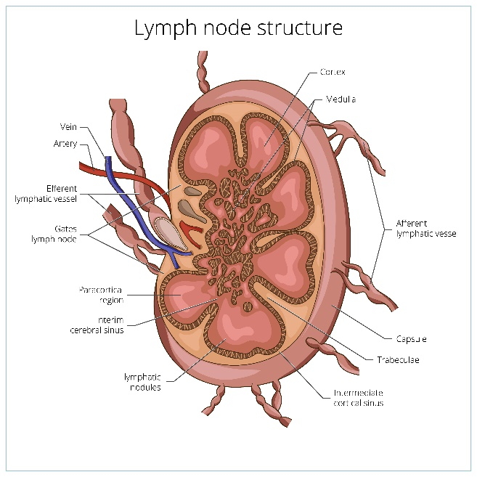 | Lymph nodes consist of a series of sinuses where fluid is cleaned along the return route to the heart. These sinuses can clog the nodes if there is a restriction to fluid flow or the nodes are overwhelmed with toxins. Nodes are a large part of our immune system, and they clean our fluids by converting toxins into substances it can process. Some toxins permanently remain in the nodes if they cannot be converted.

Problems with our Fascia and Fluids
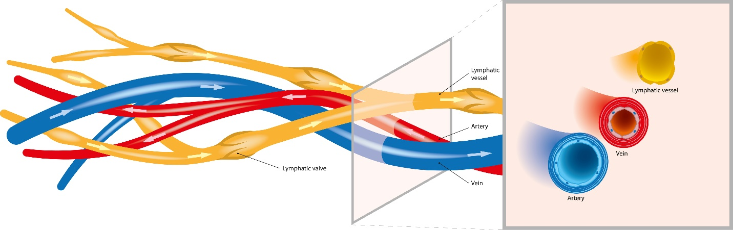
Vessels and nerves run through our extra-cellular spaces, and proper flow of fluids or electrical impulses depend on several factors. Our medical community and specialists within their respective fields tend to blame the constituent of their specialty. VFRT looks across all specialty fields and considers what causes a failure in the normal operation of vessels and nerves of the extra-cellular spaces. We find the largest contributor to problems with these spaces are caused by pressurized interstitial fluids and/or fascia fibers pressing against the vessels and verves. Our VFRT Therapists focus on the areas of pressurized fluid pockets and the fascia fiber restrictions holding the fluids in place.
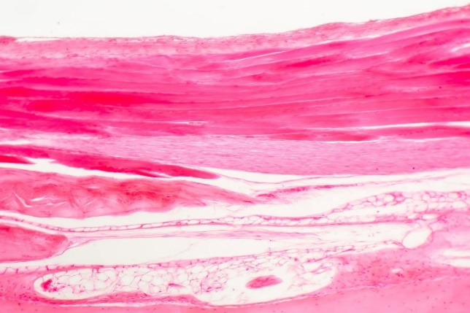 | In the image to the left, a new diagnostic process called immuno-staining and high definition ultrasound can identify the layers of fascia with different densities. The outer epidermis layer is at the top of the image, and each fascia layer is represented by a pink to red color depending on the density.
The white areas indicate interstitial fluid collecting in specific areas of the superficial fascia layer. The smaller white “bubbles” are adipose (fat) cells which also reside in the superficial fascia layer as a specialized fibroblast cell. Research studies and medical literature focusing on obesity revealed a pattern of “localized edema” around fat cells and especially in areas of enlarged fat cells.
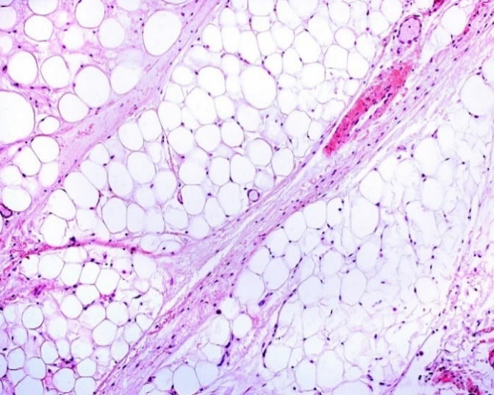 | The image to the left shows the close relationship fat cells have with the extra-cellular matrix. Through immuno-staining, we can see the fascia fibers and fibroblast cells. Some specialties focusing on the skin and fat reduction identify fat as a separate adipose layer underneath the dermis or superficial fascia layer.
Recent anatomy studies focusing on fascia research has determine fat cells to be in the same layers within the extra-cellular matrix and the interstitial fluid space.
Re-defining Edema
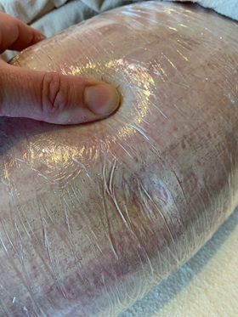 | Our medical community will diagnose edema based on the severity and possible causes of excessive interstitial fluid. For example, lymphedema is a more severe stage of edema focusing on the failure of the lymphatic vessels and one or more nodes as the cause of excessive fluid retention. In the image to the left, the client’s leg is showing a characteristic of edema called “pitting” where pressing against the skin will leave a temporary indentation due to the interstitial fluid pressure in the immediate area.

We learned earlier about the proteoglycan gel within the interstitial space with a primary purpose of slowing down the interstitial fluid coming from the artery capillaries. The process of slowing fluid flow is critical for cell survival, and the gel is very important to proper functioning of our cells. The gel also holds fluid in specific locations throughout the body so all of the interstitial fluid does not find its way into our feet and legs due to gravity. Any area of the interstitial space without gel is called a “free fluid” area. According to medical literature, our entire body should have approximately one percent of free fluid spaces at any given moment. Our VFRT Therapists are finding much more than a small percentage of free fluid areas throughout the body. Most of us are in some degree of edema in localized areas of the body or in regions of extremities like lymphedema of the legs and feet.
Problems with Fascia Fibers
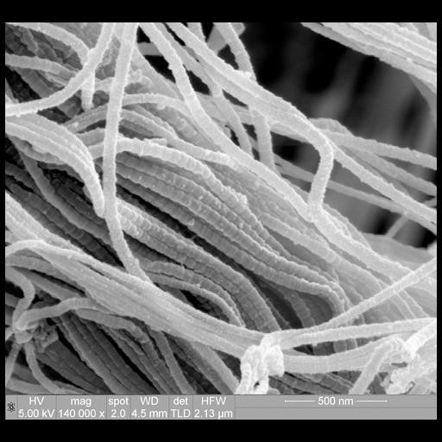  Paul Gunning (2012) CIL:40651. CIL.  https://doi.org/doi:10.7295/W9CIL40651 | In the image on the left, a microscopic view reveals a vulnerability of fascia to crimp or “cleave” along its length. A damaged fascia fiber cannot be fixed even by stretching it back into shape. This is similar to bending a straw and expecting to straighten it to fix the crease. The fascia system has a mechanism for fixing itself provided that the right conditions and commands are given to the controlling fibroblast cells. Tuning forks can give the command to dissolve fascia through stretch and vibration.

Core Skill: Palpation
With Healer Logic, we established a goal for the session to determine what we were going to work on whether our focus was pain relief or mobility restriction.
Palpation is a skill to find the physical location on the body where we will place the tuning fork to resolve the pain or restriction. In VFRT, we use one tuning fork to allow for freedom of the opposite hand for feeling and sensing for pain and restricted fascia collagen fibers.
Our method of palpation is to press our fingers against the skin to feel for contrast between normal and abnormal tissue. This skill could take some time to master since we rarely put our hands on a person for the purpose of sensing fluids and fascial adhesions.
- Proper Palpation Provides Perfect Positioning for Pain Relief
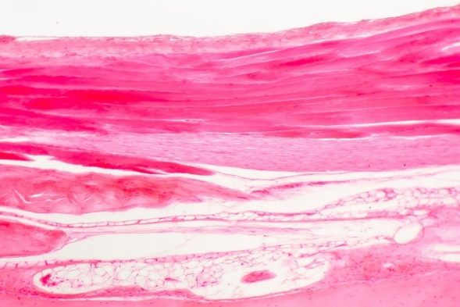
In the image above, we can see a cross-section of the body with the outer epidermis at the top and different densities of tissue as we go deeper into the tissue. The darker pink areas represent densely compacted collagen fibers of the superficial fascia layer just below the skin.
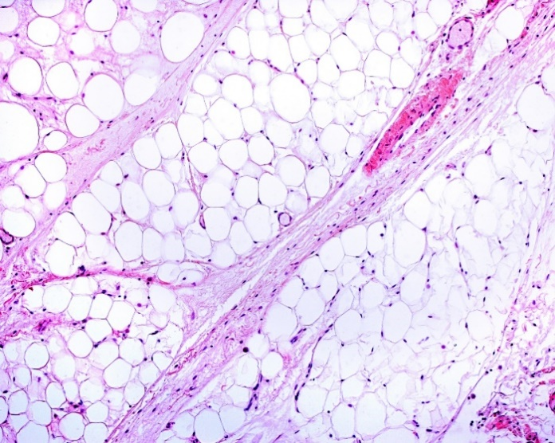
The white areas show fluid-filled tissue of the interstitial spaces of the extracellular matrix. These white fluid spaces are not a normal part of the interstitial space because the fascia network of the extracellular matrix produces a very thick gel called proteoglycan to slow down the fluids leaving the cardiovascular system so cells can benefit from the substances within the interstitial fluid.
- Pressure provides enough compression to rise above the pain threshold
- Pressure to feel for fluid compartments and fascial restrictions
- Fluid First Followed by Fascia
Activity: Feel for Pain (Normal vs. Abnormal)
- Positioning of fingers for placement
Part of the Palpation Core Skill is preparing for the placement of the tuning fork with the sensing fingers positioned where the fingernails of the first and middle finger are on either side of the placement site.
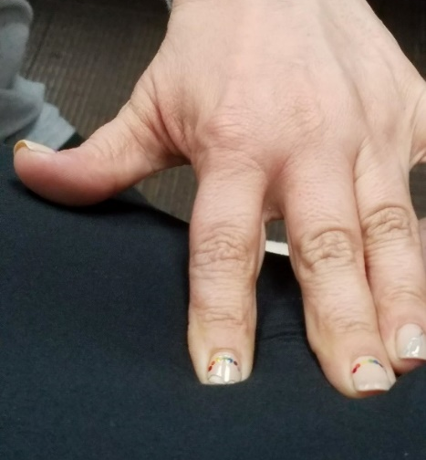 | As you spread your fingers apart, continue to palpate with the pads of the fingers to locate the exact position of placement with consideration for the secondary purpose of the sensing fingers for feedback during the placement. Palpation is for perfect positioning, but it is also for effective feedback which is a skill we will discuss after the placement of the tuning fork.
Additional considerations for mastering the Palpation Core Skill:
- Client reported (doctor) diagnosis or self-reported (Google) is just a good starting point: It’s not going to be there long enough to name it
- Local Point of Pain (POP) vs. Furthest Point: Listen to your client
- Referred vs. Connected: Does what you feel match the information provided by client (diagnosis or POP)?
- Where you think it is….It ain’t! quote by Ida P. Rolf

Core Skill: Pressure
- Necessary pressure for pain relief:
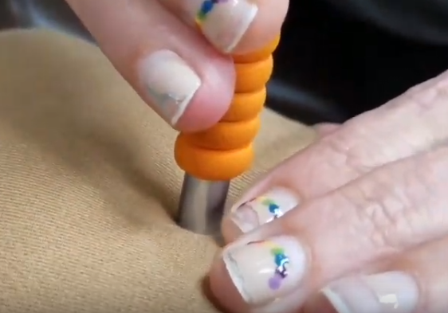 | One of most difficult Core Skills to master is identifying and providing the necessary pressure required to put tension of the fascia collagen fibers underneath the skin. It is within the superficial fascia layer of extracellular matrix where most of the changes occur when we place tuning forks against the skin.
- Pressure Threshold:
There is a threshold of pressure that must be reached for a certain period of time before the fascia cells recognize the need for change and respond with the release of tension and associated pressure in the superficial fascia.
As we learned in the Healer Logic Core Skill, we need both stretch and vibration to cause a change in cells, tissue, and systems. When the correct pressure is reached, we need to maintain the same pressure until the threshold has been reached and the conditions change. The feedback hand is in place to determine whether we have surpassed the pressure threshold.
If the fascia layers are overfilled with interstitial fluids and pressurized to cause the lymphatic system to slow down or stop completely, the weighted tuning fork with the right pressure will change the entire gridlocked area and hopefully relieve the pressure on the nerve endings currently reporting pain. We believe the importance of rapid pain relief for many ailments lives in the pressurized, fluid-filled compartments of the superficial fascia layers.
When we have too much fluid within our interstitial spaces, the pressure of the fluids will push against the pain receptors to report pain. The act of placing a weighted tuning fork on the skin will provide even more pain depending on the level of fluid and associated pressure already present. The amount of pressure we use when placing a weighted tuning fork will be painful for some clients.
- Using a cloth for a protective layer:
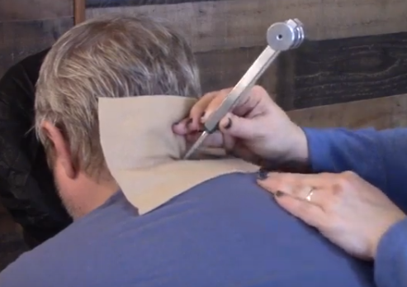
To prevent discomfort, we use the client’s own clothing or place a small square of cloth underneath tuning fork in areas where the clothing cannot be used as a protective layer.
In the image to the left, we are using a piece of fleece we always have within arms length during the session. We also could have used the client’s shirt coller by drawing it further up the neck. However, the fleece cloth would provide a better option for working on the back side of the neck as shown in the image.
Core Skill: Placement
The Placement Core Skill focuses on different considerations for the location on the body and the angle of the tuning fork to maintain appropriate pressure for the tissue density in the placement location. The placement location and angle might also require the therapist to change the normal grip and pressure especially in sensitive areas.
- Location and Angle: A Supporting Hand
Use hand on the other side of the body to provide stability and opposing force necessary to maintain proper pressure on the tuning fork. Clients tend to move in the opposite direction of pain and pressure, so it is not a natural action for a client to support the desired posture without the aid of a supporting hand. Applies to any location (feet, wrist, knee, shoulder) where the joint rotates and tuning fork is forcing the body part to rotate on its own.
- Length and strength of a tuning fork vibration:
The length of vibration for a weighted tuning fork depends on several factors including materials, length of the tines, strength and quality of strike, type of striking surface, and condition of the tissues at the location of placement. We have experienced a longer and stronger vibration from one manufacturer over another with all things being equal including frequency of the tuning fork.
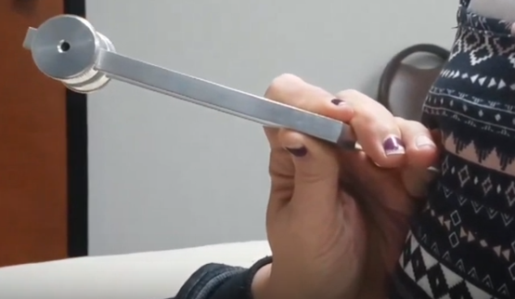
Regardless of the conditions affecting the length of vibration, the one thing you can control is the quality of your strike of the tuning fork so it will vibrate longer and require fewer activations.
We are working on-the-body in attempts to affect inflamed tissues, so the length of vibration for one strike can be extremely important to reach the necessary conditions to release inflammation. A good tuning fork sound healer will always focus on reaching optimum vibration in every strike and allow the vibration to run out before striking again.
If you happen to strike the tuning fork in a manner that is less than optimal, stop the vibration with your hand or leg and strike again. Avoid striking the tuning fork while it is vibrating to ensure the next strike will be correct and to prevent damaging the tines.
When it comes to strength of vibration, your body will be aware of a tuning fork that is not vibrating at full strength and your clients will also notice if something has changed. You can control the strength of a vibration by striking efficiently with sufficient force for the type of tuning fork and the surface in which you are using to activate the fork. You should always strive for maximum strength when working on-the-body to reduce inflammation.
A tuning fork is one of the few vibration tools that is tuned to a specific frequency. When you strike a 128hz WTF, it will consistent produce the desired frequency regardless of strength or striking conditions. The same frequency will be maintained throughout the length of vibration even when the strength fades. There might be a slight slowing of frequency at the tail end of the full vibration, but at this point you will probably think or feel that the tuning fork is no longer vibrating and bring it off the body for another strike.
Core Skill: Feedback
- Client
Do not leave the client out of the feedback loop. Do not think you know more than the client about their own body. Build a rapport and encourage feedback throughout the session. The client might not know if there is suppose to be ongoing communication. Remember your Healer Logic and Session Management Skills.

Assess and re-assess often. Many times our clients will be dis-believers that their mobility can be restored and pain can be relieved in just a few minutes. Most clients have lived with this condition for years, and other methods of resolution have not worked. Be confident in your own skills. Have them test for pain and mobility so they will have confidence as well.

You are changing thought patterns and changing lives. Our most common client feedback statement is: How is this working when nothing else has? We hope that you will have the confidence to answer this question with conviction and ownership. Know our craft and why this is working when no other options provide the same resolution.

When a client gives you verbal feedback of pain, this is not always your cue to stop working. The right solution might be different depending on the client and your pre-established agreement for your pain management response. Let your client know this treatment is going to hurt and why it hurts. If the client knows what to expect through dialog, they will not be surprised. Let them be a part of the session.
- Sensing Hand
Use your Palpation Skills throughout the placement. Your fingers will do the talking and provide very detailed information especially when something changes to the current condition.

- Strawberries through a straw
- Push up
- Water balloon with a hole in it
- Morse code
- Change between no vibration to vibration
- Hard and tight turns to soft and squishy
- What was bumpy and lumpy is now smooth
- Cold to warm
- Tuning Fork
Many of the sensing hand feedback can be felt through the tuning fork. If you are moving the base of the tuning fork with the gem foot, you can feel the tension of the fluids ahead of the fork.
In some situations, the tuning fork will slip off the placement location when a fascial adhesion releases or deflates especially with hardened nerves, tendons, ligaments, muscles, and fluid compartments.

- Visual
  - Color change
  - Deflation of tissue
  - Size and shape

- “Release doesn’t mean resolve”
Release of fascial restrictions and fluid pressure could mean it is time to re-assess, re-position, or re-focus your work on another location.
A release is not going to change their lifestyle, habits, triggers, and causes that brought your client into an overwhelmed state. If your session goal was to relieve pain or increase Range of Motion, a release might be the first step in the right direction and the ultimate goal of the session.
- Did it work?
The biggest part about the Feedback Skill is to know whether your VFR Technique worked and the Session Goal was reached. When you re-assess the client for mobility and relief of pain, ask them specifically “Where is the pain now?” Client feedback is not considered success if they say:

  - “Hmmmm……Interesting”
  - That feels a little better
  - Well, you know it didn’t get there overnight
  - That feels a lot better
Note: All of these reactions are considered a VFRT Failure!
Activity: Practice feedback on the same person and observe the different feedback indicators as you work through the session.
Core Skill: Healer Logic
Introduction: This skill refers to the logical thinking of a New Earth Vibrational Therapist as it applies to the thought process of mastering the VFRT protocols in addition to knowing:
- When to apply certain protocols to clients in a given situation
- What questions to ask the client prior to a session
- When to decline a session for the right reasons
- Why a client is in pain or restricted from normal movements
- How to respond to typical client questions during a session
- What we can resolve with VFRT protocols
- What type of session to schedule and perform
- How to establish a goal for each session
- Top 4 questions from clients:
- How long will it last?
- What do I need to be doing so it doesn’t come back?
- Where does it go? (Fluid or Fat)
- How often/soon CAN or SHOULD I have this done?
- Most of us were born with perfect fascia.
As Vibrational Therapists, we fix injuries in the fascial system using weighted tuning forks to stretch the fascia collagen fibers and vibrate and tissue to bring about a change to the current environment. Fascia and all cells need both stretch and vibration to create a change whether it is to reconfigure, produce something different, or self-destruct (apoptosis). Our cells and tissue have mechanisms for building up and tearing down. Most fascial scars beneath the skin remains in place over years because the “resolution” or clean up process was not completed.
Up until the age of 15, we are capable of self-healing until our patterns change and our fascial system responds to the new normal.
Question: How do we injure our fascia?
- Can you see or feel it?
Our VFR Technique is based on the physical science of providing mechanical vibration and pressure (stretch) in a localized area to cause a change to the cells, fluids, and tissue. In most sessions, the client is in pain or restricted in movement because of fascial scars (adhesions) and pressurized fluids.
We will learn in the next Core Skill about palpating (feeling) for both fluids and fascial adhesions. With Healer Logic, it is important to know our limitations for both a session timeframe and overall capability of the tuning fork.
Remember: The tuning fork is just a tool. You would not throw a hammer on the ground and expect it to build a house. Vibrational Therapists should look beyond the fork and understand enough biology to set realistic expectations with established limitations. Our actions and mastery of our skills are a vital part of the healing process. Although we may have limitations on what we can influence, we can still work on the symptoms of a given condition or ailment.
- Things we cannot directly influence with weighted tuning forks:

  - Medical modifications or alterations
  - Birth or developmental defects
  - Learning disabilities
  - Behavioral/cognitive/psychological diagnosis

- Goal of Session:
With Healer Logic, we are responsible for Session Management in knowing what type of session the client requires and plan the session according to a specific order of priority. Set expectations at the beginning of the session, talk to the client about what you are doing during the session, and set expectations about what the client can expect after the session (see Resolution and Accountability Core Skill)
- Danger or Risk of:
  - Falling (Mobility)
  - Heart attack
  - Stroke
  - Breathing

- Pain Relief
- Range of Motion (ROM)
- Quality of Life (QOL): “Pretty and Pain Free”
- Triggers and Causes
- Re-occurrence = no lifestyle change = chronic
- Allergies: Environment and Food
- Medical Modifications or Alterations
- Body Patterns (posture, sleeping, sitting)

- Power Session vs. Therapy Session
Therapy is where you go through steps to get better. Maintenance is where you schedule sessions to maintain the current state.
As we move through the order of priority for Session Management, there are two main types of sessions to clearly establish an expectation.
Power Sessions are typically 45 minutes or less with a focus on a specific area of pain or restriction. Our clients are paying us for an expected goal. Establish the goal and work towards 100% resolution. Avoid working on many ailments within a session without an established goal. Laundry List clients require your Healer Logic and Session Management skills to control the session and provide relief and resolution to the established goal even if it only takes 10-15 minutes.
Therapy Sessions are on-going treatments with an established goal. Some clients have long-term triggers and causes requiring several sessions to re-train the cells, fascia, and systems into a new normal. If the trigger is still in place, our Therapy Sessions should be providing more relief than the damage the trigger is causing.
For permanent causes like medical alterations, our sessions might last for the lifetime of the client at greater intervals (every other week, once a month) to maintain Quality of Life. Clients who have had their lymph nodes removed are an example of long-term sessions to remove or move the interstitial fluids in the absence of functioning local lymphatic vessels and nodes.
Core Skill: Press and Push (Hands)
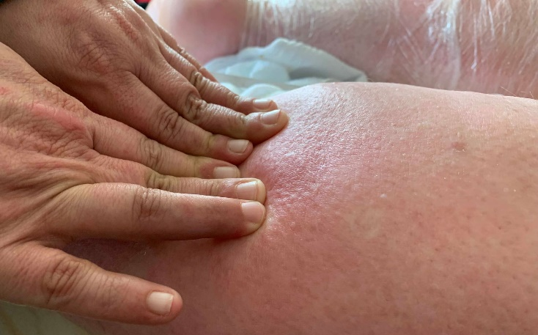
- Used for interstitial fluid movement
- Reduces session time
- Increases ability to find fascial scars or restrictions
- Toxin Containment/Quarantine
- Proper pressure
- Let the fingers sink
- Press forward slowly: Tension release controls the speed
- Keep the fluids ahead of the fingers
- Follow through with the push to a “Safe Zone”
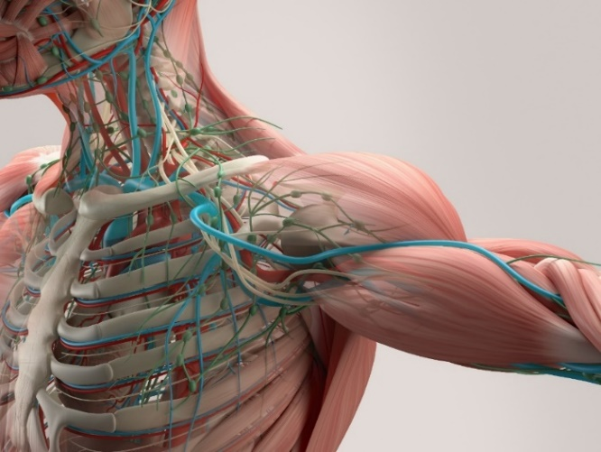

Activity: Practice a press and review for feedback.
Core Skill: Gem Foot Slide (Tuning Fork)
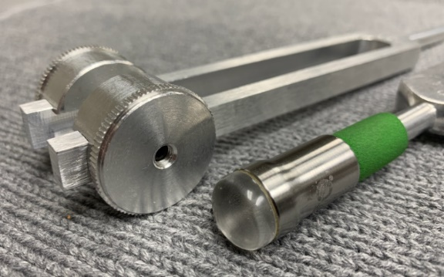
- Same concepts apply from the Press and Push Core Skill
- Less efficient than Press and Push (finger feedback)
- When a therapist cannot use their hands to press against the skin
- Alternative to using the Press and Push
- Using the right tuning fork extension

  - Crystal type
  - 6mm Trigger Point (avoid using during a fluid push)
  - 15mm (smaller or confined areas)
  - 25mm (larger areas and longer distance)

- Used in sensitive areas of the body

  - Maintain angle awareness since the edge of the gem foot could scrape against the skin.
Activity: Perform or receive a gem foot push and review for feedback.

Core Skill: Resolution and Accountability
- Knowing when you are done with the session
  - Fully resolving the issue
  - Re-assess and ask the right questions
  - “Where does it hurt now?”
  - Re-enforcing expectations
- Controlling the session
  - Dealing with “talkers”
  - Laundry List Clients
  - Working on too many conditions
  - If it’s not first session resolution, it’s considered therapy
- Chasing the Pain
- “Jack of all trades and master of none”
  - Adding modalities
- Blaming the client
- Giving the Client Homework

Head and Neck Protocol:
Healer Logic: Things you are breathing. Bottom up approach. Gravity controls the fluid flow and restriction. Each individual diagnosis for head and neck conditions are actually considered symptoms of fluid pressure and fascial restrictions.
Starting Protocol:
- Client in sitting position. Use gem foot (15mm or 25mm)

- Ring of Fire (one side at a time)
  - Start half-way and push fluid to gap between clavicles (Safe Zone)
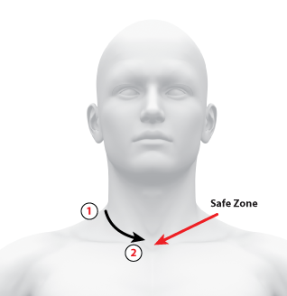
  - Work towards back of neck and push fluids forward
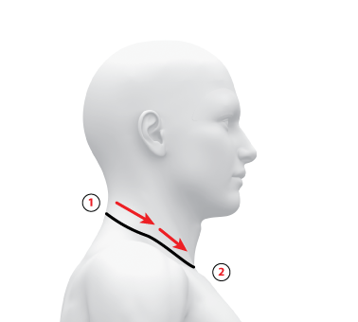
  - Stop at spine and repeat on other side

- Throat Drain
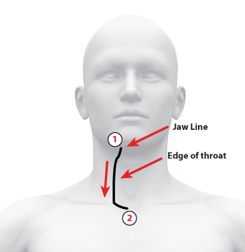
  - Start on one side and push fluids from bottom of jaw and directly down the side of the throat to drain point

  - Always continue to push fluids around the ring of fire to end in the drain point
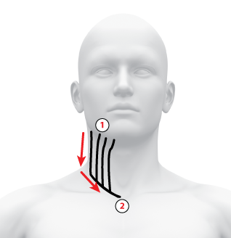

  - Work in vertical lines around half-circumference of the neck around to spine and repeat on other side

- Head conditions (Sinus pressure, face nerve pain, Migraines and Headaches, Receding gums, Jaw pain and TMJ)
Healer Logic: Sinus pressure is connected to fluid in the head and neck. Use the starting protocol before working on any of the head conditions. Then focus on the specific area of pain. Migraines and headaches are symptoms of fluid pressure in the head. Once the neck pressure has been released, the head fluids can be released and pushed down the neck. There is also a connection with high blood pressure and headaches/migraines. Loosen the back of the neck first before working on the headaches and migraines.
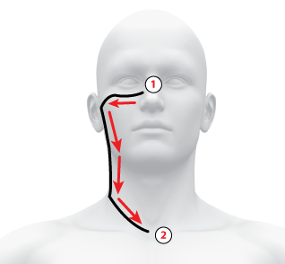

- Neck conditions (Tonsillitis, sore throat, fatigue, cysts, tumors, thyroid, high blood pressure)
Healer Logic: Work with barefoot fork directly on any area of pain, fluid pockets, fascial restrictions. Do not press hard against the throat. Use a supporting hand on the other side of the jaw or throat. Never slide a barefoot tuning fork against the skin. For high blood pressure, focus on loosening the tension on both sides of the spine from the skull to the neck line.
- Ailments (Colds and viruses)
Healer Logic: Fluid pressure in the head and neck keep the viruses and bacteria contained. Flush the fluids using the starting protocol to release the substances that are sustaining the illness.
- Ear conditions (vertigo, tinnitus, hearing loss)
Healer Logic: Fluid pressure near the ear and along the neck is causing most of the ear conditions. Use the starting protocol to relieve the head and neck fluid pressure. Then continue working on the neck just below the ear to relieve additional fluid pockets. Vertigo should clear up with one session. Tinnitus could reduce and resolve within one session. However, it could take a few days for the ringing to subside completely. Some hearing loss and tinnitus that is caused from high impact sound trauma might not resolve completely. Most tinnitus and ear conditions that are not birth defects and long-term trauma are able to be resolved with fluid flushing.
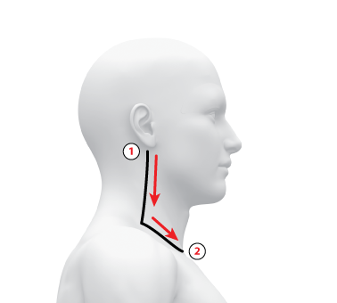

- Eye conditions (Vision loss, Sty, Cataracts, Floaters)
Healer Logic: Most eye conditions can be resolved by removing the fluid pressure around the eye. Begin with the starting protocol to flush the fluids and then focus the tuning fork with gem foot above and below the eye. For sty, put tuning fork directly on the sty and push the eye lid up into the bone. Sty can be resolved immediately. Never put the tuning fork directly into the eye.
- Neck pain and range of motion
Healer Logic: Problems with neck pain and mobility are caused from too much fluid and fascia restrictions in the lower neck and shoulders. Sleeping causes most of the neck issues. Use starting protocol and then focus on what you feel. The gem foot and hands are for fluid push, and the barefoot tuning fork is for fascia release. Fluid first followed by fascia restrictions. Test for range of motion first and re-assess often. Range of motion should allow for the chin to be aligned with the shoulder. Sometimes the full range cannot be reached until working on both sides and the shoulder restrictions.
- Breathing restrictions (snoring, apnea)
Healer Logic: Breathing problems are usually associated with the inner sinuses. Fluid and fascia in the head, face, and neck are connected to the inner sinuses. Using the starting protocol will begin the process of removing the breathing restrictions. Then focus on the fluid and fascia restrictions based on feel. Fluid pockets will build up near bony areas (underneath cheek bone, at the corner of the bottom jaw). Reducing restrictions in these areas should restore breathing restrictions.

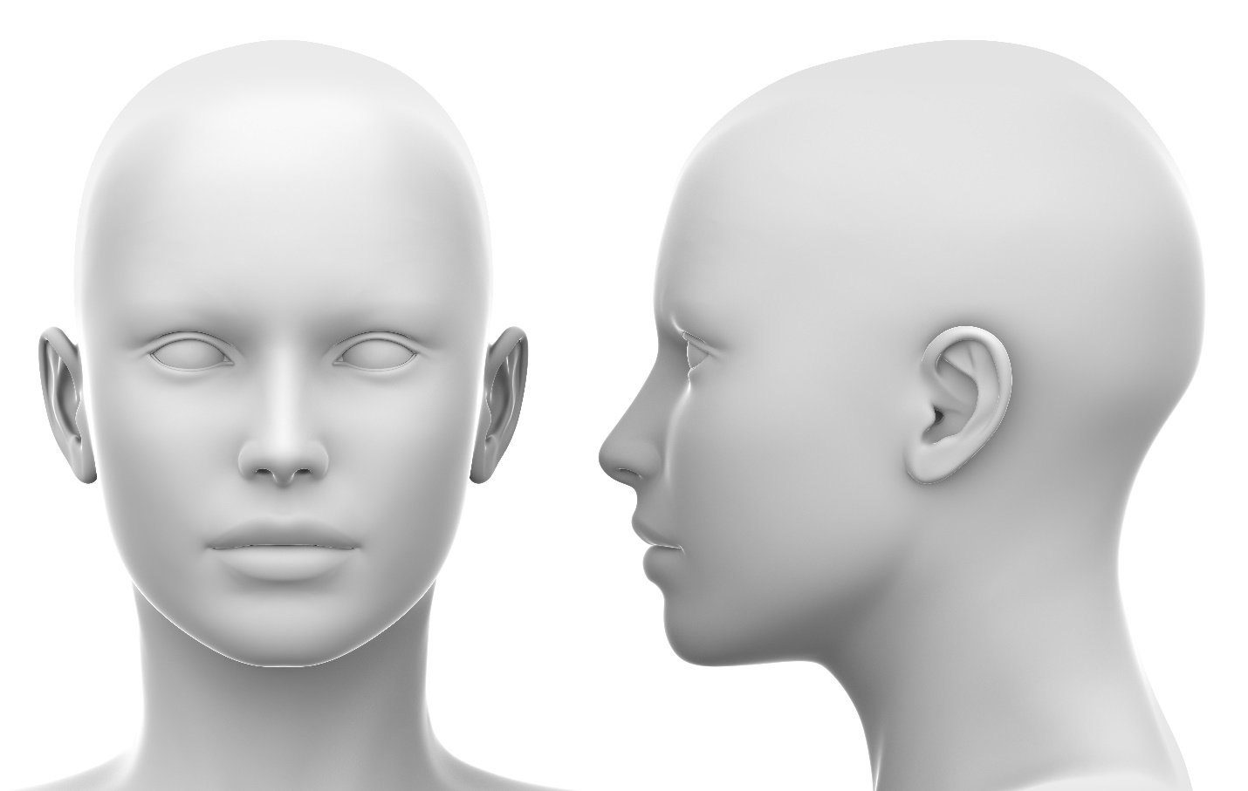

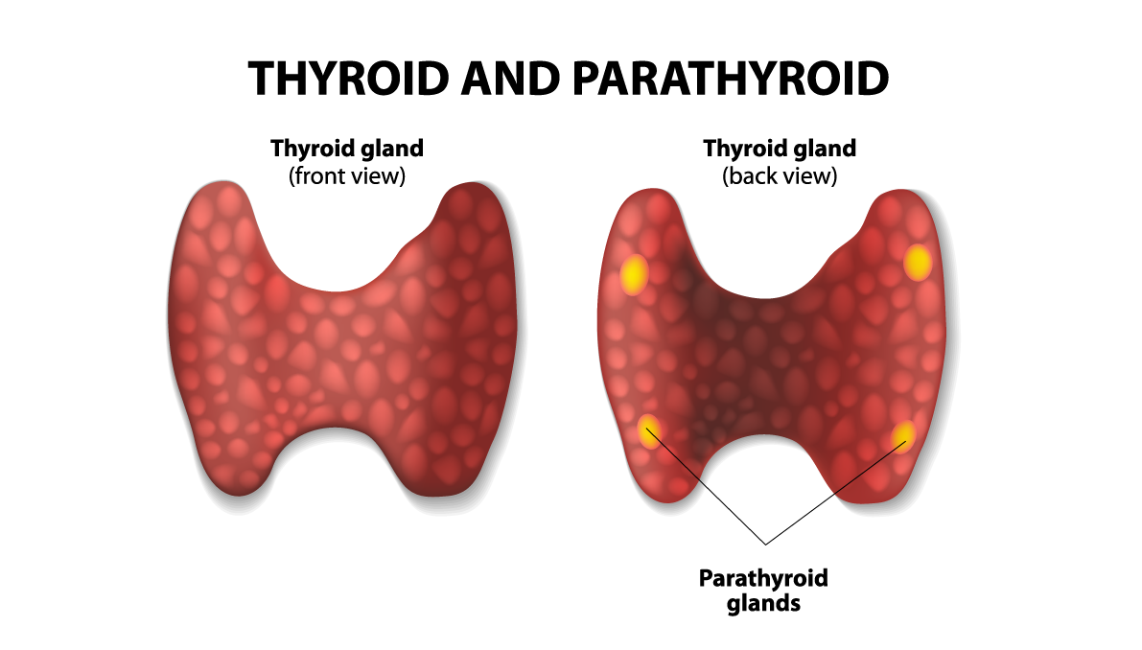
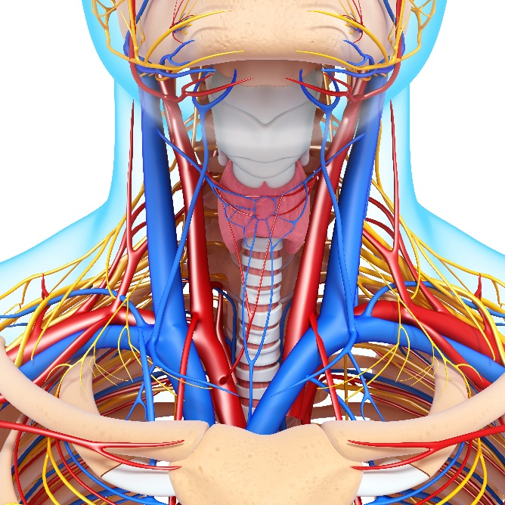

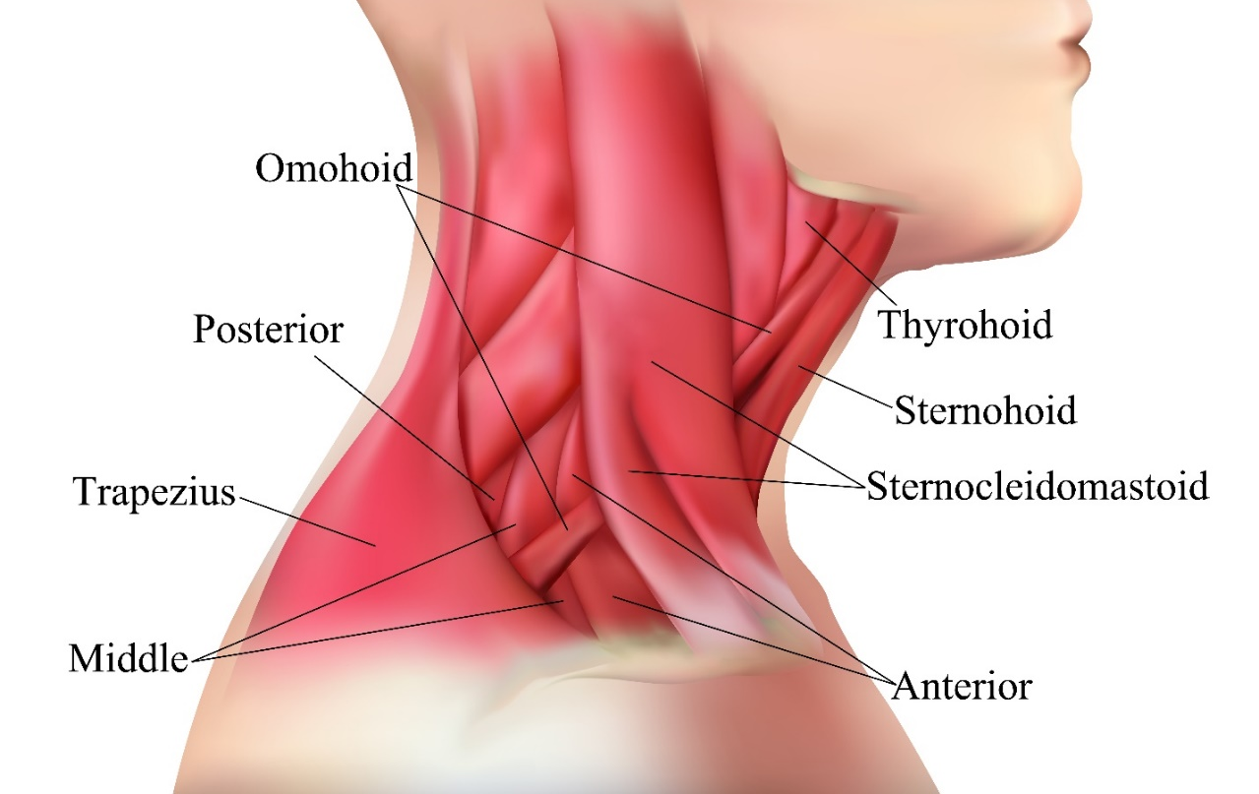
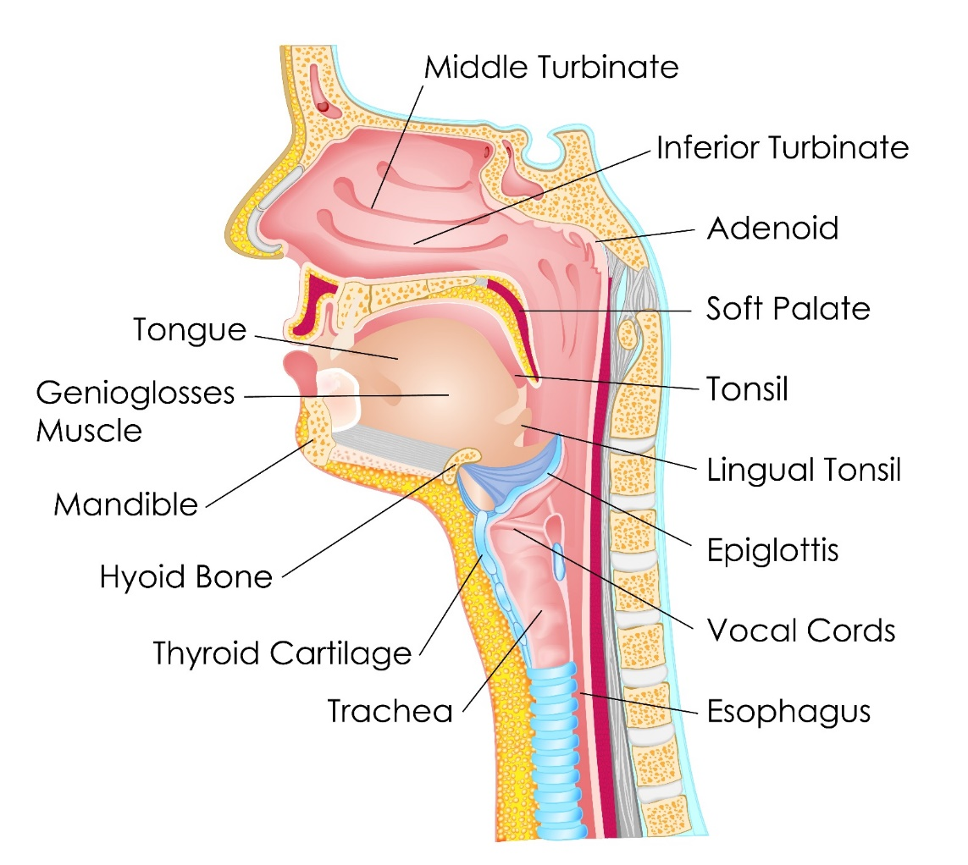
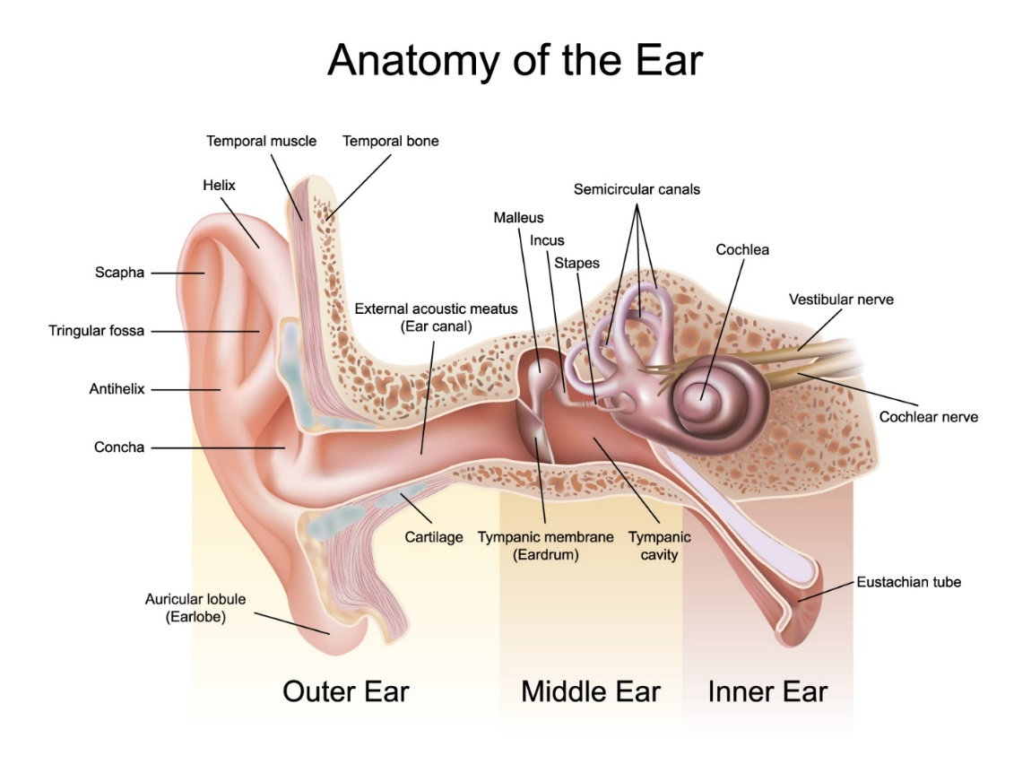
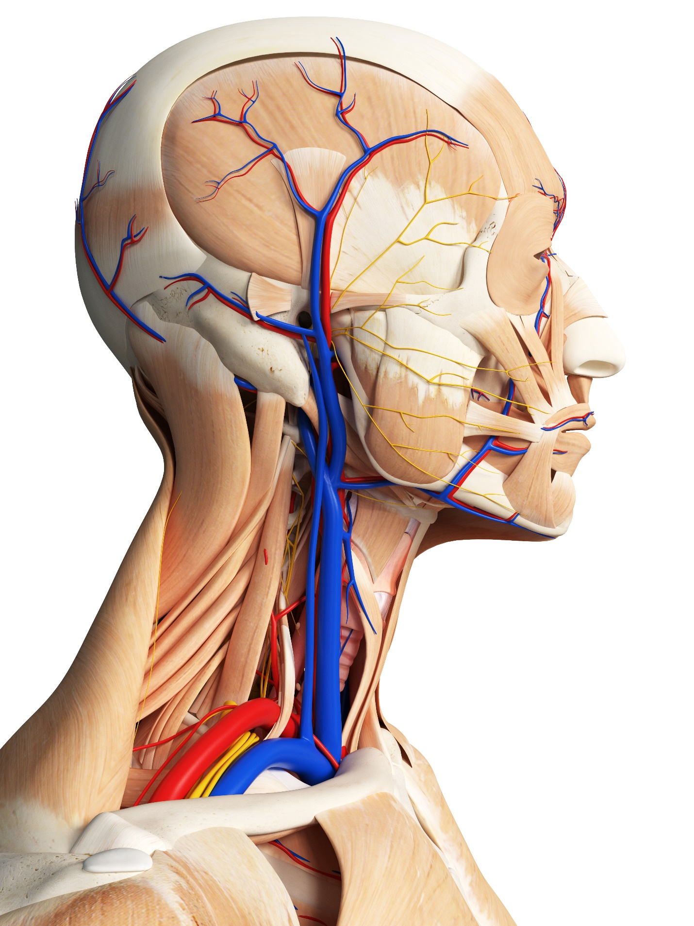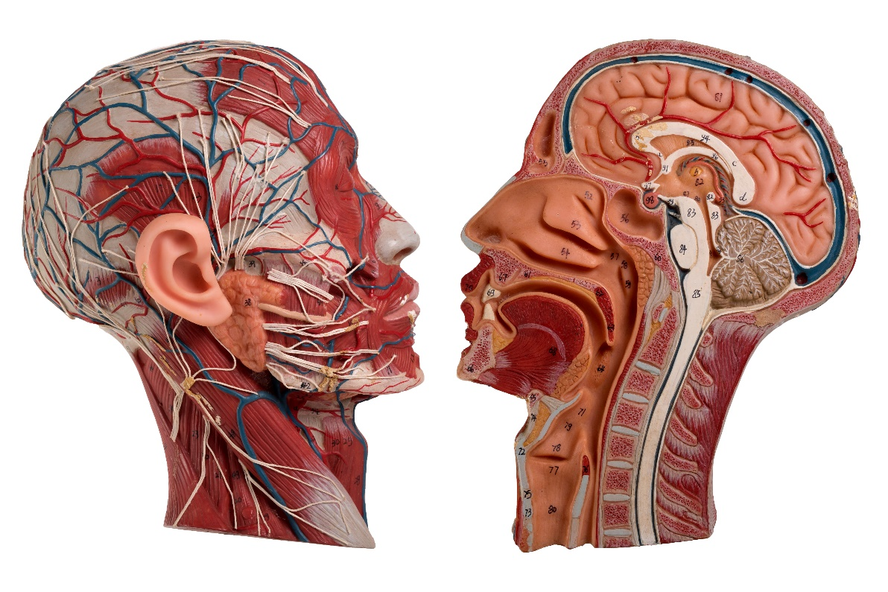
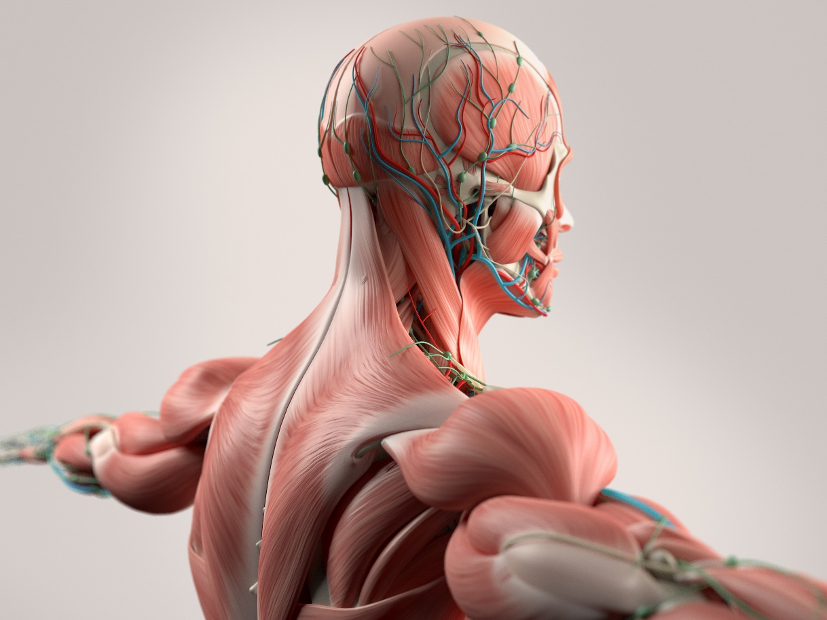

Abdominal Pain and Digestion:
Healer Logic: Things you are ingesting. The abdomen is full of organs in fascia sacks. Fluid build up and pressure causes most of the problems in the abdomen. Fascia fibers create the structure of our organs, so use the same logic as the superficial fascia layer for each organ.
Starting Protocol:

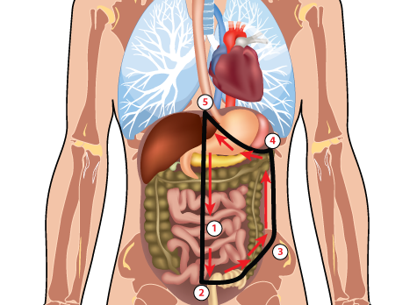
- Start pressing down with your hand right above the pubis bone near the belly button and work your way down to identify the edge of the pubis bone.

- Start working at the bottom of the abdomen by palpating for pain, stiff, and hard spots from the center line of the abdomen and working to the right iliac crest (hip bone). This area focuses on the bladder and lower part of the intestines where the colon can be impacted for constipation conditions. Work on areas you identify with palpation. Use appropriate pressure depending on the amount of fluid build-up in the abdomen.

- Continue palpating upwards along the right side (client’s left) between the hip bone to the bottom of the rib cage.

- Palpate along the edge of the rib cage up to the sternum. This area will focus on the intestines, stomach, liver, and other organs of the abdomen. At a minimum, focus several placements in the stomach area. Stay a few inches away from the bones if you are pressing deep in the abdomen.

- Palpate down the centerline of the abdomen from the sternum to the starting point below the belly button at the pubis bone. The repeat the process on the left side (client’s right) of the abdomen stopping at the sternum on the left side.

- Menstrual and menopause conditions (Cramps, bloating, endometriosis, ovarian cysts)

- Bladder conditions (UTI, infection, incontinence)

- Stomach conditions (Acid reflux, indigestion, hiatal hernia, ulcers, gall bladder)

- Intestinal conditions (Constipation, diarrhea, IBS, Crohn’s, Colitis)
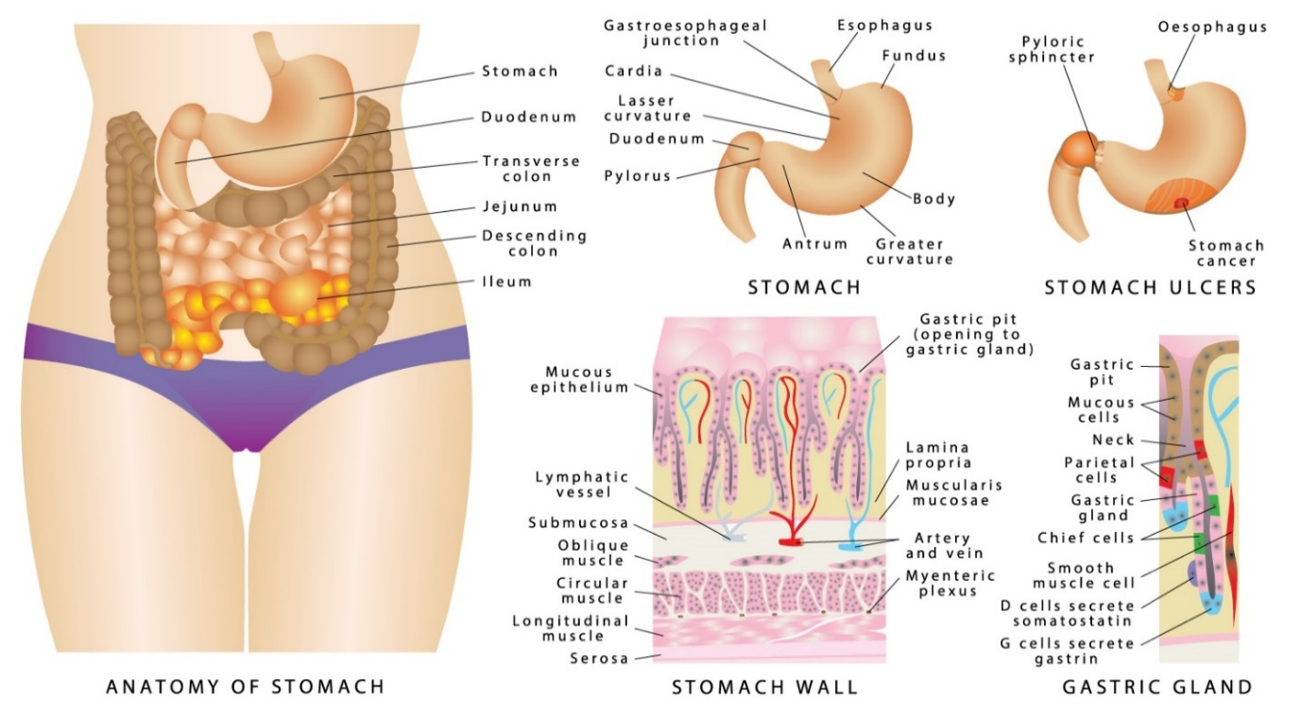

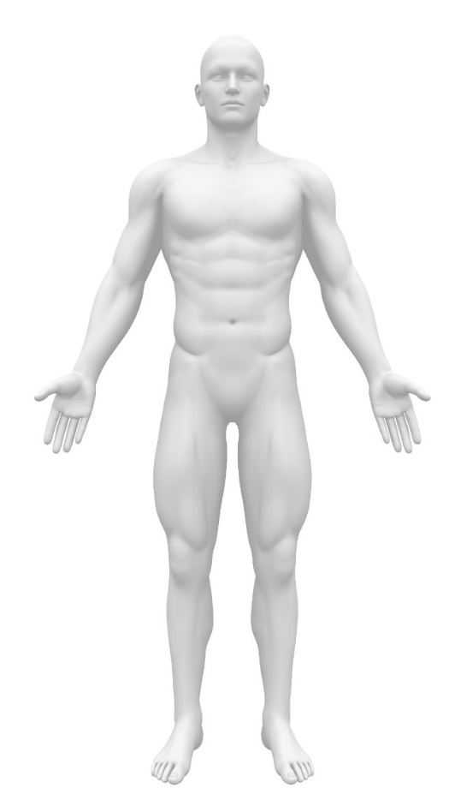 | 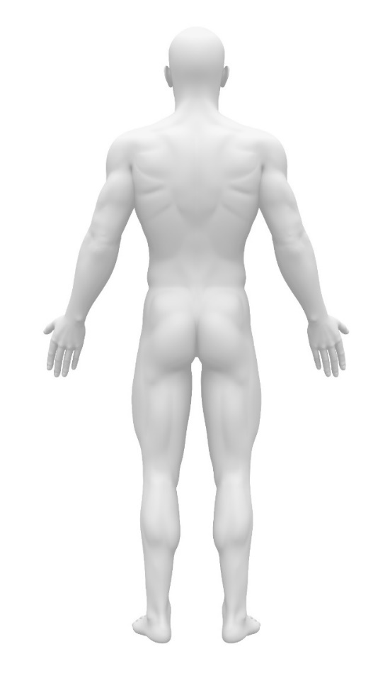

Lower Back and Hip Pain Protocol:
Healer Logic: Results of long-term posture and movement.
Starting Protocol:
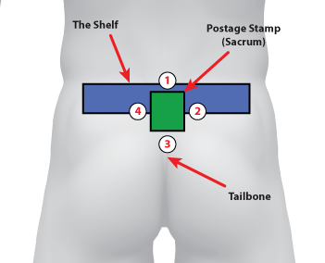
- Start at the top of the postage stamp and press down against the top edge of the postage stamp using a butterfly grip. Hold at an angle over the edge of the hard tissue and into the softer tissue.
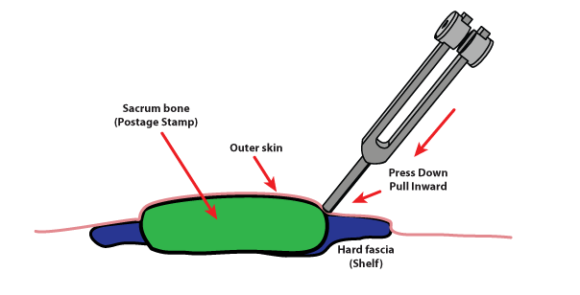

- Work on the shelf of hard fascia radiating from both sides of the postage stamp. Start on the outer edges and work your way inward toward the postage stamp.
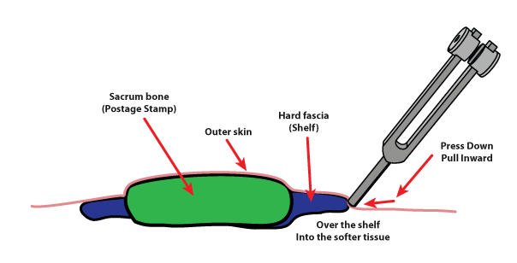

- Work on the tailbone trauma. Find the strip of hardened fascia on both sides of the tailbone. Press down and inward toward the center just like the shelf.

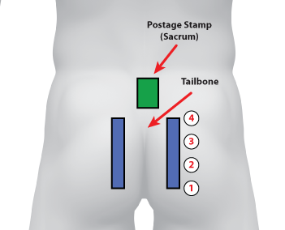

- Follow the bottom of the tailbone fascia tightness down into the sit bone. This area should be tender to the touch for your client. It is the bone that rests against the seat while we are sitting for long periods of time. Skinner people generally have sit bone pain, but we will include it in our starting protocol for all clients. Two or three placements on both sides should reduce any fluid pressure and pain. Put the tuning fork right on top of where you determine the sit bone to be located during palpation.

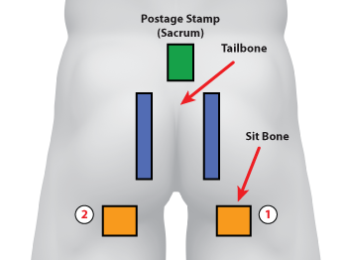

- Work on the Margaret Ball on the hips where the ball joint creates at ball of inflammation in some clients. In certain clients, the lower back pain and tightness cannot be relieved if the Margaret Ball is not resolved. It is more effective to work on the Margaret Ball while the client lays on the side. Sometimes you cannot properly palpate and locate the ball unless the client on laying on the side. Work your way around the outside of the inflammation ball and work toward the center until all of the inflammation is gone.

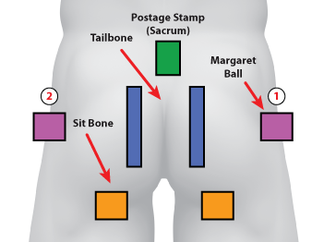

- Finally, Work on the hip bone (Iliac Crest). Feel for the top of the hip where the bone comes closest to the surface of the skin. This hip bone flexes with the entire pelvic girdle and the bones create inflammation near the surface where the fascia slides across this “joint”. Focus on two placements near the front the back locations of the bone where you feel the most inflammation.

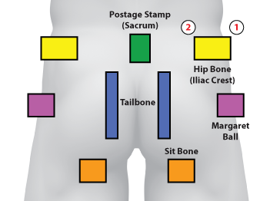

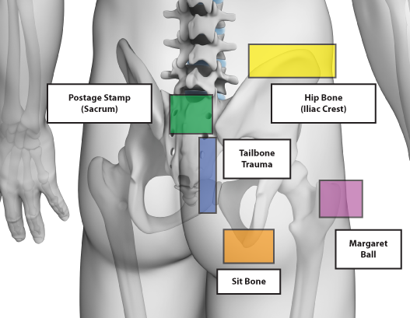

- Disc or spine conditions

- Sciatic pain

- Hip pain (Margaret Ball, Iliac crest)

- Slipped Disc

- Tailbone trauma

- Sit bone
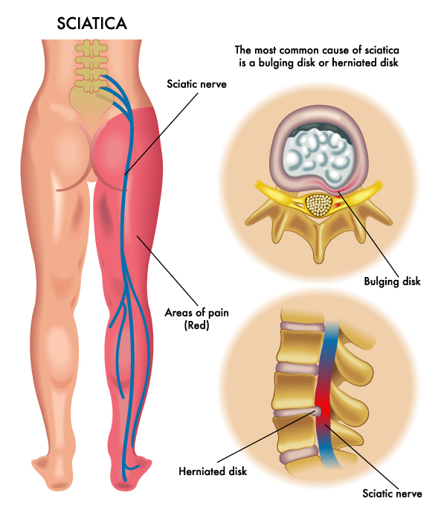
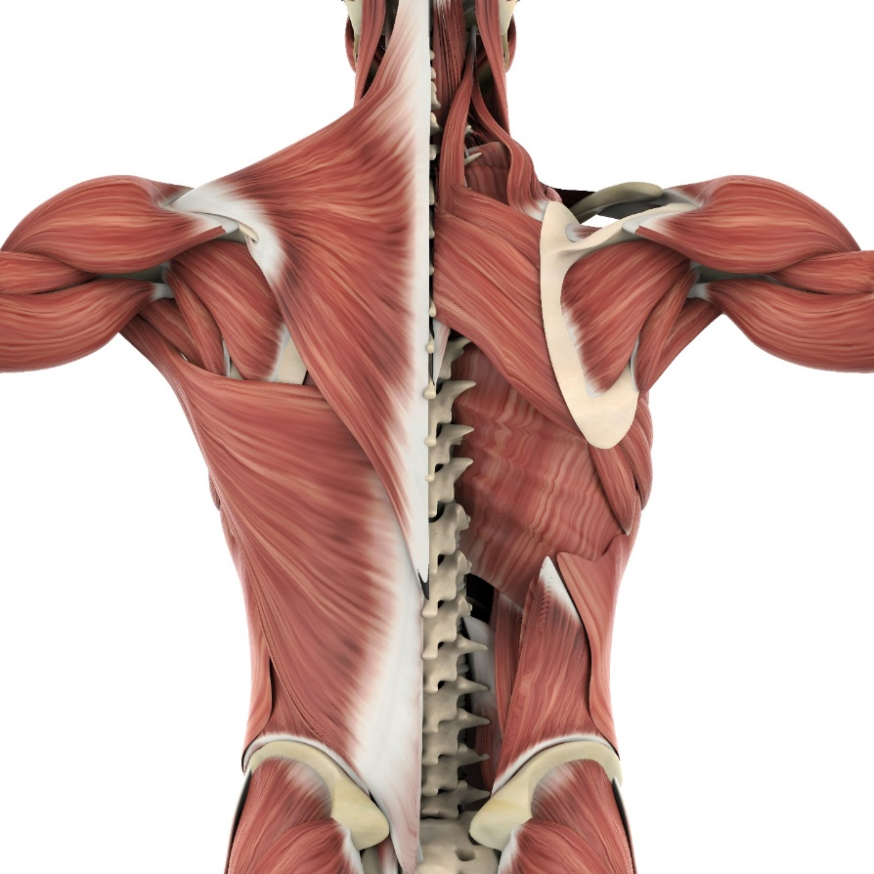

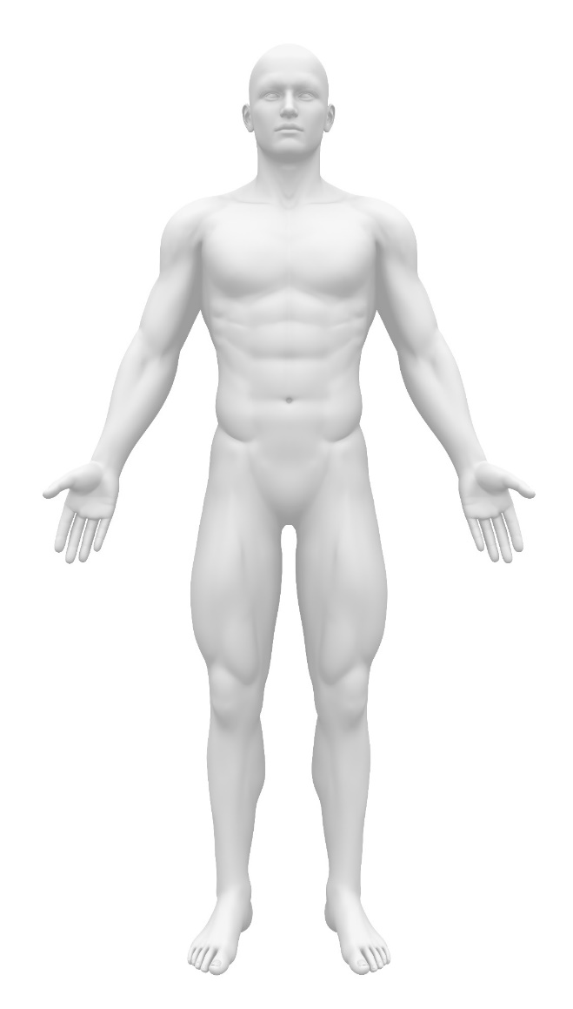 | 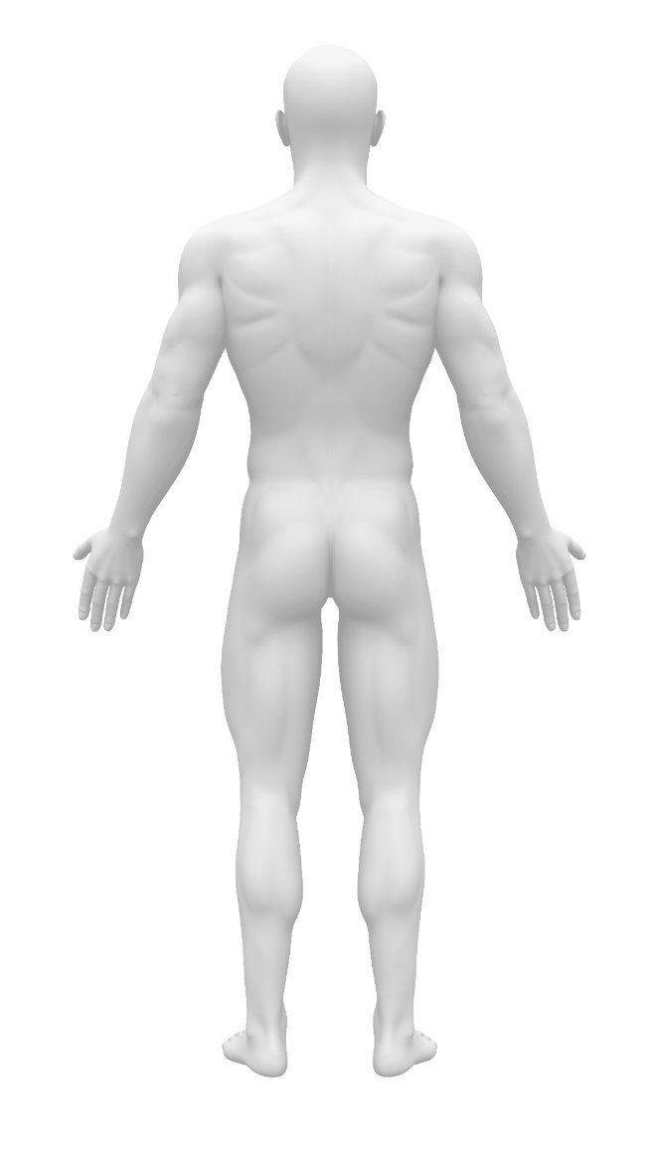

Joint Pain and Range of Motion:
Healer Logic: Results of repetitive movement. Don’t blame the bones. Focus on fluids and fascia as the cause.

- Medical modifications and alterations

- Arthritis, gout, bursitis

- Trauma and injury (with or without surgery)

- Carpel Tunnel

- Dupuytren’s contraction, trigger finger

- Frozen shoulder

- Tennis/Golfer’s Elbow

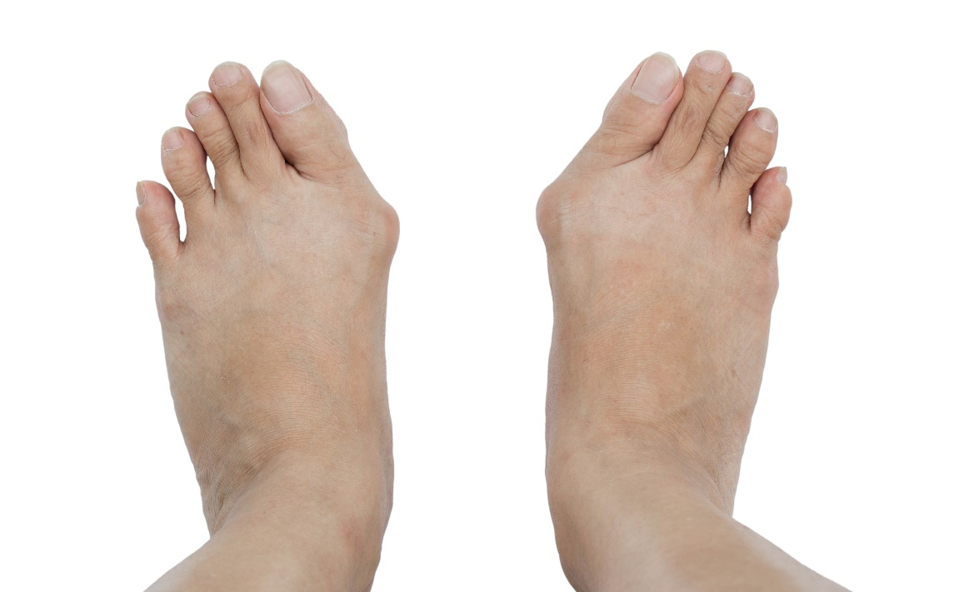

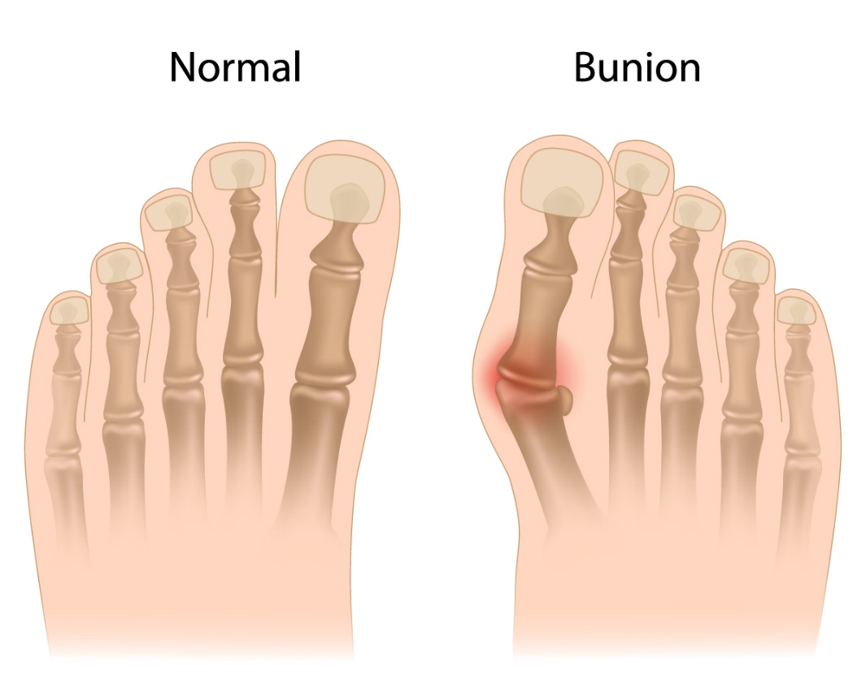
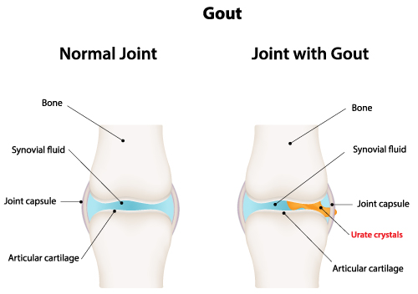

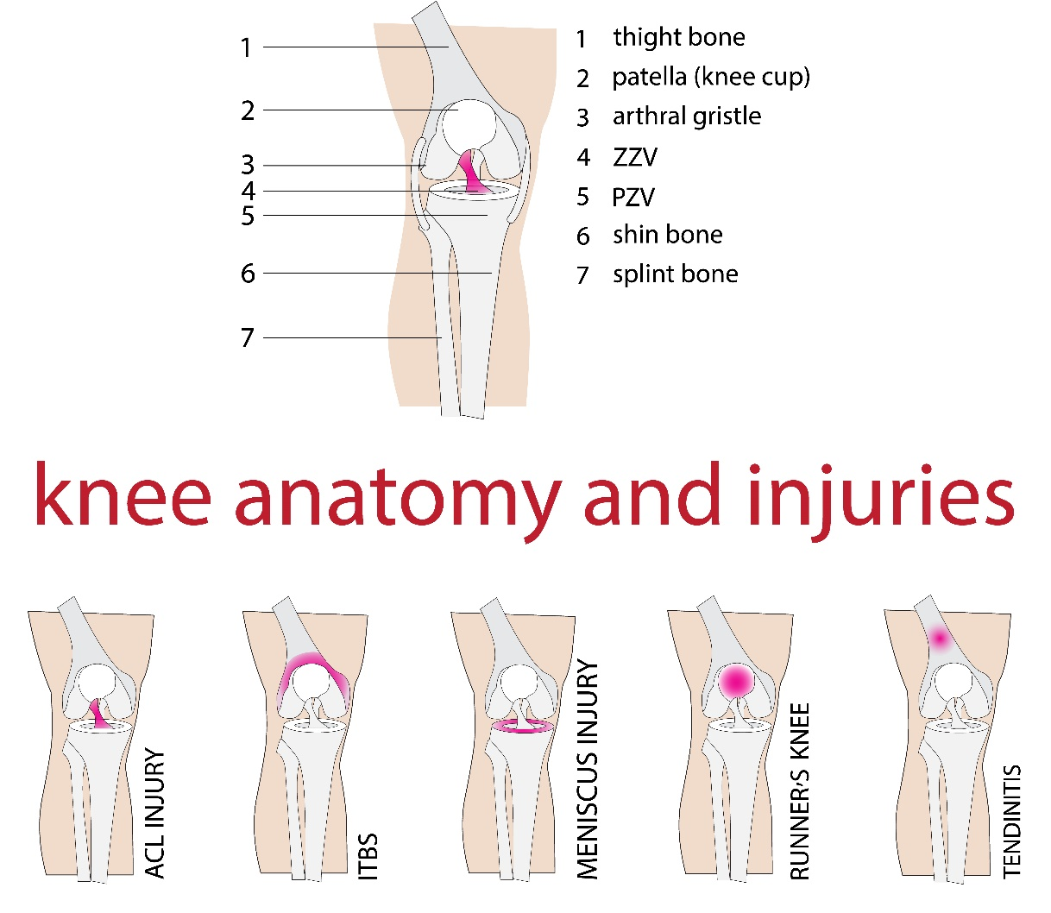
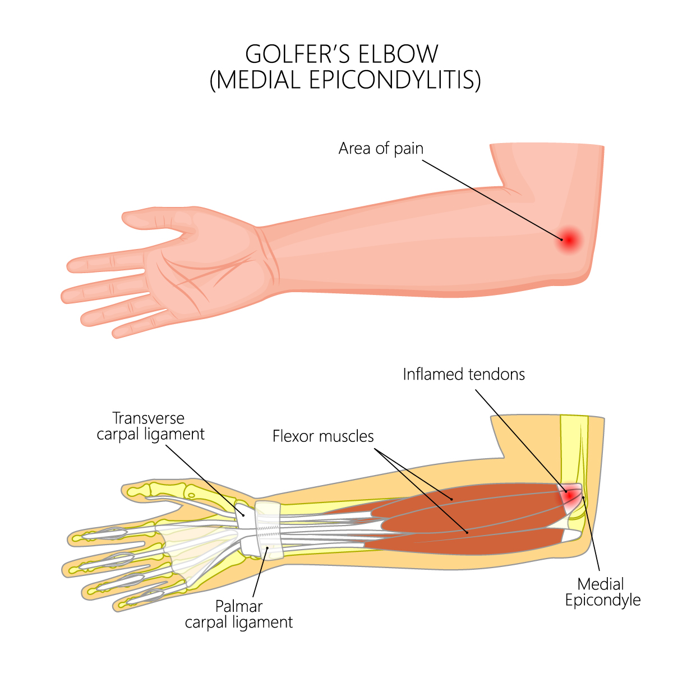
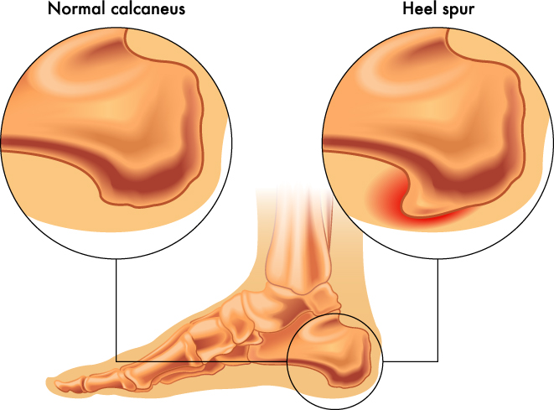

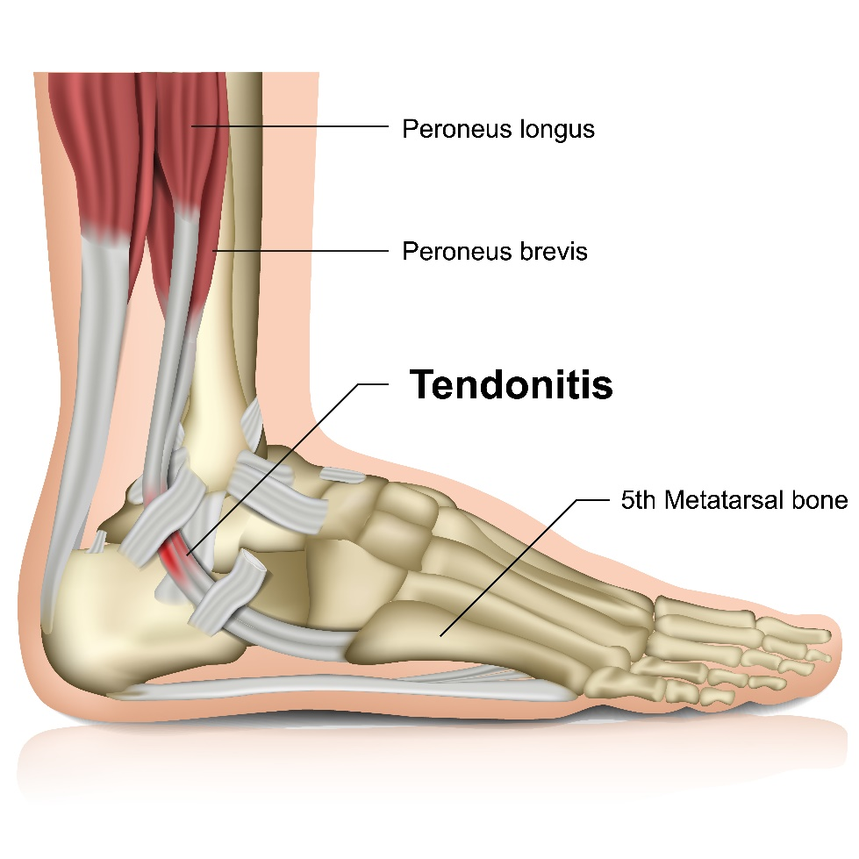
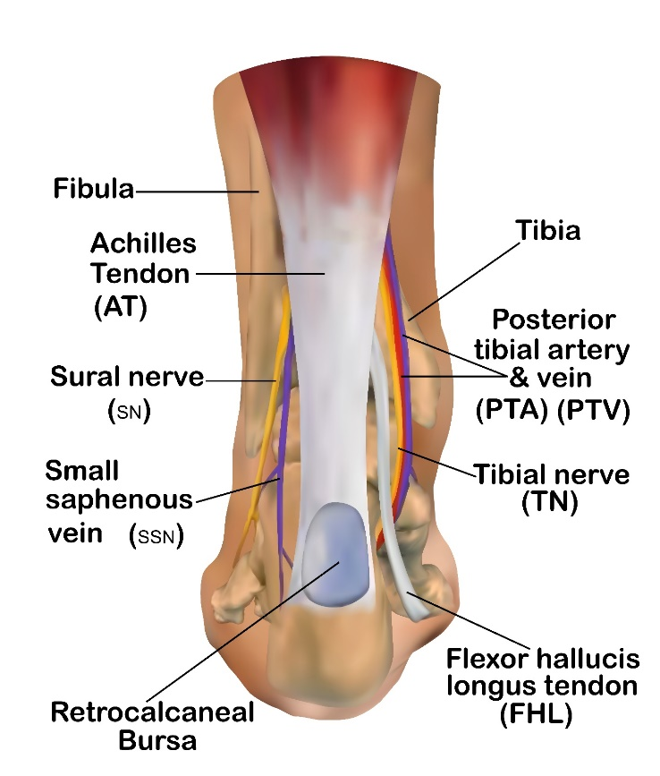

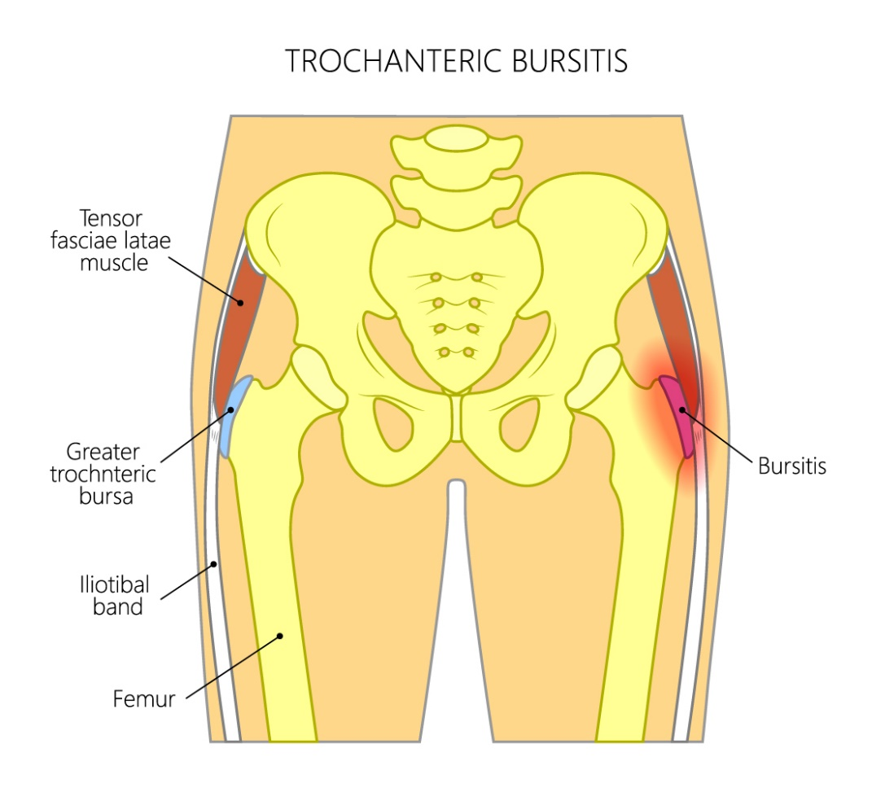
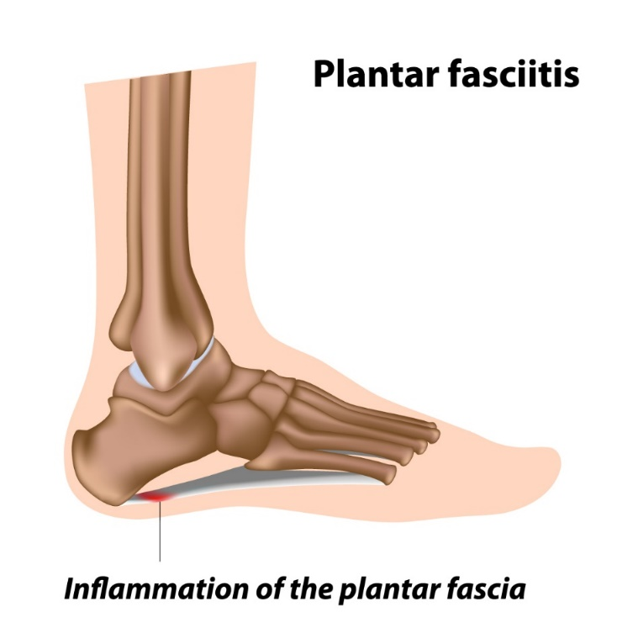

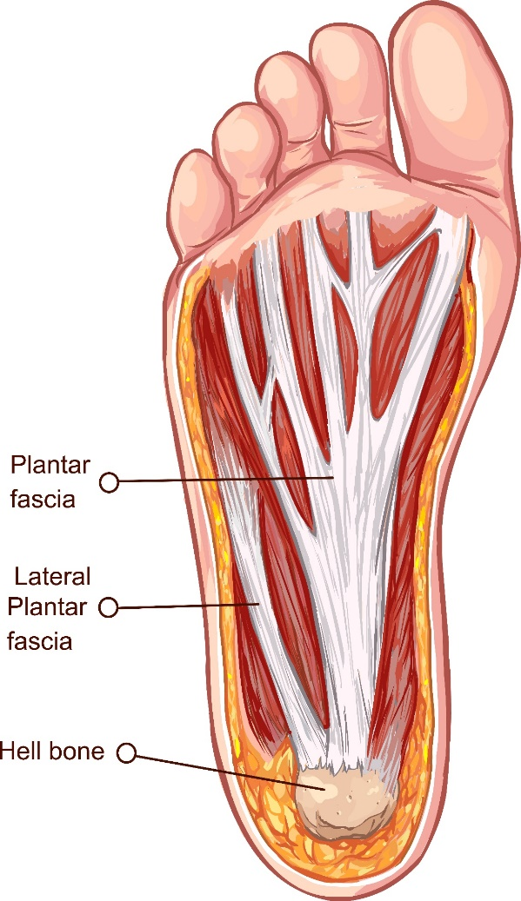
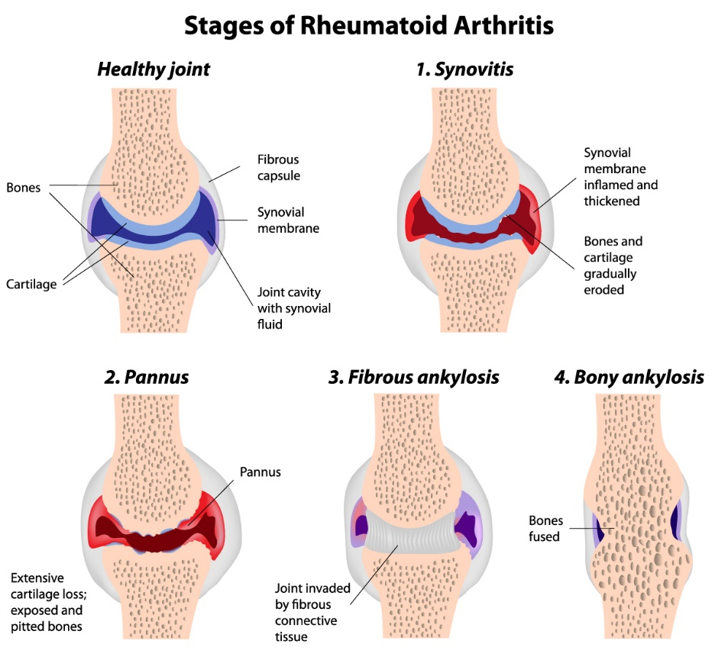

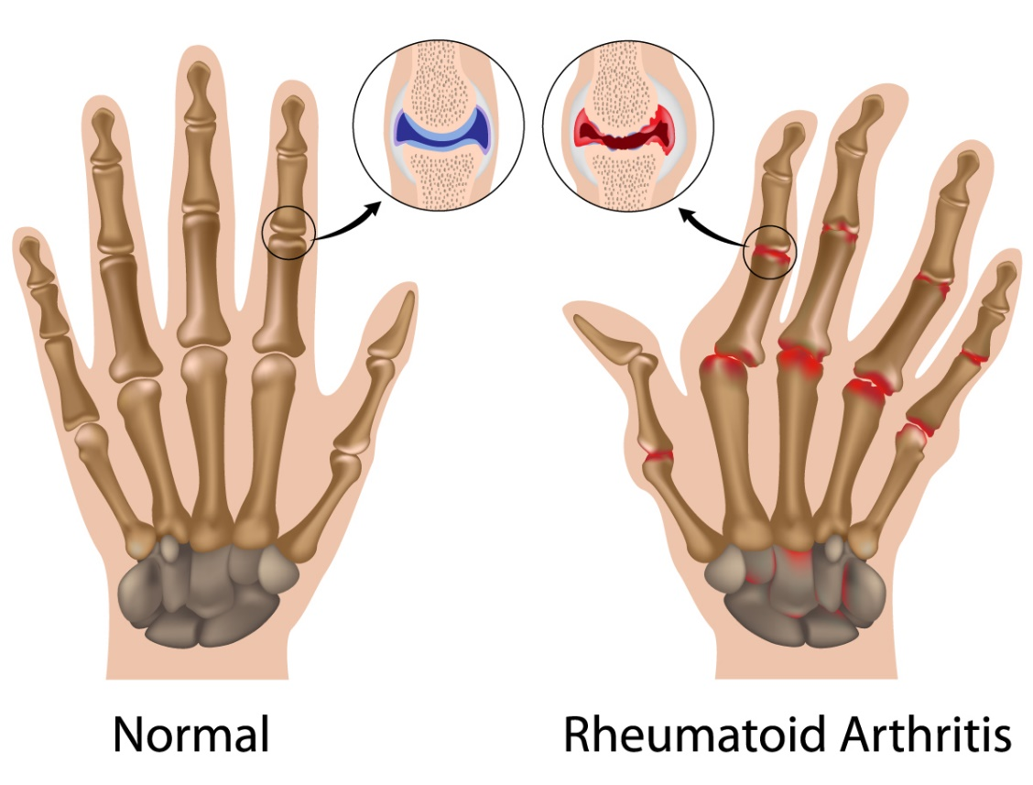

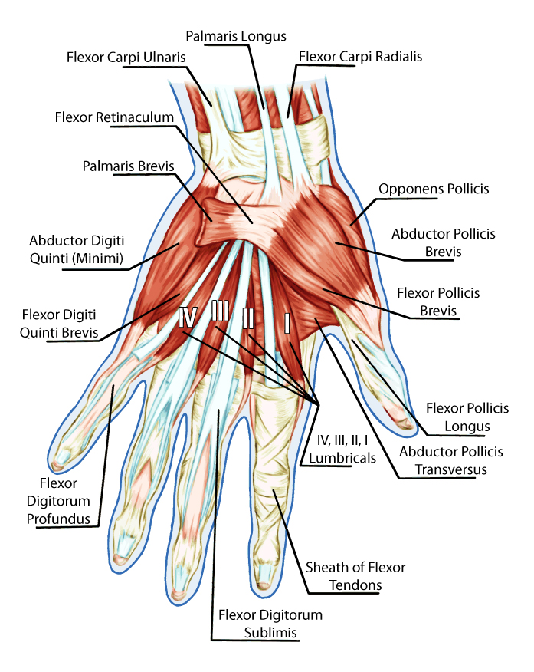

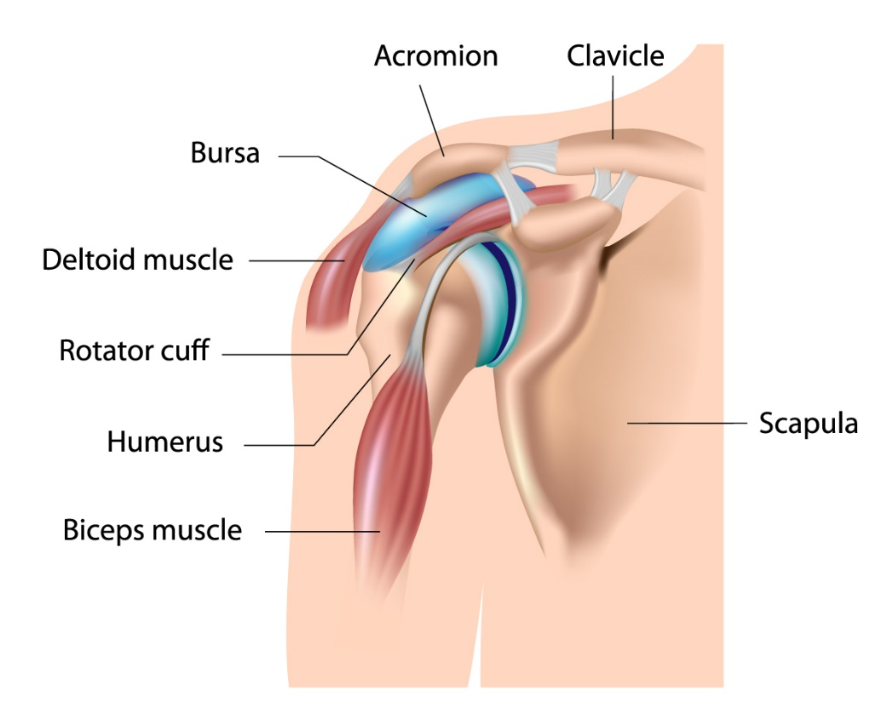
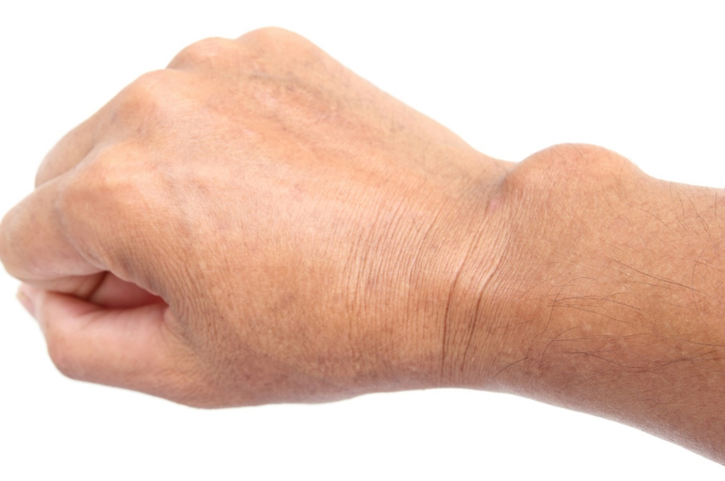

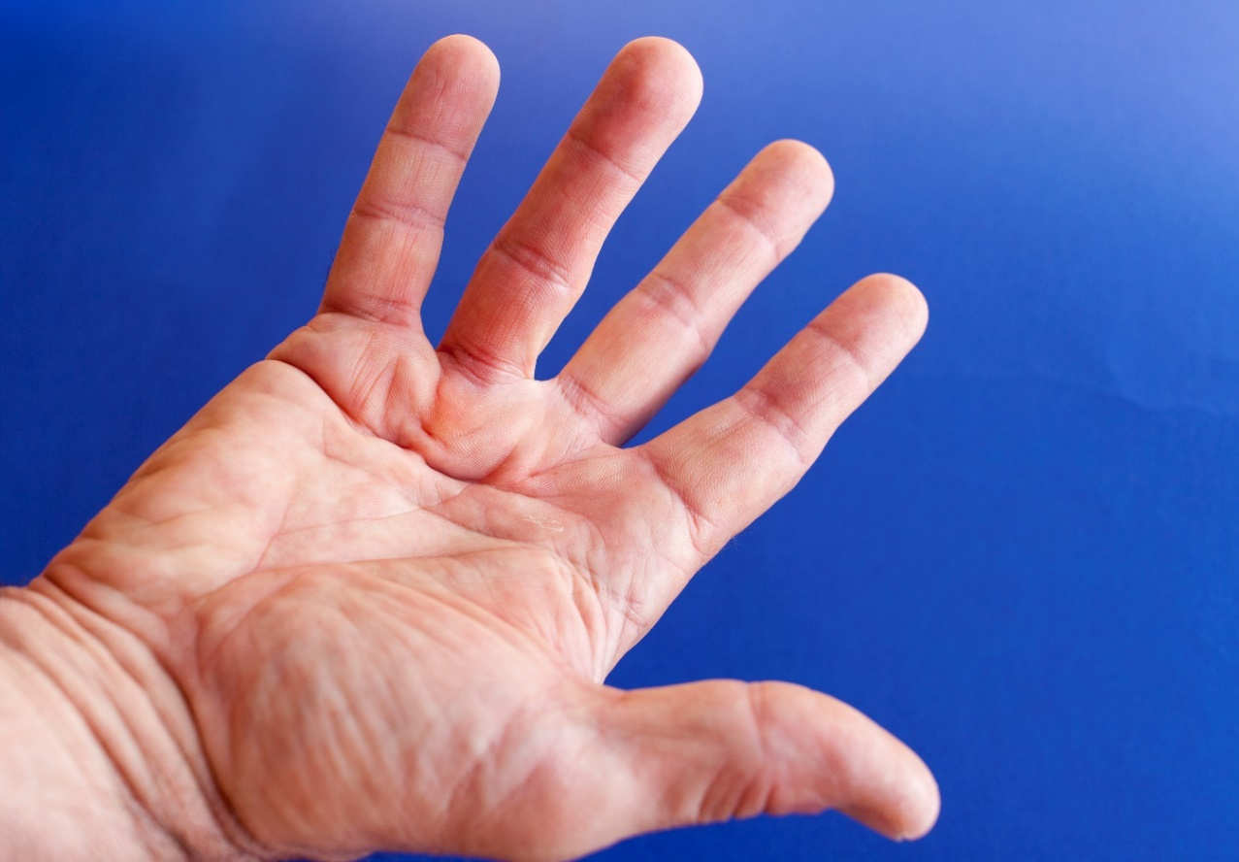

Foot and Leg Pain:
Healer Logic: Results of lifestyle decisions. Foot and leg pain is usually caused from fluid pressure in the extremities or a localized fascial restriction.
Starting Protocol:
- Begin at the back of the upper thigh and palpate down the leg to feel for fluid, lumps, hard spots, and things that feel abnormal.

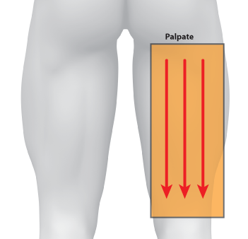

- Use the barefoot tuning fork on areas identified during palpation.

- Use the Press and Push or gem foot for any areas of high fluid pressure. Move the fluid up toward the heart.

- Focus on the lymph nodes behind the knee. The area behind the knee should be concave. If lymph nodes are swollen or the interstitial fluids are compressing the nodes, the tuning fork or a press and push can drain the pressure. Sometimes the knee pain on the front side of the knee is caused by too much fluid pressure behind the knee. The area behind the knee is very tender especially when it is under pressure. Use less pressure compared to other parts of the soft tissue. Acclimate the client to the tuning fork pressure by starting out with less pressure at the beginning of a strike and press with more pressure over time. After a few placements in the same area, you should be able to use more pressure.

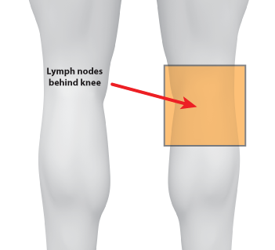

- Feel for a hard spot on the side of the inside of the knee. This area might need to be loosened in order to relieve the pressure behind the knee. This location is referenced as the “Jackpot” because of the first client where we found this particular drain spot. It is also extremely pain and sensitive to most clients for touch and pressure from the tuning fork. Work your way up the inside of the knee for a few strikes (between spots 1&2).
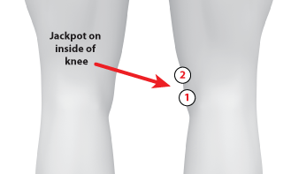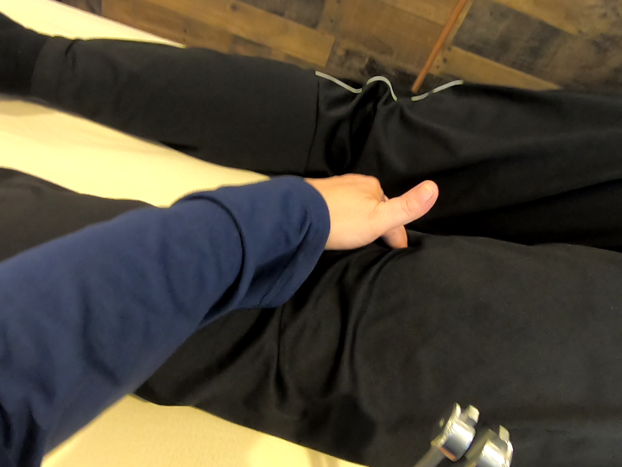

- As a reminder, you are using a lot more pressure on the tuning fork when you angle the tuning fork towards you. Extra pressure or a butterfly grip would be too much pressure in this situation.
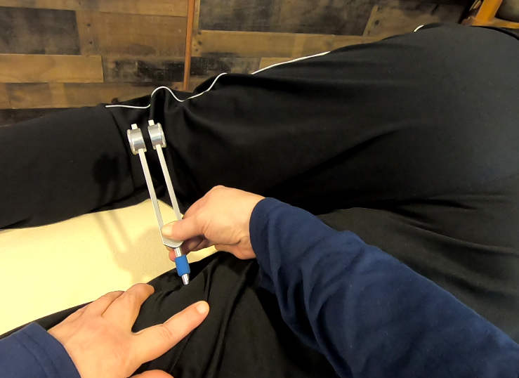

- Feel for fluid areas below the knee in the calf area. Perform a Press and Push to get the fluids above the knee. Get rid of the fluids in the lower leg so you can properly assess for fascial restrictions and smaller fluid pockets.

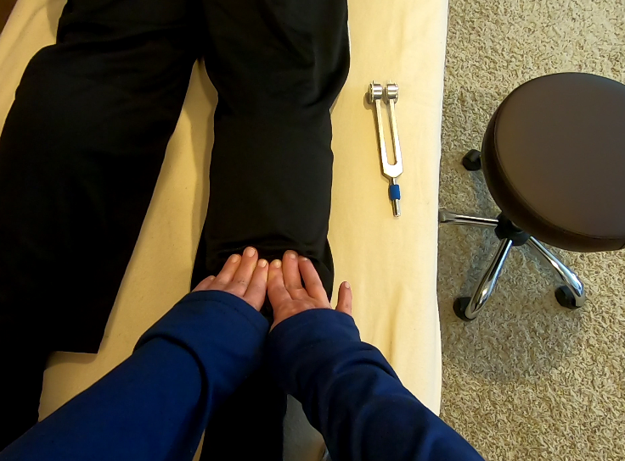

- If there is a lot of fluid in the calf area, use the Press and Push several times getting deeper each time with more pressure. Start out with much less pressure at the beginning and work deeper as you go. Make sure you push the fluids all the way past the knee. You do not want the fluids sitting in the cavity behind the knee. You should be able to feel fluid collecting in front of your fingers as you push. Fluid pressure in the calf is the biggest cause of restless leg syndrome, cramps, and Charlie horses.
- After the fluid push, come back and palpate again for the small areas that need work in the calf area.
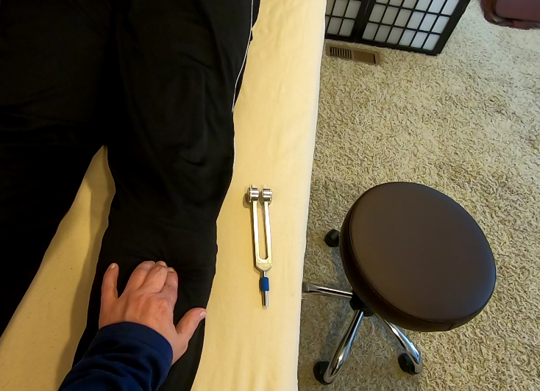

- Palpate and work on the soft part of the ankle. Angle the tuning fork downward to get behind the ankle bone.

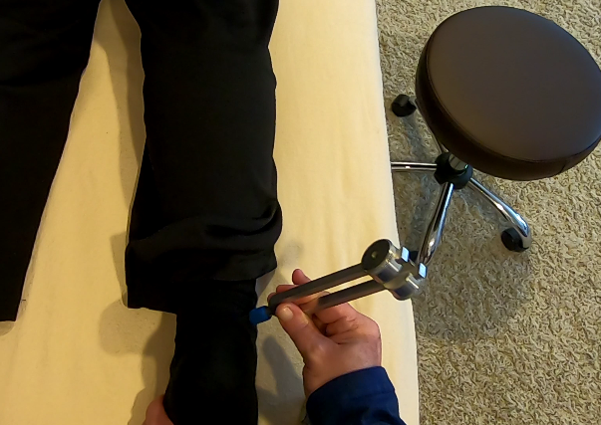

- Work behind and underneath the Achilles tendon. Never work right on top of the tendon. Put a supporting hand on the other side of the foot. Continue working around the ankle bone in the soft tissue. This will dramatically increase range of motion.

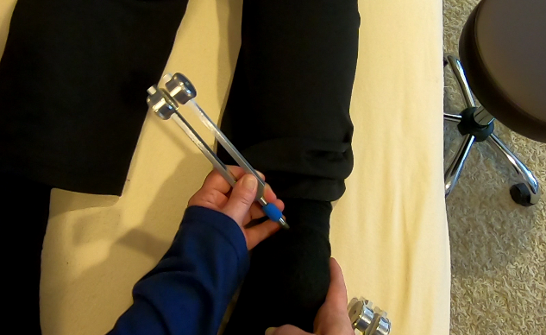

- Palpate the bottom of the foot to check for adhesions.

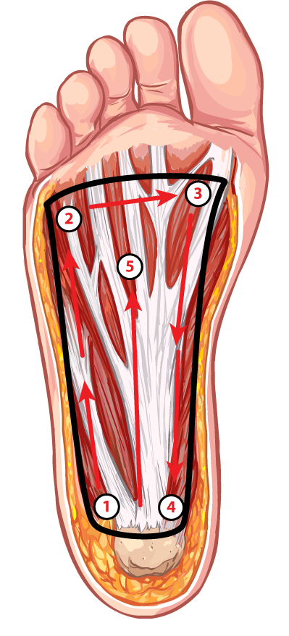

- Feel for something that feels like a pencil underneath the skin. Fluid can get inside of the tendons making them roll back and forth during palpation. Once located, work on it with the barefoot tuning fork by positioning it between your fingers for stability.

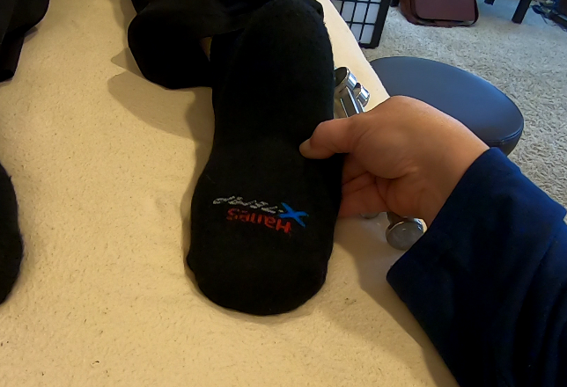

- Leg pain (Restless leg, cramps, Charlie horse)

- Plantar’s warts

- Fallen arches/flat feet

- Plantar fasciitis

- Bunions, hammer toe, in-grown toenails (trauma)

- Bone spurs

Anti-aging Protocols:
Healer Logic: Consider the logic and protocols of the Head and Neck group for this area.
- Age symptoms (Wrinkles, scars, stretch marks, smoker’s lines)

- Double-chin

- Hair loss and gray hair

- Spider and varicose veins

- Eye bags

- Skin conditions (Acne, rashes, rosacea)

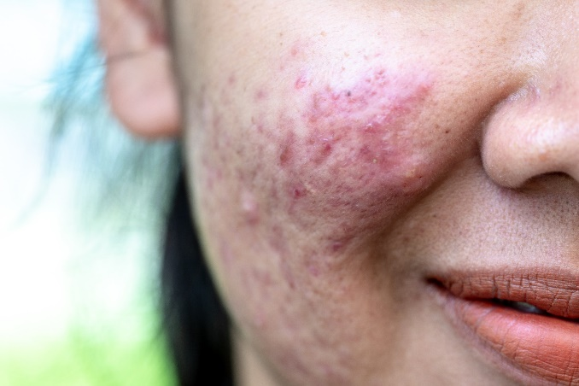 | 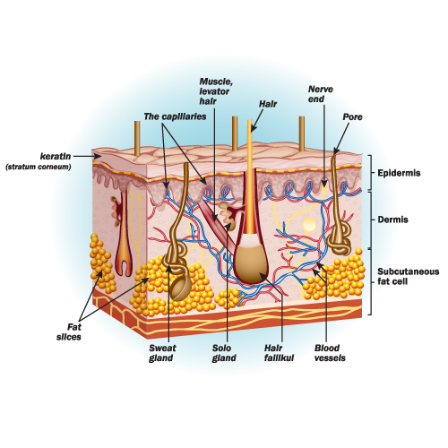
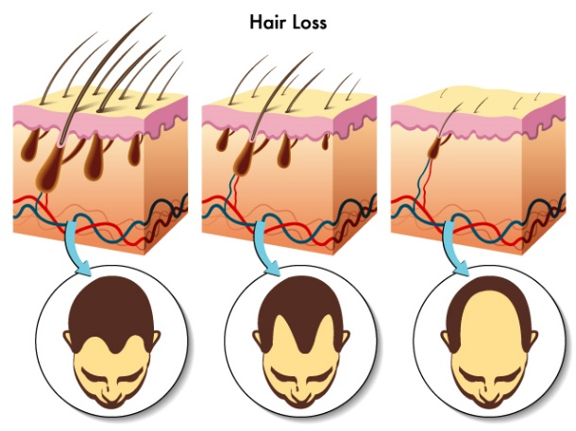 | 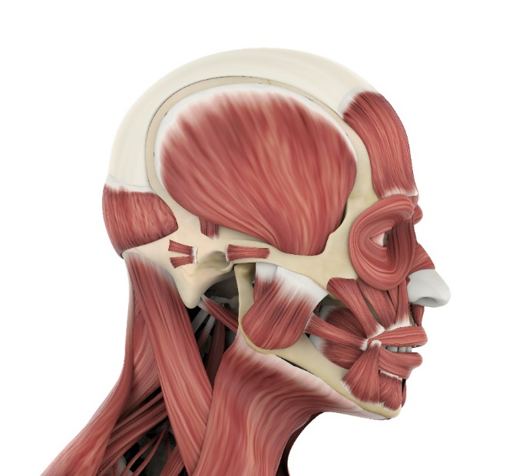

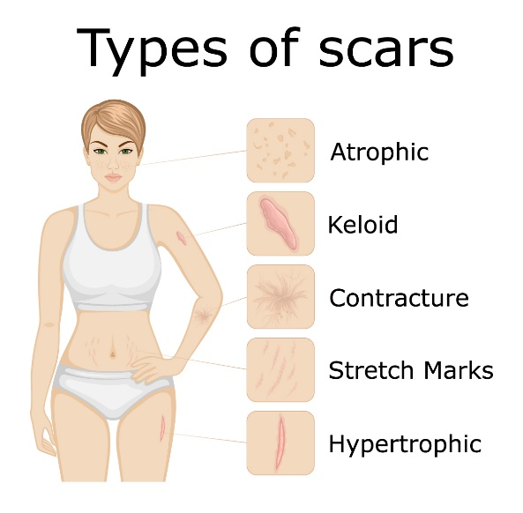 | 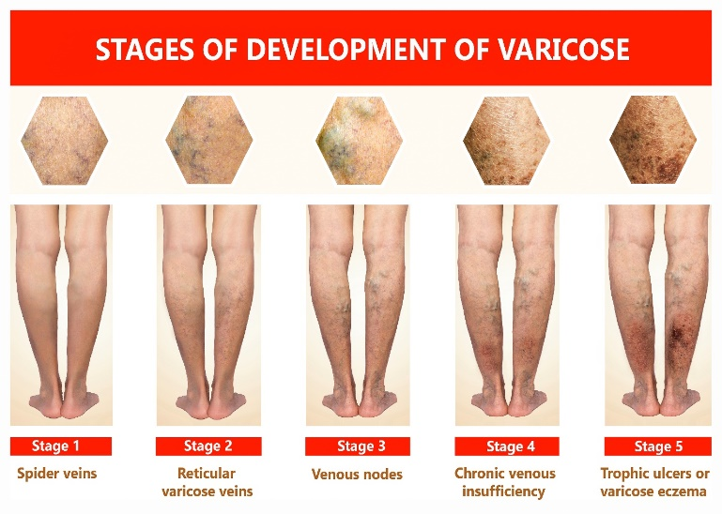

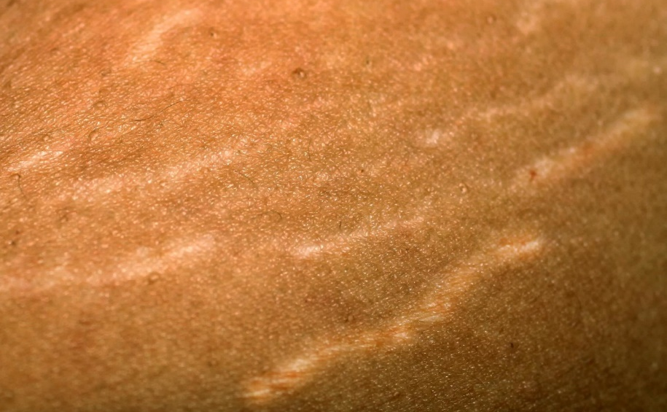

Fat Burning Protocol:
Healer Logic: Consider the logic and protocols of the Abdomen and Digestion group.
- Stomach (upper abdomen)

- Lower abdomen

- Thighs

- Buttocks

- Side boob

- Boob lift

- Double chin

- Sagging arms

- Back fat

- Body shaping and contouring

- Body Wrapping and mud/clay

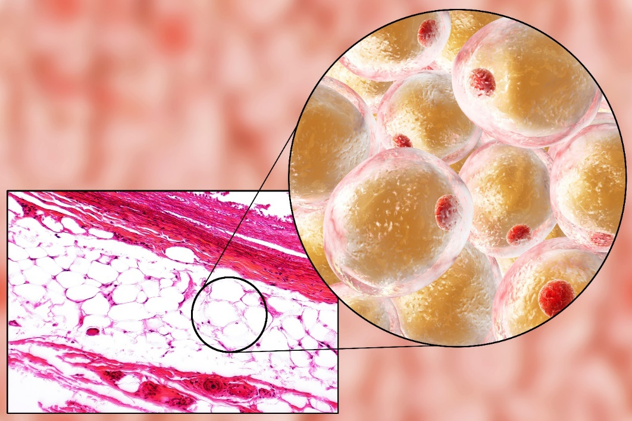
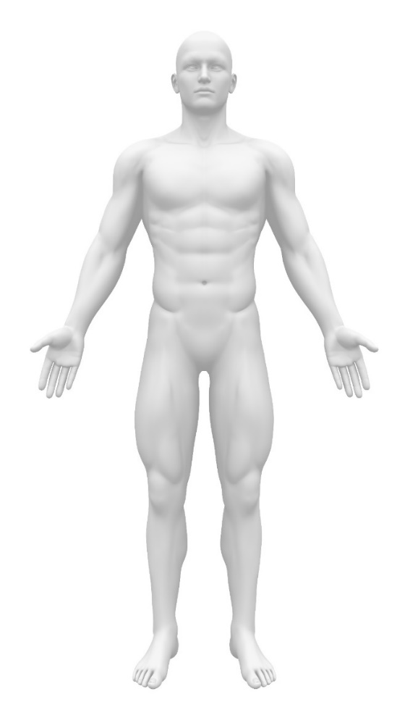 | 