Volume One
Vibrational Fascia Release Technique™
3-Day Intensive Class Manual
Name:
©2019 New Earth Healing Center LLC Ver3 (8/19)
All Rights Reserved: Do not copy without permission

Disclaimer:
Practitioners, owners, and authors of New Earth Healing Center LLC and NEHC Academy are not medical professionals and shall not be held liable for results based on information provided in this document. The information provided within these pages are suggested techniques and opinions based on knowledge and experience gained from sound healing with singing bowls. Information provided in this document is not backed by research-based information or peer-reviewed science. Consult with a medical professional and use professional judgement before attempting any action suggested within this document and for treatments where using singing bowls or tuning forks on the body is contraindicated.
New Earth Healing Center LLC and its training division NEHC Academy operate within the State of Michigan in the United States. Techniques suggested within this document may not apply to all local, state, and national laws for performing sound healing or placing hands on a client. Check with your own rules and regulations prior to attempting these techniques with any client.
Do Not Reproduce:
This document is provided as a workbook for an NEHC Academy training course, and receipt of this document assumes the owner will print pages for personal or professional use. However, reproduction in any format for re-sale is prohibited. Do not share information from this document in a public forum.

Table of Contents:
What Is Fascia Release | 5
ILF Loop | 7
Superficial Fascia | 8
Interstitial Fluid | 12
Lymphatic System | 16
Failure of one ILF component | 18
Resolving the ILF Loop | 20
10 Core Skills | 23
Healer Logic | 24
Palpation | 29
Grip | 32
Strike | 36
Placement | 39
Pressure | 40
Feedback | 46
Press and Push (Hand) | 49
Gem Foot Slide (Tuning Fork) | 51
Resolution and Accountability | 52
Head and Neck Protocols | 53
Abdominal Pain and Digestion Protocols | 65
Lower Back and Hip Pain Protocols | 68
Join Pain and Range of Motion Protocols | 76
Foot and Leg Pain Protocols | 87
Anti-aging Protocols | 95
Fat Burning Protocols | 99

Purpose of this class manual:
This manual is to be used in conjunction with a live 3-day Intensive VFRT Certification Course. The content found within this manual may follow the workflow for the course. However, the instructor may also change the workflow based on the needs of the class.
The content is structured in a bullet format in some areas with adequate space for writing notes. This manual is not designed to be an all-encompassing document with all of the material presented within the course. Additional resources have been provided in electronic format within our NEHC Academy Learning Management System.

- Fascial Restrictions (Fascia Lasagna):
We believe that there is not a specific substance of inflammation to be found trapped or existing within the woven fascia fibers. It is the response of the fascia that causes the condition in which we call chronic inflammation. When the fascia responds to every change in condition, it will realign, loosen, and tighten to keep this marvelous machine upright and moving. But we are not working in unison with the fascia programming. We stop moving and start changing our movement patterns which causes the fascia to continue responding to our deliberate actions to move without pain. The fascia near the joints or that support movements associated with that joint will continue to tighten in some areas and loosen in others.
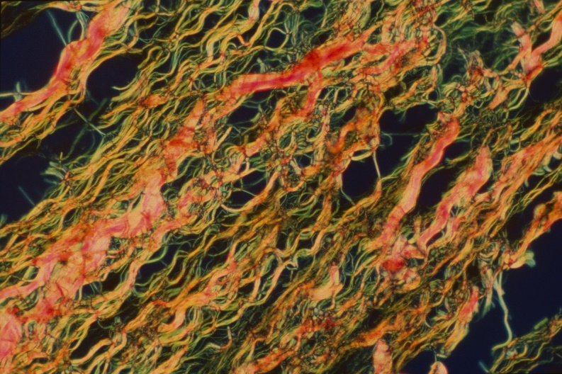
We also must consider that the tendons, ligaments, and bones are also fascia that will respond to changes in movement. These three components can work against each other to eventually sacrifice the layers of tissue normally in place to prevent injury and pain like cartilage and viscous fluids to reduce friction and cushion from impacts (also called fascia).
PW31 [CC BY 4.0 (https://creativecommons.org/licenses/by/4.0)], from Wikimedia Commons
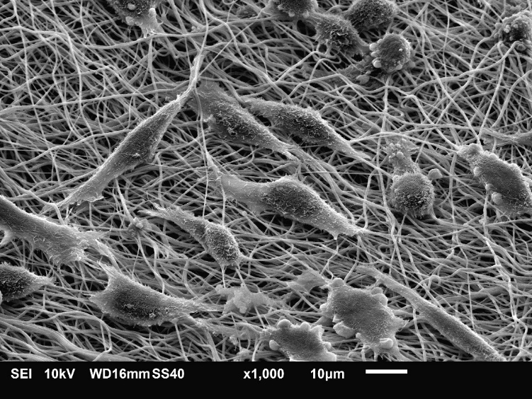
We should also consider how the superficial fascia layer is sometimes called the adipose or fat layer since we see the pockets of lipid-filled fat cells dispersed through the fascia fibers of this superficial layer just below the skin. Most people recognize the individual fat cells, but we do not recognize the structure around the fat cells as a unique component.
Judyta Dulnik [CC BY-SA 4.0 (https://creativecommons.org/licenses/by-sa/4.0)], from Wikimedia Commons

We also incorrectly believe that our muscles and tendons are the main component and do not consider the fascia surrounding the fibers as the primary and critical part of muscle or tendon. In the image below, we can see references to a tendon broken down into the individual components of collagen fibers creating fibrils which group into fibers and then into fascicles to make up a tendon. All of these components are fascia-based fibers made up of collagen; a component of fascia. Without fascia part of a tendon, the tendon fibers would not work as designed. Fascia fibers are a part of the tendon component.

- ILF Loop Fundamentals:
The ILF Loop stands for Interstitial Fluid, Lymphatic System, and Superficial Fascia.
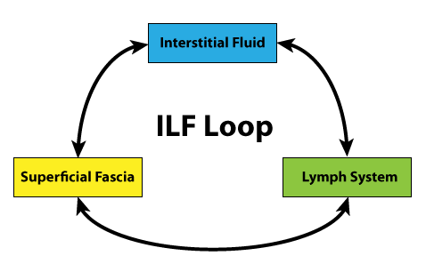
A deep understanding of the unique relationship between these three systems is critical for sound healers to understand how vibration, pressure, and movement affect the body as a whole system.
Each component of the ILF Loop is responsible for balancing multiple systems through independent and inter-related feedback mechanisms to constantly monitor and adjust to current conditions.
If one component fails to operate as designed, the entire loop is compromised causing blockages in the other two components. Each component relies on the others to maintain proper flow and tension to move fluids through the body for various critical purposes like providing oxygen and nutrients to cells and removing waste materials. A blocked ILF Loop can result in chronic conditions like edema, neuropathy, inflammatory diseases, and sinus ailments. Ultimately, a failed loop can result in serious illnesses that compromises vital systems with critical conditions.
Although the body is comprised of multiple inter-related closed system loops, we are focusing on one specific part of the whole body system where substances leave the cardiovascular loop and enter into the vast space of the Superficial Fascia layer as Interstitial Fluid to perform vital functions before entering into the Lymphatic System for cleaning and transportation back into the cardiovascular or “circulatory” system. The ILF Loop shows an inter-relationship between these three components and how a failure in one system causes a blockage in the other two components.
The initial cause of a failure in an individual component and the cascading effects leading to blockages in all components is less relevant than the focus on entering into the loop as a sound healer to unravel the entire loop. When major cities experience a gridlock of traffic, travel routes in all directions are blocked to the point where no cars can move. A gridlock condition remains until at least one point of relief allows smaller changes which ultimately leads to the system returning back to normal operating conditions. In our ILF Loop, there are specific actions that can bring the other two components back into balance where the entire loop can self-correct and eventually return to a fully balanced system.
In our discussion here, we will focus on each individual component and provide the necessarily information to understand the inter-relationship to the other components and the entire loop. We will not dig deep into the detailed mechanisms required for proper operation of a single component.
- Superficial Fascia:
The term “superficial” means it is a layer closer to the outside of the body. Fascia permeates the entire body in almost every aspect of structure and flow of every system from the fluids inside of the cardiovascular system to the vascular tubes and the supporting structure of the fascia network holding everything together.
Modern science has now revealed our bones, muscles, tendons, ligaments, cartilage, organs, and connective tissue are structured within a fascia fibrous network. In fact, new methods and techniques within the medical and bio-research fields have led to the ability to remove the tissue cells of many organs to reveal the underlying collagen and elastin fiber structure making up the organ. Biologists believe they can replicate new supporting collagen structures then re-introduce the recipient’s own tissue cells back into the structure to create a replacement organ that the body would not reject. After all, it was made from the recipient’s own cells.
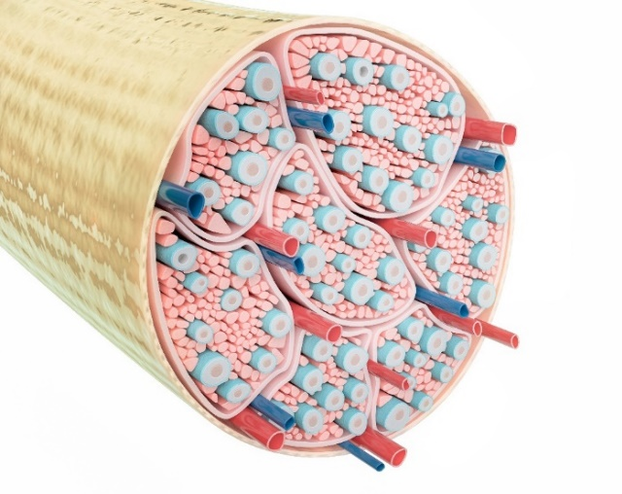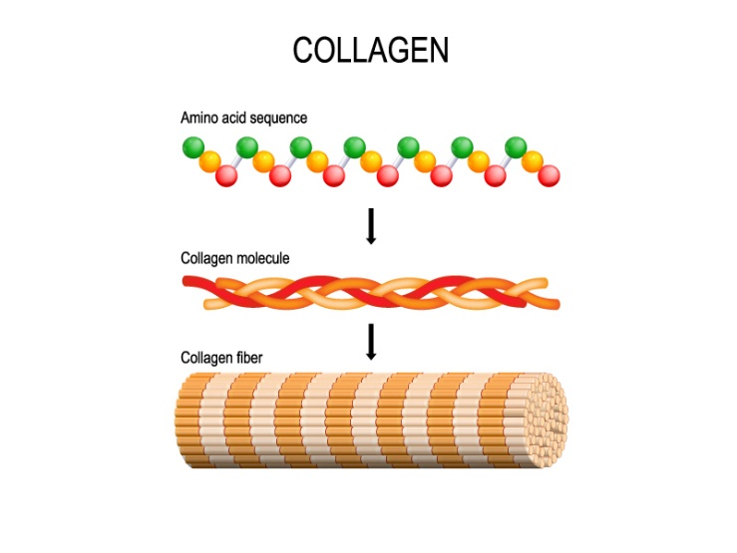

In the scheme of things, the superficial fascia layer is located just underneath the skin or more specifically the epidermis and dermis layers. Most people think of the superficial fascia layer as the adipose or fatty layer because the adipose or fat cells also reside within the spaces of the collagen fibers. Once again, the superficial fascia is a supporting structure responsible for providing a space for interstitial fluid flow while also providing a space to support the vast network of vascular tubes and nerves. The superficial fascia layer also acts as a thermo barrier along with the adipose cells to act as a blanket to maintain body temperature.
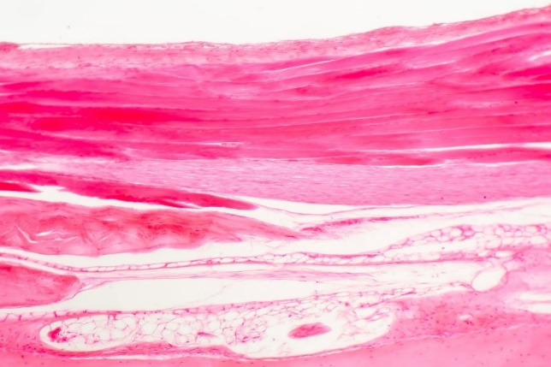
We can also think of the superficial fascia layer as a shock absorber due to the unique nature of the collagen fibers absorbing many outside forces. One of the biggest roles of the superficial fascia layer is the ability to provide tension in response to load, posture, and movement demands at any given moment. We have learned from the structural integration and manual therapy experts like Thomas Myers of Anatomy Trains how the superficial fascia network has a connected relationships along “meridians” or planes running across musculoskeletal joints and regions. For example, the Superficial Back Line (SBL) meridian starts in the plantar fascia of the foot and runs the entire length of the legs, back, neck, and head to end at the brow line of the forehead. Changes to tension in one area communicates rapidly to other areas along the meridian similar to tugging on one thread of a knit sweater to see the same thread respond some distance away.
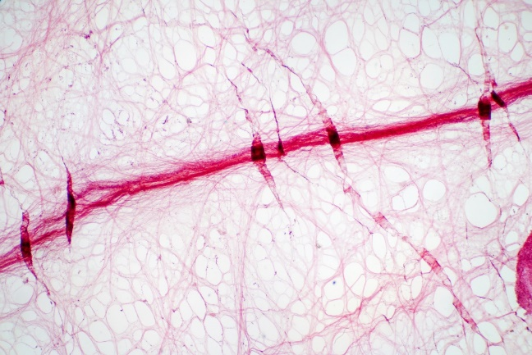
We include the superficial fascia layer in our ILF Loop because it acts as the “hotel” to house the guest interstitial fluid substances inside of what is known as the Extracellular Matrix or ECM. This matrix is the superficial fascia layer with a much more descriptive identification of several components interacting within a woven network of collagen fascia fibers, nerves, arteries, veins, and lymph vessels. In between this woven ECM lives the tissue and fluids of the interstitial space. Even though all of these things make up the ECM, the fascia fibers and controlling cells called fibroblasts are responsible for the supporting structure like the hotel manager and staff.
The fascia part of this network makes sure all of the guests are comfortable and can move through the ECM hotel efficiently using the collagen fibers along with a specialized “ground substance” liquid that can change from thick to watery based on realtime flow demand. In other words, this fascia liquid can get thick and attach between the fibers to cause the interstitial fluids to flow across the tissue cells then transform into a watery liquid at appropriate locations to adjust flow as needed. Just as in our previous example, the fascia liquid part of the hotel staff and not a part of the interstitial guest of the matrix. This fluid works for the hotel manager and is controlled by the fibroblast cells.
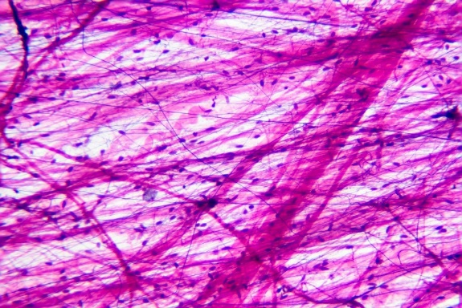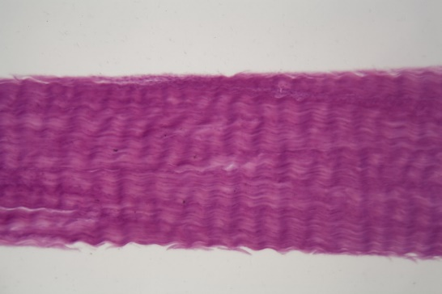

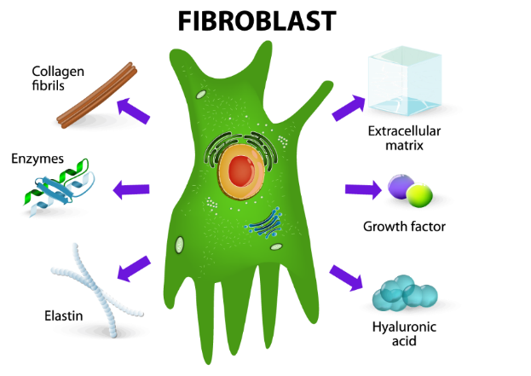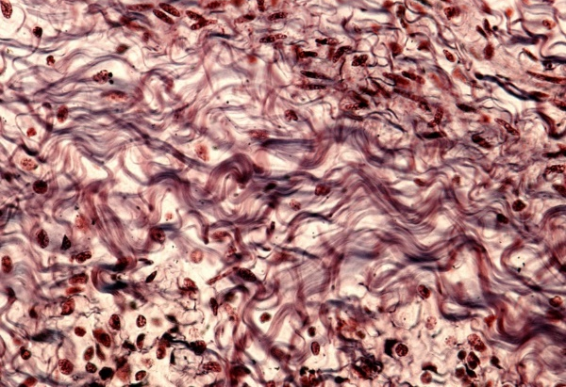

- Interstitial Fluid:
We start with the interstitial fluid because this is the place where substances leave the cardiovascular system through artery capillaries and into the “interstitial” space so the substances to perform their various purposes like providing nutrients and oxygen to tissue cells and provide chemicals for cellular processes. It is important to point out how far we have zoomed into the body down to the cell level where all of the players in this story interact. We can see in the image below how the arteries, veins, capillaries, and tissue cells are all communicating and interacting with each other at the cell level.
In other words, the interstitial space is the area in between and surrounding the cells where fluids flow to cells and waste substances are carried away for cleaning, processing, and/or elimination from the body.
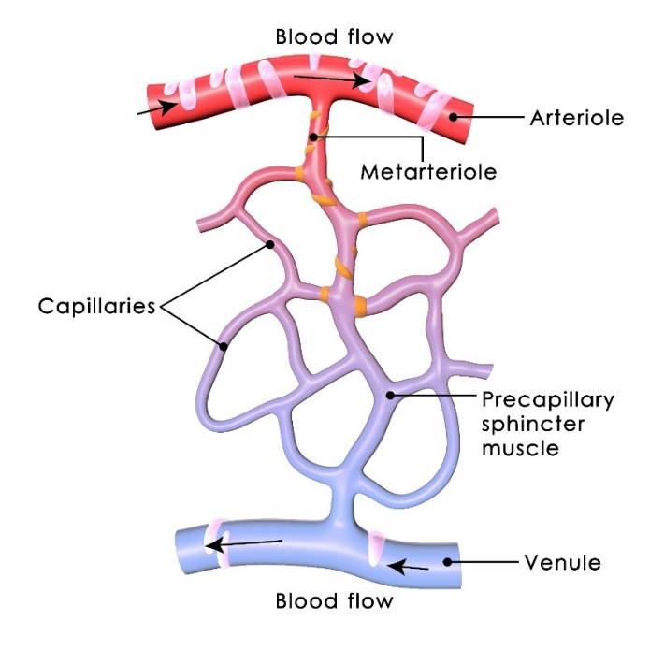
One of the biggest challenges is identifying the substances within the interstitial fluid because the same substances were called blood plasma moments earlier while still inside of the artery. Once forced through the capillaries, the same substances are now called interstitial fluid until they enter into the lymphatic vessels only to renamed as lymph fluid.
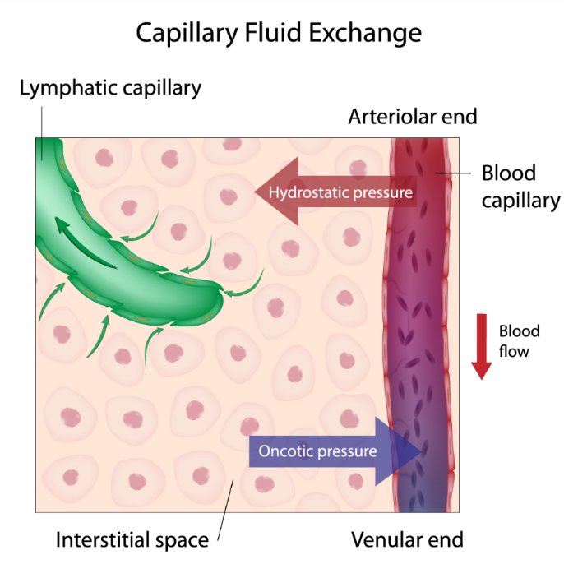
The true composition of interstitial fluid can differ depending on the location of the cell tissue, the current condition of the body component, and the overall health condition of the body. For example, a person currently experiencing chronic inflammation in the superficial fascia below the knees may see more inflammatory substances and a build up of waste products that never made it into the lymphatic system for removal. The fluids in this interstitial space can comprise of so many substances in differing quantities that it would resemble the famous Cantina scene in Star Wars where inhabitants of different planets mingle together for various purposes.
Let’s take a closer look at the composition of all the body’s fluids. According to Wikipedia, fluids make up from 45 to 75 percent of the body’s total weight. This fluid can be further broken down into two-thirds being found within the cells and the remaining one-third found outside of the cells in what is known as Extracellular Fluid. The term “Extra” means outside of the cells. The main component of Extracellular Fluid is the interstitial fluid which surrounds the cell tissue.
The interstitial fluid is further separated into “delivery system” fluids like plasma and lymph that originate within the cardiovascular and lymphatic systems. The other part of interstitial fluid is the other substances like water, sugars, salts, fatty acids, amino acids, coenzymes, hormones, neurotransmitters, white blood cells, and cell waste-products. The exact composition at any given point within the body depends on the location and type of tissue.
If we take another look at the substances of the interstitial fluid, we can think of the sugars, salts, fatty acids, enzymes, hormones, white blood cells, and neurotransmitters as the guests of the fascia network. They are all moving through from one location to another for a specific purpose, but they are not designed to stick around permanently. They are temporary guests on their way from the cardiovascular system, through the interstitial spaces surrounding the tissue cells, and then ultimately back into the lymphatic system for cleaning and redistribution back into the closed loop of the cardiovascular system. The tissue cells take what they need and the rest is recycled or removed.
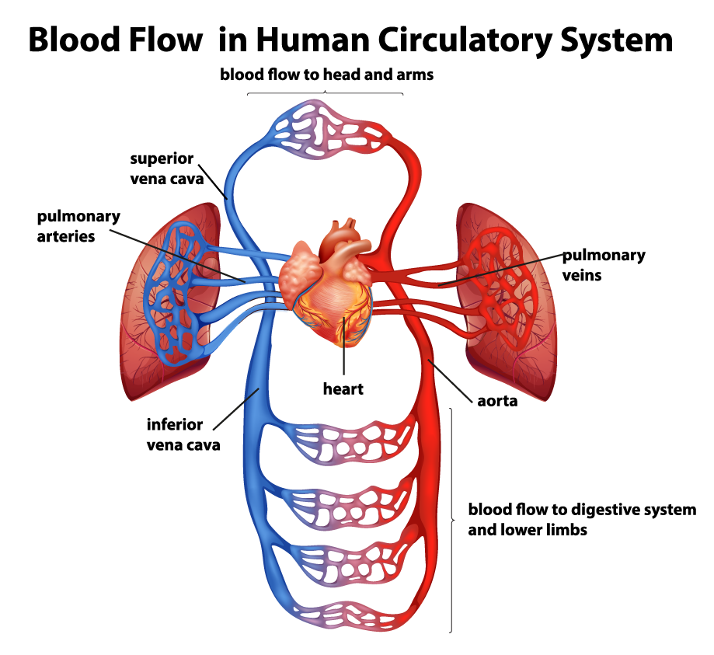
Another factor to consider with your interstitial fluid “guests” is the purpose of some of those substances like the hormones and neurotransmitters which are part of the communication system of the cardiovascular and nervous system. Keep in mind that not all nervous system communication takes place as an electrical signal.
There are parts of the body that require the chemical part of the “electro-chemical” signals of the nervous system. In other words, some of our body’s systems communicate through multiple forms like being transported through planes, trains, and automobiles to accomplish a task from a transmitter to the intended receiver. The interstitial fluid also plays a part in providing an opportunity for the substances of chemical communication to float in the vicinity of cell with special sensors designed to activate when touched by a specific molecule.

- Lymphatic System:
The lymph vessels and nodes work together to remove fluids from the interstitial spaces of the ECM for cleaning, recycling, and removal. The lymphatic system has many tasks along the return route of the lymphatic system to the cardiovascular system, but we are mainly concerned with the ability for the lymphatic vessels and nodes to work properly within the confines of the ECM.
We can see from the image below how the lymph vessels reside in the same space as the cardiovascular capillaries so the lymphatic capillaries can pick up the interstitial fluids and transport it through the vast network towards the direction of the heart for eventual hand off of cleaned fluids back into the closed cardiovascular system.
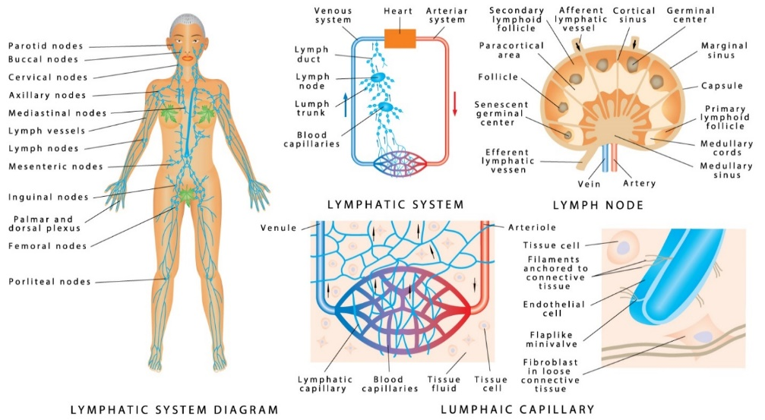

Unlike the cardiovascular system, the lymphatic system has no internal “pump” like the heart to force fluid flow inside a closed network. This system is considered open because the contents or fluids being transported within the lymphatic vessels begin and end in open spaces instead of a closed circulatory system. Also, the flow of fluid towards the heart requires movement from the body otherwise the fluid remains stuck and stagnant during periods of inactivity. The lymphatic vessels have special valves designed to keep the fluids from moving backwards due to gravity.
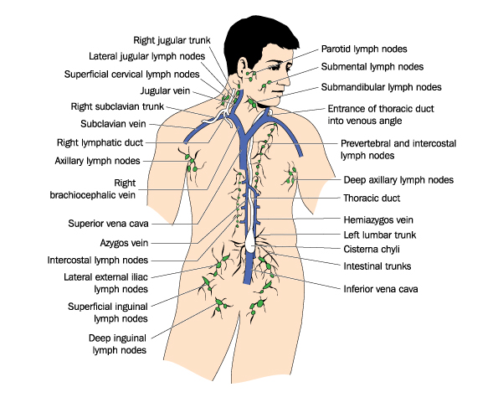
We tend to find lymph nodes near areas of the body where injury is likely to occur, and these nodes can support the healing process. The largest gathering of lymph nodes are found at joints like the behind the knees, at the groin leg crease, and arm pits. They are also found in great numbers throughout the face, neck, upper chest, and deep inside of the abdomen.
Proper flow of the entire lymphatic system is generally the goal of the healer especially when the system is degraded from inflammation within the vessels and nodes or being overwhelmed with an abundance of substances like viruses, bacteria, fungi, heavy metals, cell waste products, and foreign materials. There are many healing methods designed to help flush or drain the lymph nodes and keep fluids moving properly through the system.

- Failure of one ILF component:
As we have previously stated, a failure in one component of the ILF Loop can cause the other two to degrade or fail as well. Now that we have a better understanding of how these components interact within the confined spaces of the ECM, we can discuss the interaction and unique relationship they have to each other inside the Loop.
We can start with any component and eventually reach the same results of a complete shutdown or degradation of the entire Loop. However, we can randomly choose an initial culprit to start the bio-cascade of events. We described earlier how the lymphatic system and associated nodes can become overwhelmed with removing and cleaning various substances as part of the body’s overall immune system. Overwhelmed nodes grouped in a location of the body will slow down the flow of lymph fluids downstream which also degrades the removal of interstitial fluids also in downstream locations. This is why people experiencing viral and bacterial illnesses tend to feel dull pain throughout regions of the body as the pressure builds with the interstitial spaces putting activating the appropriate nerve endings.
In our initial example of an overwhelmed lymphatic system, we show an increase of interstitial fluid as the cardiovascular system continues to push plasma and substances out into the interstitial space of the ECM. Eventually, the superficial fascia will respond accordingly to the increase in pressure as an associated increase in tension. Fascia fibers respond to demands in tension and do not necessarily understand the details behind the increase in tension. In other words, increased fluid pressure pulls on the collagen fibers and communicates to the fascia fibroblast cells in the same manner as a change in posture or body movement which ultimately translates into greater tension on the fibers creating more pressure and more degradation of the underlying lymphatic system.
This same bio-cascade of events can be triggered from inactivity instead of a viral or bacterial infection. The superficial fascia fibers are in constant flux responding to every change in tension across large sections of the body. New fibers are constantly created or extruded by the fibroblast cells as the posture changes over time or as the body remains inactive even during the night during your sleep cycle. Layers of muscle and tissue that were designed to slide freely across each other can become fused with fascia fibers laid down over days and weeks of inactivity. Without stretching or movement to break up the new collagen fibers, eventually the fascia fibers continue to create more fibers in various patterns in efforts to maintain the current movement or postural pattern.
Eventually, increased density of the fascia fibers can hinder the proper flow of the interstitial fluid with the ECM and trigger the rest of the two ILF components to degrade into a complete shutdown or gridlock where the lymphatic system slows down and fluid continues to build up.
The interstitial fluid can also start to build up if the cardiovascular system provides too much plasma and fluids into the interstitial space of the ECM. There are many factors and reasons that cardiovascular system is out of balance to produce more fluid than can be circulated throughout the entire system, and a typical indicator of an overactive cardiovascular system is high blood pressure. We might attribute edema to an overactive cardiovascular system, but interstitial fluid build up associated with edema might be the result of other ILF Loop components and incorrectly diagnosed. Sometimes the healer will not know the trigger or cause of a condition at the beginning of a session, but we can respond accordingly and focus on the symptoms instead of the diagnosis.
Interstitial fluid can also build up if the cells are not in balance. There are mechanisms within the cell to transfer fluids between the intercellular space to the extracellular space through pumps to maintain homeostasis and prevent swelling of the cell. However, degradation of the cell functions and excess or not enough of certain substances can prevent the cells from operating properly resulting in transferring too much fluid out of the cell body.
- Resolving the ILF Loop
A resolved Loop requires the healer to work with one or two of the three components to hopefully allow the entire loop to return to either normal operation or a much less degraded condition. Sometimes the resolution will take several days before returning to full homeostasis depending on the severity or event causing the loop degradation.
If the trigger or cause is unknown, the best place to start with Loop Resolution is in the superficial fascia layer because the tension or pressure on the tissue and fascia fibers can respond quickly to the compression and vibration of the tuning fork. Since the fascia network communicates through mechanical stimulation, our manipulation of the fascia using pressure and vibration can speak directly to the fascia fibroblast cells to “do something different” which tends to be an instant change to the current condition and a rapid release in tension.
With fascia manual therapy manipulation, there are a few techniques or methods involved in resolving this ILF component. Our main goal is to release facia fiber tension in the local area and remove enough fluid to relieve the pressure on the interstitial space of the ECM. In most cases, resolution of both tension and fluid will also provide resolution to the underlying lymphatic system. This is one reason why we start with the superficial fascia layer since the outcome provides a much greater response. Releasing fascia fiber tension and removing or relocating interstitial fluids requires different techniques of the tuning forks or the press and push method to force the fluids away from the local area. During the initial assessment of the tissue, one placement of the tuning fork will determine the order of the techniques. If the fluid pressure is too great to be relieved by vibration on the fascia fibers, the first tuning fork placement will result in a “pitting” effect where the tuning fork will leave a divot or small indentation in the skin at the spot surrounding the base of the tuning fork. Pitting is your indication to use another technique since the fluid pressure is too great for vibration alone.
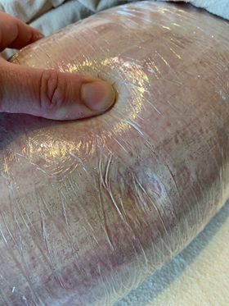
If there is extreme fluid pressure over a large area of the body, you can use plastic wrap to compress the tissue and enhance the area of influence of the tuning fork vibration. When tissue is wrapped, the vibration will travel much further and release tension over large areas to overcome the challenge of overwhelming fluid pressure. Tuning forks can be placed across entire regions of the body at greater spacing depending on the sensing and feedback of the vibration during placement. Fascia fibroblast cells usually respond within 3 to 5 seconds during a placement to cause the fascia layer to deflate similar to a water balloon with a pinhole leak. Your sensing hand will feel the deflation of the tissue and the plastic wrap will also show less tension.
The Press and Push technique can be used with the plastic wrap in place. However, the use of lotion underneath the plastic wrap will help with the Press and Push while also help to maintain body heat to increase the effects of the plastic wrap technique. The Press and Push technique can also be used without wrapping the area or using the tuning forks ahead of the fluid push. Using the Press and Push before the tuning forks could be painful for the client since the pressure of the fluid generates signals within the pain receptors of the fascial network. Unfortunately, the fluid push might be the only initial option depending on the condition and situation.

10 Core Skills:

Introduction: The Vibrational Fascia Release Technique™ and associated protocols presented within this course are successful in providing rapid pain relief and resolution of mobility restrictions primarily because of the therapist’s core skills. Mastery of these core skills is crucial to becoming an efficient therapist and each skill is equally critical to success while performing VFRT on a client.
The overall flow of the 10 Core Skills is designed to be used in order of the skill number. However, the workflow is technically a decision matrix where a therapist would return to an earlier skill throughout a session in smaller skill “loops” until the intended outcome has been reached.
Here are the 10 Core Skills:
- Healer Logic
- Palpation
- Grip
- Strike
- Placement
- Pressure
- Feedback
- Press and Push (hands)
- Gem Foot Slide (tuning fork)
- Resolution and Accountability
(1) Healer Logic:
Introduction: This skill refers to the logical thinking of a New Earth Vibrational Therapist as it applies to the thought process of mastering the VFRT protocols in addition to knowing:
- When to apply certain protocols to clients in a given situation
- What questions to ask the client prior to a session
- When to decline a session for the right reasons
- Why a client is in pain or restricted from normal movements
- How to respond to typical client questions during a session
- What we can resolve with VFRT protocols
- What type of session to schedule and perform
- How to establish a goal for each session
Activity: What are some other examples of Healer Logic?
We will discuss Healer Logic throughout this course as we progress through each Core Skill. This section includes the initial skills and knowledge required to prepare us for the Palpation Skill.

- Top 4 questions from clients:
- How long will it last?
- What do I need to be doing so it doesn’t come back?
- Where does it go? (Fluid or Fat)
- How often/soon CAN or SHOULD I have this done?
- Most of us were born with perfect fascia.
As Vibrational Therapists, we fix injuries in the fascial system using weighted tuning forks to stretch the fascia collagen fibers and vibrate and tissue to bring about a change to the current environment. Fascia and all cells need both stretch and vibration to create a change whether it is to reconfigure, produce something different, or self-destruct (apoptosis). Our cells and tissue have mechanisms for building up and tearing down. Most fascial scars beneath the skin remains in place over years because the “resolution” or clean up process was not completed.
Up until the age of 15, we are capable of self-healing until our patterns change and our fascial system responds to the new normal.
Activity: How do we injure our fascia?
- Can you see or feel it?
Our VFR Technique is based on the physical science of providing mechanical vibration and pressure (stretch) in a localized area to cause a change to the cells, fluids, and tissue. In most sessions, the client is in pain or restricted in movement because of fascial scars (adhesions) and pressurized fluids.
We will learn in the next Core Skill about palpating (feeling) for both fluids and fascial adhesions. With Healer Logic, it is important to know our limitations for both a session timeframe and overall capability of the tuning fork.
Remember: The tuning fork is just a tool. You would not throw a hammer on the ground and expect it to build a house. Vibrational Therapists should look beyond the fork and understand enough biology to set realistic expectations with established limitations. Our actions and mastery of our skills are a vital part of the healing process. Although we may have limitations on what we can influence, we can still work on the symptoms of a given condition or ailment.
- Things we cannot directly influence with weighted tuning forks:

  - Medical modifications or alterations
  - Birth or developmental defects
  - Learning disabilities
  - Behavioral/cognitive/psychological diagnosis

- Goal of Session:
With Healer Logic, we are responsible for Session Management in knowing what type of session the client requires and plan the session according to a specific order of priority. Set expectations at the beginning of the session, talk to the client about what you are doing during the session, and set expectations about what the client can expect after the session (see Resolution and Accountability Core Skill)
- Danger or Risk of:
  - Falling (Mobility)
  - Heart attack
  - Stroke
  - Breathing

- Pain Relief

- Range of Motion (ROM)

Activity: What are some examples of limited ROM?

- Quality of Life (QOL): Pretty and Pain Free

Activity: What are some examples of QOL?

- Triggers and Causes
- Re-occurrence = no lifestyle change = chronic

- Allergies: Environment and Food

- Medical Modifications or Alterations

- Body Patterns (posture, sleeping, sitting)

- Power Session vs. Therapy Session
Therapy is where you go through steps to get better. Maintenance is where you schedule sessions to maintain the current state.
As we move through the order of priority for Session Management, there are two main types of sessions to clearly establish an expectation.
Power Sessions are typically 45 minutes or less with a focus on a specific area of pain or restriction. Our clients are paying us for an expected goal. Establish the goal and work towards 100% resolution. Avoid working on many ailments within a session without an established goal. Laundry List clients require your Healer Logic and Session Management skills to control the session and provide relief and resolution to the established goal even if it only takes 10-15 minutes.
Therapy Sessions are on-going treatments with an established goal. Some clients have long-term triggers and causes requiring several sessions to re-train the cells, fascia, and systems into a new normal. If the trigger is still in place, our Therapy Sessions should be providing more relief than the damage the trigger is causing.
For permanent causes like medical alterations, our sessions might last for the lifetime of the client at greater intervals (every other week, once a month) to maintain Quality of Life. Clients who have had their lymph nodes removed are an example of long-term sessions to remove or move the interstitial fluids in the absence of functioning local lymphatic vessels and nodes.

(2) Palpation:
With Healer Logic, we established a goal for the session to determine what we were going to work on whether our focus was pain relief or mobility restriction.
Palpation is a skill to find the physical location on the body where we will place the tuning fork to resolve the pain or restriction. In VFRT, we use one tuning fork to allow for freedom of the opposite hand for feeling and sensing for pain and restricted fascia collagen fibers.
Our method of palpation is to press our fingers against the skin to feel for contrast between normal and abnormal tissue. This skill could take some time to master since we rarely put our hands on a person for the purpose of sensing fluids and fascial adhesions.
- Proper Palpation Provides Perfect Positioning for Pain Relief
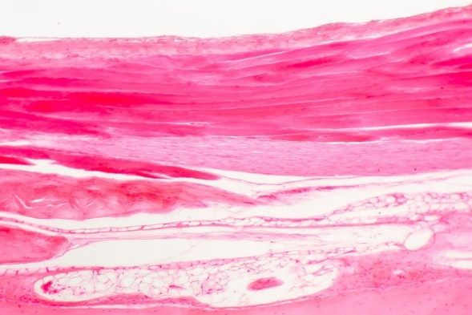
In the image above, we can see a cross-section of the body with the outer epidermis at the top and different densities of tissue as we go deeper into the tissue. The darker pink areas represent densely compacted collagen fibers of the superficial fascia layer just below the skin.
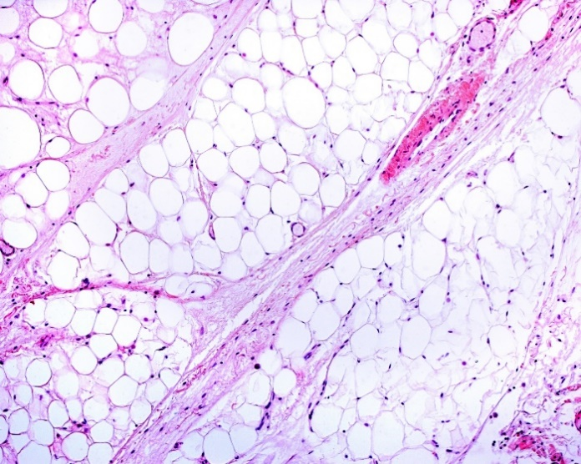
The white areas show fluid-filled tissue of the interstitial spaces of the extracellular matrix. These white fluid spaces are not a normal part of the interstitial space because the fascia network of the extracellular matrix produces a very thick gel called proteoglycan to slow down the fluids leaving the cardiovascular system so cells can benefit from the substances within the interstitial fluid.
- Pressure provides enough compression to rise above the pain threshold
- Pressure to feel for fluid compartments and fascial restrictions
- Fluid First Followed by Fascia
Activity: Feel for Pain (Normal vs. Abnormal)
- Positioning of fingers for placement
Part of the Palpation Core Skill is preparing for the placement of the tuning fork with the sensing fingers positioned where the fingernails of the first and middle finger are on either side of the placement site.
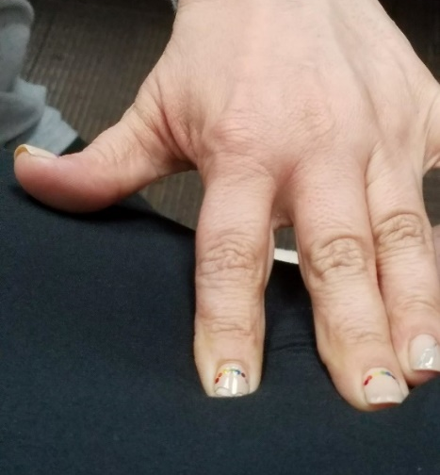
As you spread your fingers apart, continue to palpate with the pads of the fingers to locate the exact position of placement with consideration for the secondary purpose of the sensing fingers for feedback during the placement. Palpation is for perfect positioning, but it is also for effective feedback which is a skill we will discuss after the placement of the tuning fork.
Additional considerations for mastering the Palpation Core Skill:
- Apply your Healer Logic specific to palpation skills
- Client reported (doctor) diagnosis or self-reported (Google) is just a good starting point: It’s not going to be there long enough to name it
- Local Point of Pain (POP) vs. Furthest Point: Listen to your client
- Referred vs. Connected: Does what you feel match the information provided by client (diagnosis or POP)?
- Where you think it is….It ain’t! quote by Ida P. Rolf

(3) Grip:
Once the placement location has been established using the Palpation Core Skill, it’s time to strike the tuning fork in preparation for placement. The Grip Core Skill is vital for both a proper strike and ability to provide the grip strength for the necessary pressure required for a vibrational fascia release.
We will discuss the primary categories of tuning fork grip. In the Striking Grip, we focus on holding the tuning fork for striking against a surface such as the hand or knee. Grips for striking are designed to prevent or reduce repetitive injury of the therapist while also providing a more effective grasping area on the yolk of the tuning fork instead of the stem where other practitioners tend to strike and hold the tuning fork.
- Anatomy of a Weighted Tuning Fork

In the image to the left, we can see the yolk is a U-shaped section where the tines merge and transition into the stem. Weighted tuning forks have thinner tines than unweighted tuning forks, and the thin construction of the tines and addition of the weights focus the vibrations downward into the base instead of outward into the air. However, the story of vibration does not stop there.

The bigger story is told in the weight distribution of the tuning fork and the unbalanced physics dynamics across the entire length of the tuning fork.

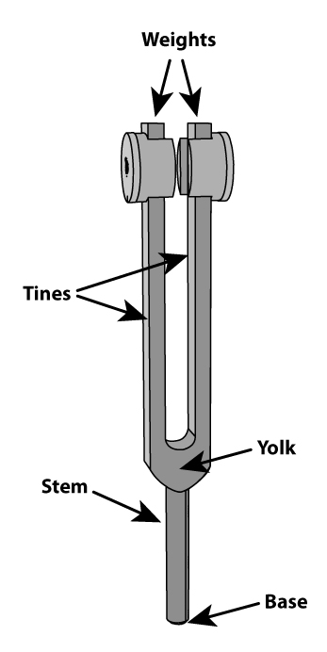
A weighted tuning fork is designed with an unbalanced fulcrum with the weights at the end of the tine forcing the vibrations down the tines, through the yolk, and into the stem. By placing the base of the tuning fork against the skin, we not only benefit from the downward travel of the vibrations created as the tines swing or oscillate back and forth, we also receive a much stronger effect of the stem vibrating in many directions just due to the physics of an unbalanced device.
In other words:
“It’s all about the Fork Torque”

- Striking Grips:
 | - Standard Grip: for striking to efficiently transition to placement grip with proper pressure and angle
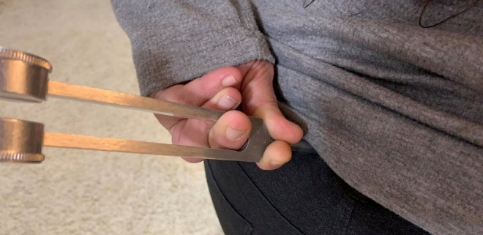 | - Reverse Grip: for self-care, under chin, lymph nodes, sore throat

- Holding Grips:
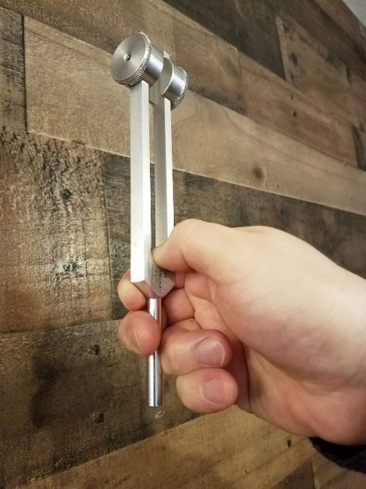 | - Finger Assist Grip: need for sensing hand. Can be used to reduce grip fatigue.
  - Butterfly Grip: max pressure with less grip: Remember: Sometimes you do not need maximum pressure. Designed to reduce repetitive stress, but it is used for increased pressure. Do not use in areas where maximum pressure is not required. Reduces feedback from opposite hand.
“Don’t rely on the Butterfly!”

 | - Modified Standard Strike Grip: Rotate hand to maximize hand weight

- Reducing Hand Exhaustion:

- Don’t maintain standard grip for repetitive, sustained, or increased pressure areas: Use the dead-fall or weight of the hand(s). No extra force or pressure is needed.
- Vice Grip (striking) vs. Weighted Grip
- Which Grip is Which? Is it a Good Which or a Bad Which?
- It’s all about the Angle of Approach (Healer Logic)
- Vary Grip and Placement Hand

(4) Strike:
The Strike Core Skill is important because the quality of a strike will affect the length and strength of the vibration for each placement. In vibrational fascia release, the release point for the cells and tissue might be at the trailing end of one specific strike that fell below the breakpoint.
Fascia collagen fibers and supporting cells require both pressure (stretch) and vibration to cause a change, and sometimes the change is the destruction (apoptosis) of the cells involved in the restriction or the release of the necessary substances to dissolve the collagen fibers responsible for the adhesion.
After our own testing and thousands of strikes, we believe that the best quality striking surface is our own body in two primary locations; the hand and knee. Body strike locations are efficient because we do not have to hold onto another object like an activator. Therefore, we can use the strike hand solely for sensing and feedback.
A mastered Striking Core Skill should not hurt the therapist or leave marks. A properly executed strike has a distinct sound and feel. The key to a proper strike is the follow through of the hand holding the tuning fork. In many sports involving a skilled action like martial arts, baseball, football, and basketball, we are trained to master certain movements by extending the action through the “target” as if the point of focus was a few inches beyond the point of impact so the hand continues to follow through after striking. With a proper follow-through, the weight of the tuning fork will “bounce” off the striking surface instead of controlling the exact moment of impact. In other words, it’s more of a bounce than a strike.

- Hand Strike:
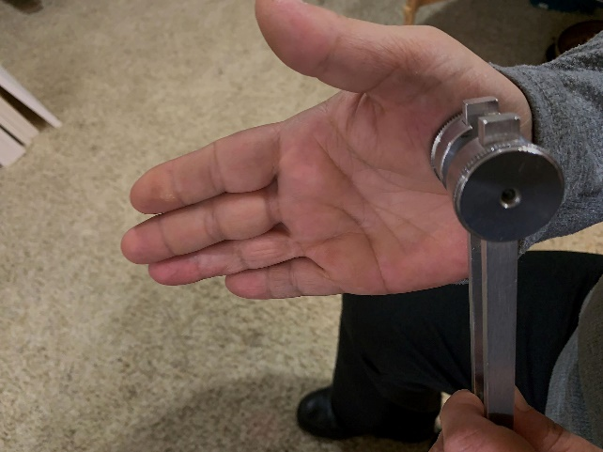
“If you Torque the Fork, you might Ping the Thing.”

- Knee Strike:
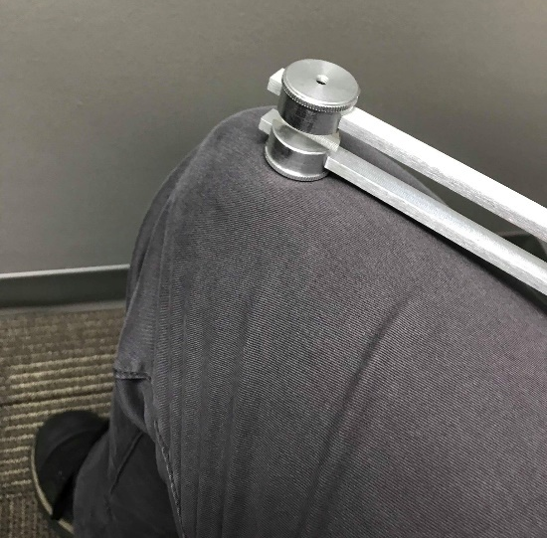
If you need to leave both hands on the client, then a knee strike is the most efficient option especially if you are in a sitting position. The image to the left shows the optimum location for striking the right knee with a tuning fork in the right hand.
Strike the flat edge of the tuning fork weight against the meaty part of the muscle just above the knee cap. Notice how the placement is slightly inwards toward the inside of the leg where the muscle is thicker. Avoid striking at such an angle where you might inadvertently strike the knee cap or the “knobby” bone about 2 inches to the right of the location you see in the example image.

(5) Placement:
The Placement Core Skill focuses on different considerations for the location on the body and the angle of the tuning fork to maintain appropriate pressure for the tissue density in the placement location. The placement location and angle might also require the therapist to change the normal grip and pressure especially in sensitive areas.
- Location and Angle
- A Supporting Hand
Use hand on the other side of the body to provide stability and opposing force necessary to maintain proper pressure on the tuning fork. Clients tend to move in the opposite direction of pain and pressure, so it is not a natural action for a client to support the desired posture without the aid of a supporting hand. Applies to any location (feet, wrist, knee, shoulder) where the joint rotates and tuning fork is forcing the body part to rotate on its own.

(6) Pressure:
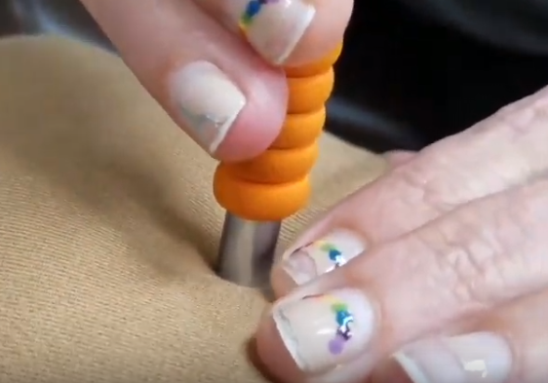
- Necessary pressure for pain relief:
One of most difficult Core Skills to master is identifying and providing the necessary pressure required to put tension of the fascia collagen fibers underneath the skin. It is within the superficial fascia layer of extracellular matrix where most of the changes occur when we place tuning forks against the skin.
- Pressure Threshold:
There is a threshold of pressure that must be reached for a certain period of time before the fascia cells recognize the need for change and respond with the release of tension and associated pressure in the superficial fascia.
As we learned in the Healer Logic Core Skill, we need both stretch and vibration to cause a change in cells, tissue, and systems. When the correct pressure is reached, we need to maintain the same pressure until the threshold has been reached and the conditions change. The feedback hand is in place to determine whether we have surpassed the pressure threshold.
If the fascia layers are overfilled with interstitial fluids and pressurized to cause the lymphatic system to slow down or stop completely, the weighted tuning fork with the right pressure will change the entire gridlocked area and hopefully relieve the pressure on the nerve endings currently reporting pain. We believe the importance of rapid pain relief for many ailments lives in the pressurized, fluid-filled compartments of the superficial fascia layers.
When we have too much fluid within our interstitial spaces, the pressure of the fluids will push against the pain receptors to report pain. The act of placing a weighted tuning fork on the skin will provide even more pain depending on the level of fluid and associated pressure already present. The amount of pressure we use when placing a weighted tuning fork will be painful for some clients.

- Using a cloth for a protective layer:
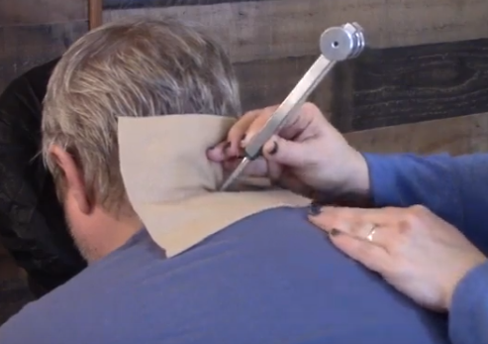
To prevent discomfort, we use the client’s own clothing or place a small square of cloth underneath tuning fork in areas where the clothing cannot be used as a protective layer.
In the image to the left, we are using a piece of fleece we always have within arms length during the session. We also could have used the client’s shirt coller by drawing it further up the neck. However, the fleece cloth would provide a better option for working on the back side of the neck as shown in the image.
Activity: What are some other things you could use for a protective layer?
- Length and strength of a tuning fork vibration:
The length of vibration for a weighted tuning fork depends on several factors including materials, length of the tines, strength and quality of strike, type of striking surface, and condition of the tissues at the location of placement. We have experienced a longer and stronger vibration from one manufacturer over another with all things being equal including frequency of the tuning fork.
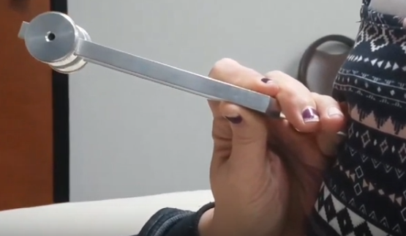
Regardless of the conditions affecting the length of vibration, the one thing you can control is the quality of your strike of the tuning fork so it will vibrate longer and require fewer activations.
We are working on-the-body in attempts to affect inflamed tissues, so the length of vibration for one strike can be extremely important to reach the necessary conditions to release inflammation. A good tuning fork sound healer will always focus on reaching optimum vibration in every strike and allow the vibration to run out before striking again.
If you happen to strike the tuning fork in a manner that is less than optimal, stop the vibration with your hand or leg and strike again. Avoid striking the tuning fork while it is vibrating to ensure the next strike will be correct and to prevent damaging the tines.
When it comes to strength of vibration, your body will be aware of a tuning fork that is not vibrating at full strength and your clients will also notice if something has changed. You can control the strength of a vibration by striking efficiently with sufficient force for the type of tuning fork and the surface in which you are using to activate the fork. You should always strive for maximum strength when working on-the-body to reduce inflammation.
A tuning fork is one of the few vibration tools that is tuned to a specific frequency. When you strike a 128hz WTF, it will consistent produce the desired frequency regardless of strength or striking conditions. The same frequency will be maintained throughout the length of vibration even when the strength fades. There might be a slight slowing of frequency at the tail end of the full vibration, but at this point you will probably think or feel that the tuning fork is no longer vibrating and bring it off the body for another strike.
- Maximum number of placements:
One of the most well know rules in our sound healing community has to do with the maximum number of placements in one location. We believe this rule to be connected to the nitric oxide puffing cycles and the effects to tuning fork vibrations to cause the cells to re-engage their natural release of a nitric oxide gas present during a non-stressed state. In documentation written by Dr. John Beaulieu, he believed that a third or fourth placement of a tuning fork in the same location could inadvertently cause the cells in that area to return to a stressed state and once again shut down the nitric oxide puffing cycle.
With VFRT, we focus on reducing pain caused by tightness in the fascia collagen fibers. Sometimes the number of placements of a weighted tuning fork in one location will require more than 3 placements in order to provide the necessary length of vibration to cause the fascia tension to release. Pressure and vibration of cells and tissue provide the necessary conditions to change the current programming.
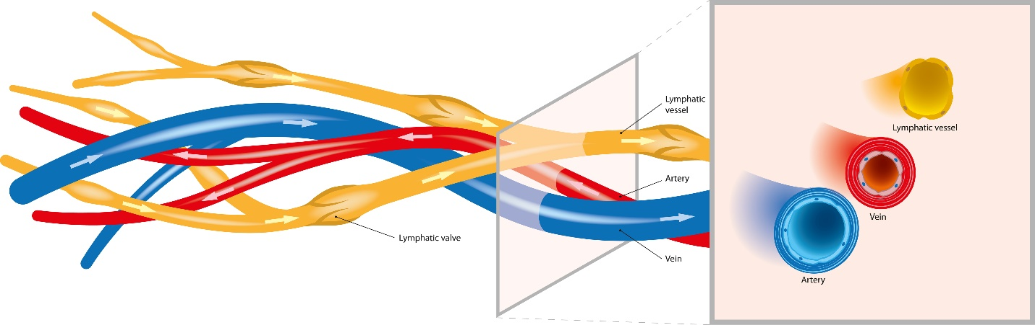In most cases, the current and chronic condition is a myriad of overwhelmed systems incapable of returning itself back to normal operating conditions. We feel the entire body is in a stress state with too much tension in the fascial network and too much fluid spaces creating pressure underneath the skin. Remember: Our goal is to use the pressure (stretch) and vibration from the tuning fork to relieve the tension, resolve fascial adhesions, and reduce fluid pressure to decompress nerve endings and restore normal flow to the cardiovascular and lymphatic systems in the interstitial spaces of the extracellular matrix.
The maximum number of placements in one location depends the condition of the tissue at the end of each placement. This is the reason we use a sensing and feedback hand to determine at each moment whether the current placement had provided the desired effect and released enough inflammation to move on to another location. Use your professional judgement on how many successive placements and continuous vibration the body can handle in any given situation.
Activity: Practice placements on the same person you performed the previous activities. What are your observations?

(7) Feedback:
- Client
Do not leave the client out of the feedback loop. Do not think you know more than the client about their own body. Build a rapport and encourage feedback throughout the session. The client might not know if there is suppose to be ongoing communication. Remember your Healer Logic and Session Management Skills.

Assess and re-assess often. Many times our clients will be dis-believers that their mobility can be restored and pain can be relieved in just a few minutes. Most clients have lived with this condition for years, and other methods of resolution have not worked. Be confident in your own skills. Have them test for pain and mobility so they will have confidence as well.

You are changing thought patterns and changing lives. Our most common client feedback statement is: How is this working when nothing else has? We hope that you will have the confidence to answer this question with conviction and ownership. Know our craft and why this is working when no other options provide the same resolution.

When a client gives you verbal feedback of pain, this is not always your cue to stop working. The right solution might be different depending on the client and your pre-established agreement for your pain management response. Let your client know this treatment is going to hurt and why it hurts. If the client knows what to expect through dialog, they will not be surprised. Let them be a part of the session.

- Sensing Hand
Use your Palpation Skills throughout the placement. Your fingers will do the talking and provide very detailed information especially when something changes to the current condition.

- Strawberries through a straw
- Push up
- Water balloon with a hole in it
- Morse code
- Change between no vibration to vibration
- Hard and tight turns to soft and squishy
- What was bumpy and lumpy is now smooth
- Cold to warm

- Tuning Fork
Many of the sensing hand feedback can be felt through the tuning fork. If you are moving the base of the tuning fork with the gem foot, you can feel the tension of the fluids ahead of the fork.

In some situations, the tuning fork will slip off the placement location when a fascial adhesion releases or deflates especially with hardened nerves, tendons, ligaments, muscles, and fluid compartments.

- Visual
  - Color change
  - Deflation of tissue
  - Size and shape
- “Release doesn’t mean resolve”
Release of fascial restrictions and fluid pressure could mean it is time to re-assess, re-position, or re-focus your work on another location.
A release is not going to change their lifestyle, habits, triggers, and causes that brought your client into an overwhelmed state. If your session goal was to relieve pain or increase Range of Motion, a release might be the first step in the right direction and the ultimate goal of the session.
- Did it work?
The biggest part about the Feedback Skill is to know whether your VFR Technique worked and the Session Goal was reached. When you re-assess the client for mobility and relief of pain, ask them specifically “Where is the pain now?” Client feedback is not considered success if they say:

  - “Hmmmm……Interesting”
  - That feels a little better
  - Well, you know it didn’t get there overnight
  - That feels a lot better
Note: All of these reactions are considered a VFRT Failure.
Activity: Practice feedback on the same person and observe the different feedback indicators as you work through the session.

(8) Press and Push (Hands):

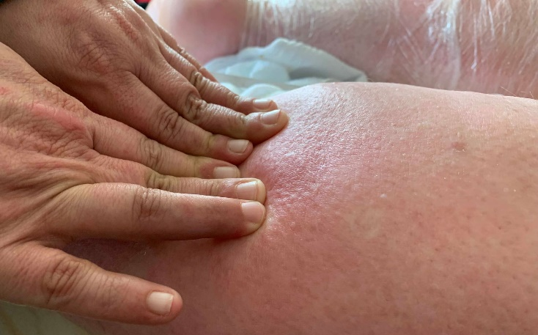

- Used for interstitial fluid movement

- Reduces session time

- Increases ability to find fascial scars or restrictions

- Toxin Containment/Quarantine

- Proper pressure

- Let the fingers sink

- Press forward slowly

  - Tension release controls the speed

- Keep the fluids ahead of the fingers

- Follow through with the push to a “Safe Zone”

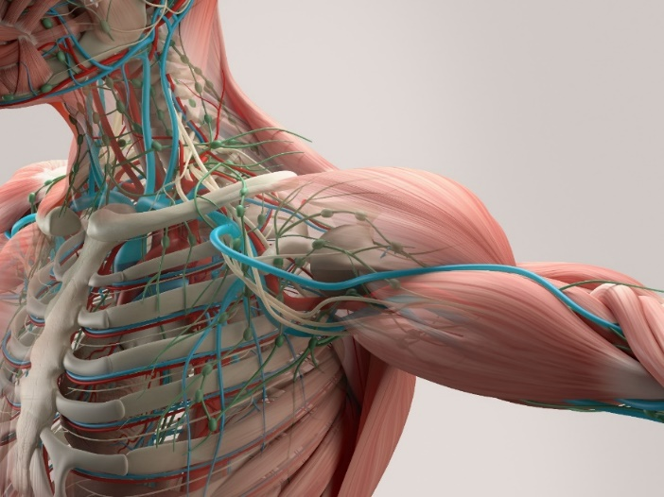

Activity: Practice a press and push for the shoulder and record your observations.

(9) Gem Foot Slide (tuning fork):

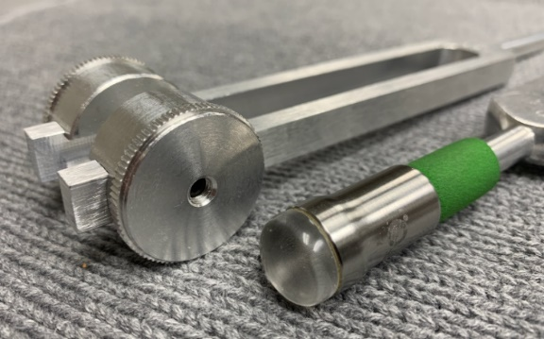
- When a therapist cannot use their hands to press against the skin

- Alternative to using the Press and Push

  - Same concepts apply from the Press and Push Core Skill
  - Less efficient than Press and Push (finger feedback)

- Using the right tuning fork extension

  - Crystal type
  - 6mm Trigger Point (avoid using during a fluid push)
  - 15mm (smaller or confined areas)
  - 25mm (larger areas and longer distance)

- Used in sensitive areas of the body

  - Maintain angle awareness since the edge of the gem foot could scrape against the skin.
Activity: Perform or receive a gem foot push and record your observation on the comparison between a Press and Push and a Gem Foot Push. What are the differences between sizes of the gem foot?

(10) Resolution and Accountability:
- Knowing when you are done with the session

  - Fully resolving the issue
  - Re-assess and ask the right questions
  - “Where does it hurt now?”
  - Re-enforcing expectations

- Controlling the session

  - Dealing with “talkers”
  - Laundry List Clients
  - Working on too many conditions
  - If it’s not first session resolution, it’s considered therapy

- Chasing the Pain

- “Jack of all trades and master of none”
  - Adding modalities

- Blaming the client

- Giving the Client Homework

Head and Neck Protocol:

Healer Logic: Things you are breathing. Bottom up approach. Gravity controls the fluid flow and restriction. Each individual diagnosis for head and neck conditions are actually considered symptoms of fluid pressure and fascial restrictions.
Starting Protocol:
- Client in sitting position. Use gem foot (15mm or 25mm)

- Ring of Fire (one side at a time)
  - Start half-way and push fluid to gap between clavicles (Safe Zone)
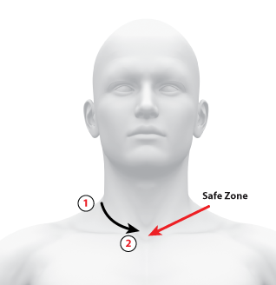
  - Work towards back of neck and push fluids forward
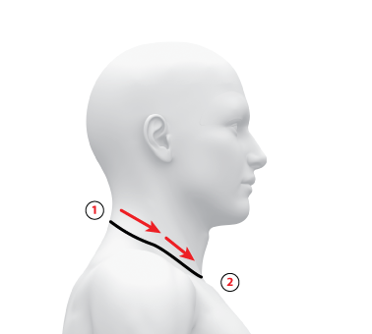
  - Stop at spine and repeat on other side

- Throat Drain
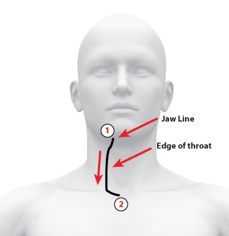
  - Start on one side and push fluids from bottom of jaw and directly down the side of the throat to drain point

  - Always continue to push fluids around the ring of fire to end in the drain point
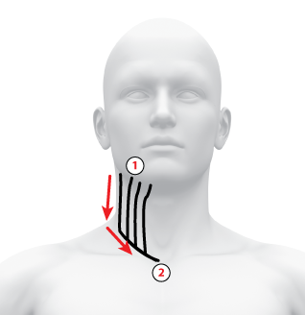

  - Work in vertical lines around half-circumference of the neck around to spine and repeat on other side

- Head conditions (Sinus pressure, face nerve pain, Migraines and Headaches, Receding gums, Jaw pain and TMJ)
Healer Logic: Sinus pressure is connected to fluid in the head and neck. Use the starting protocol before working on any of the head conditions. Then focus on the specific area of pain. Migraines and headaches are symptoms of fluid pressure in the head. Once the neck pressure has been released, the head fluids can be released and pushed down the neck. There is also a connection with high blood pressure and headaches/migraines. Loosen the back of the neck first before working on the headaches and migraines.
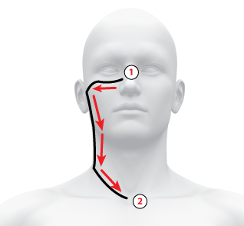

- Neck conditions (Tonsillitis, sore throat, fatigue, cysts, tumors, thyroid, high blood pressure)
Healer Logic: Work with barefoot fork directly on any area of pain, fluid pockets, fascial restrictions. Do not press hard against the throat. Use a supporting hand on the other side of the jaw or throat. Never slide a barefoot tuning fork against the skin. For high blood pressure, focus on loosening the tension on both sides of the spine from the skull to the neck line.
- Ailments (Colds and viruses)
Healer Logic: Fluid pressure in the head and neck keep the viruses and bacteria contained. Flush the fluids using the starting protocol to release the substances that are sustaining the illness.
- Ear conditions (vertigo, tinnitus, hearing loss)
Healer Logic: Fluid pressure near the ear and along the neck is causing most of the ear conditions. Use the starting protocol to relieve the head and neck fluid pressure. Then continue working on the neck just below the ear to relieve additional fluid pockets. Vertigo should clear up with one session. Tinnitus could reduce and resolve within one session. However, it could take a few days for the ringing to subside completely. Some hearing loss and tinnitus that is caused from high impact sound trauma might not resolve completely. Most tinnitus and ear conditions that are not birth defects and long-term trauma are able to be resolved with fluid flushing.
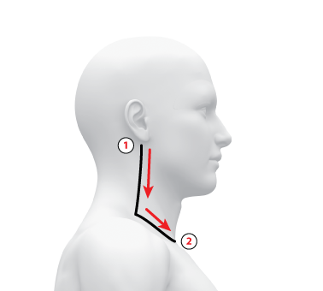

- Eye conditions (Vision loss, Sty, Cataracts, Floaters)
Healer Logic: Most eye conditions can be resolved by removing the fluid pressure around the eye. Begin with the starting protocol to flush the fluids and then focus the tuning fork with gem foot above and below the eye. For sty, put tuning fork directly on the sty and push the eye lid up into the bone. Sty can be resolved immediately. Never put the tuning fork directly into the eye.
- Neck pain and range of motion
Healer Logic: Problems with neck pain and mobility are caused from too much fluid and fascia restrictions in the lower neck and shoulders. Sleeping causes most of the neck issues. Use starting protocol and then focus on what you feel. The gem foot and hands are for fluid push, and the barefoot tuning fork is for fascia release. Fluid first followed by fascia restrictions. Test for range of motion first and re-assess often. Range of motion should allow for the chin to be aligned with the shoulder. Sometimes the full range cannot be reached until working on both sides and the shoulder restrictions.
- Breathing restrictions (snoring, apnea)
Healer Logic: Breathing problems are usually associated with the inner sinuses. Fluid and fascia in the head, face, and neck are connected to the inner sinuses. Using the starting protocol will begin the process of removing the breathing restrictions. Then focus on the fluid and fascia restrictions based on feel. Fluid pockets will build up near bony areas (underneath cheek bone, at the corner of the bottom jaw). Reducing restrictions in these areas should restore breathing restrictions.

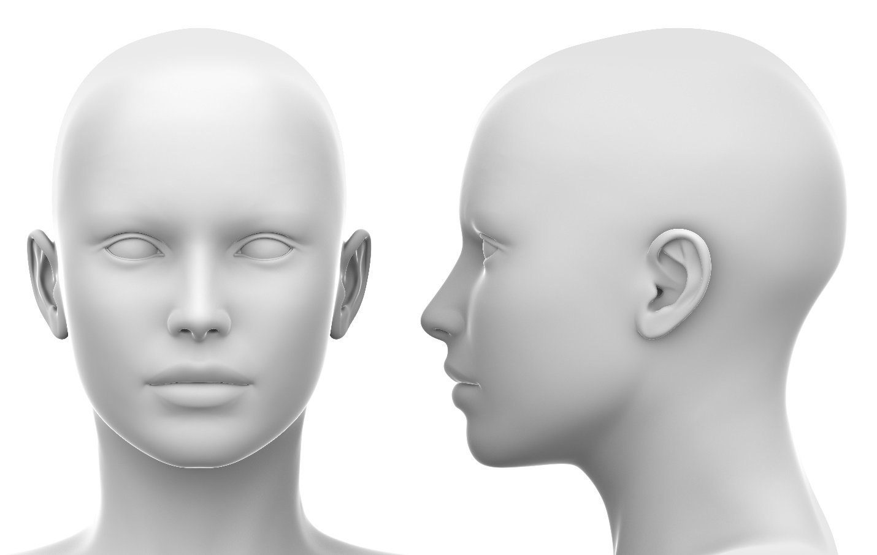

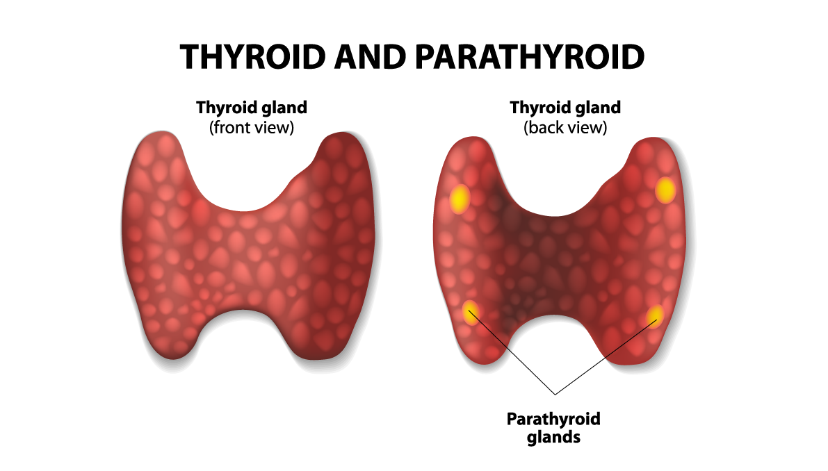
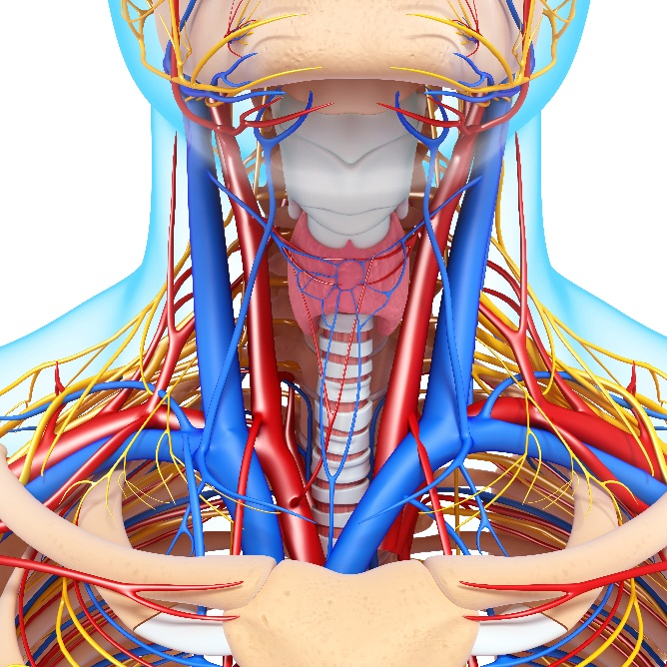

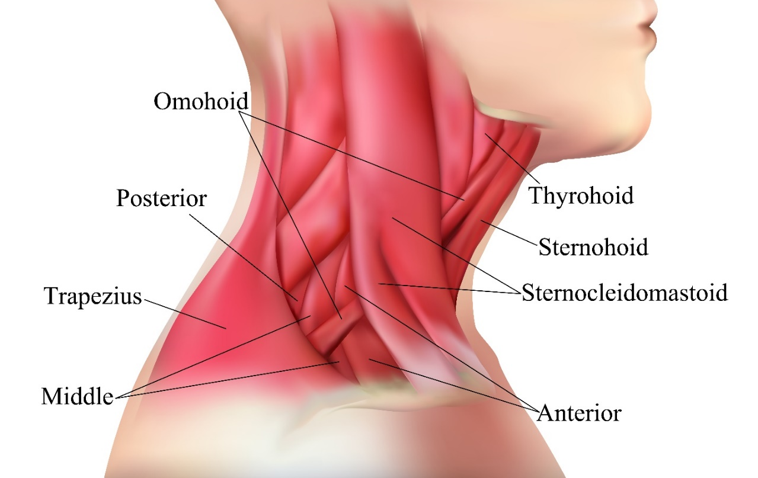
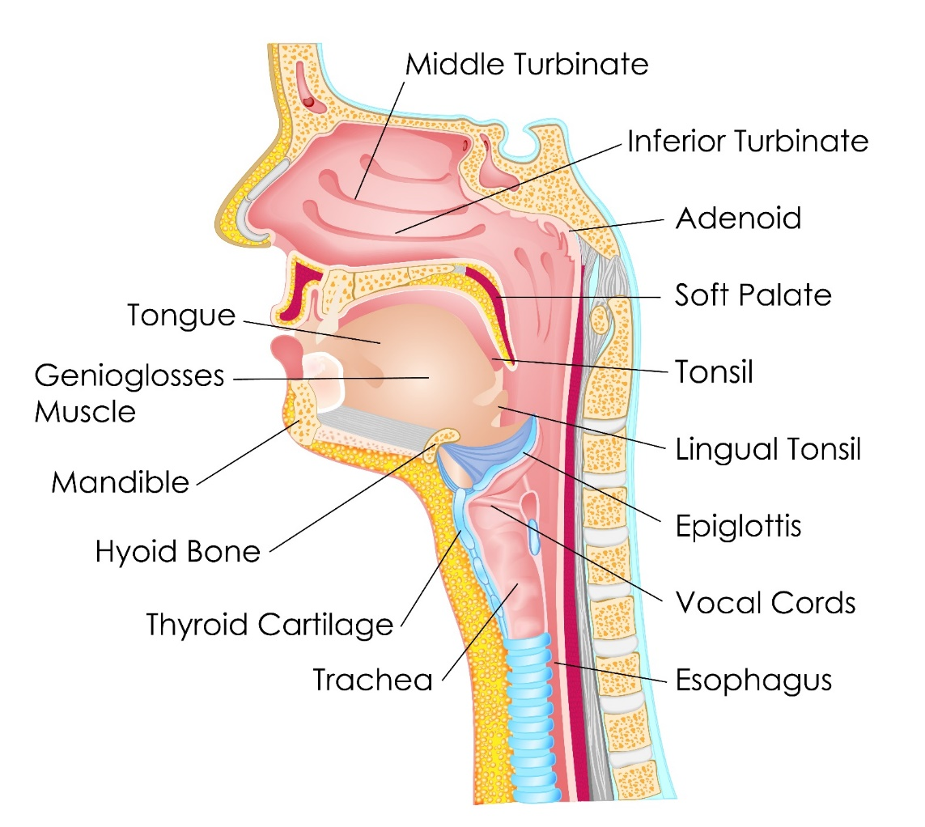
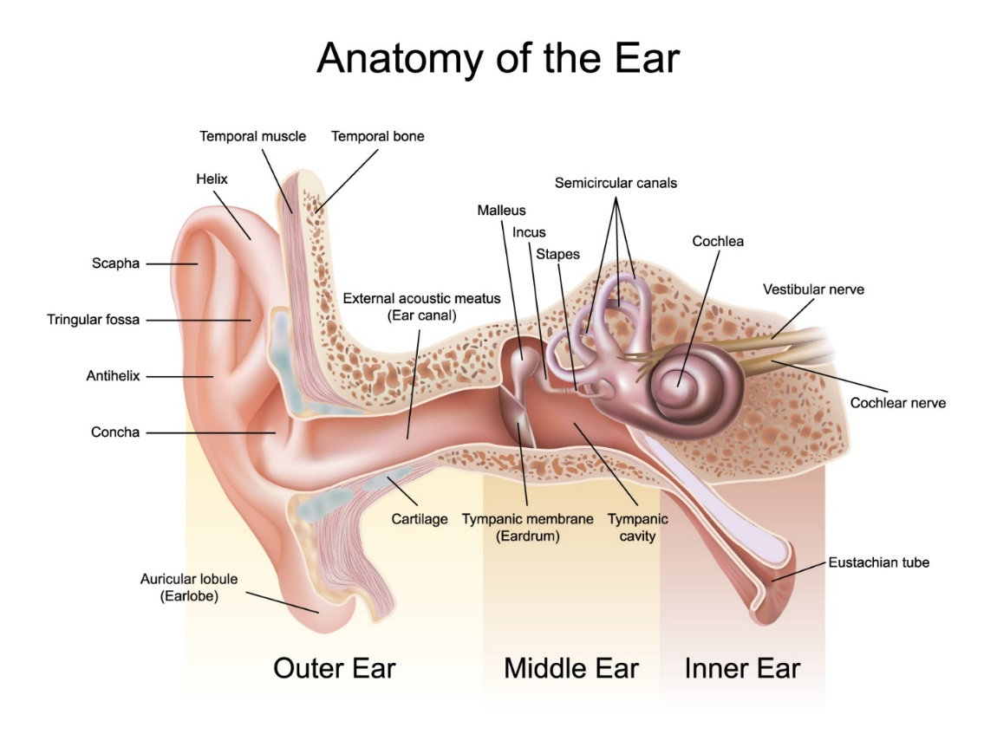
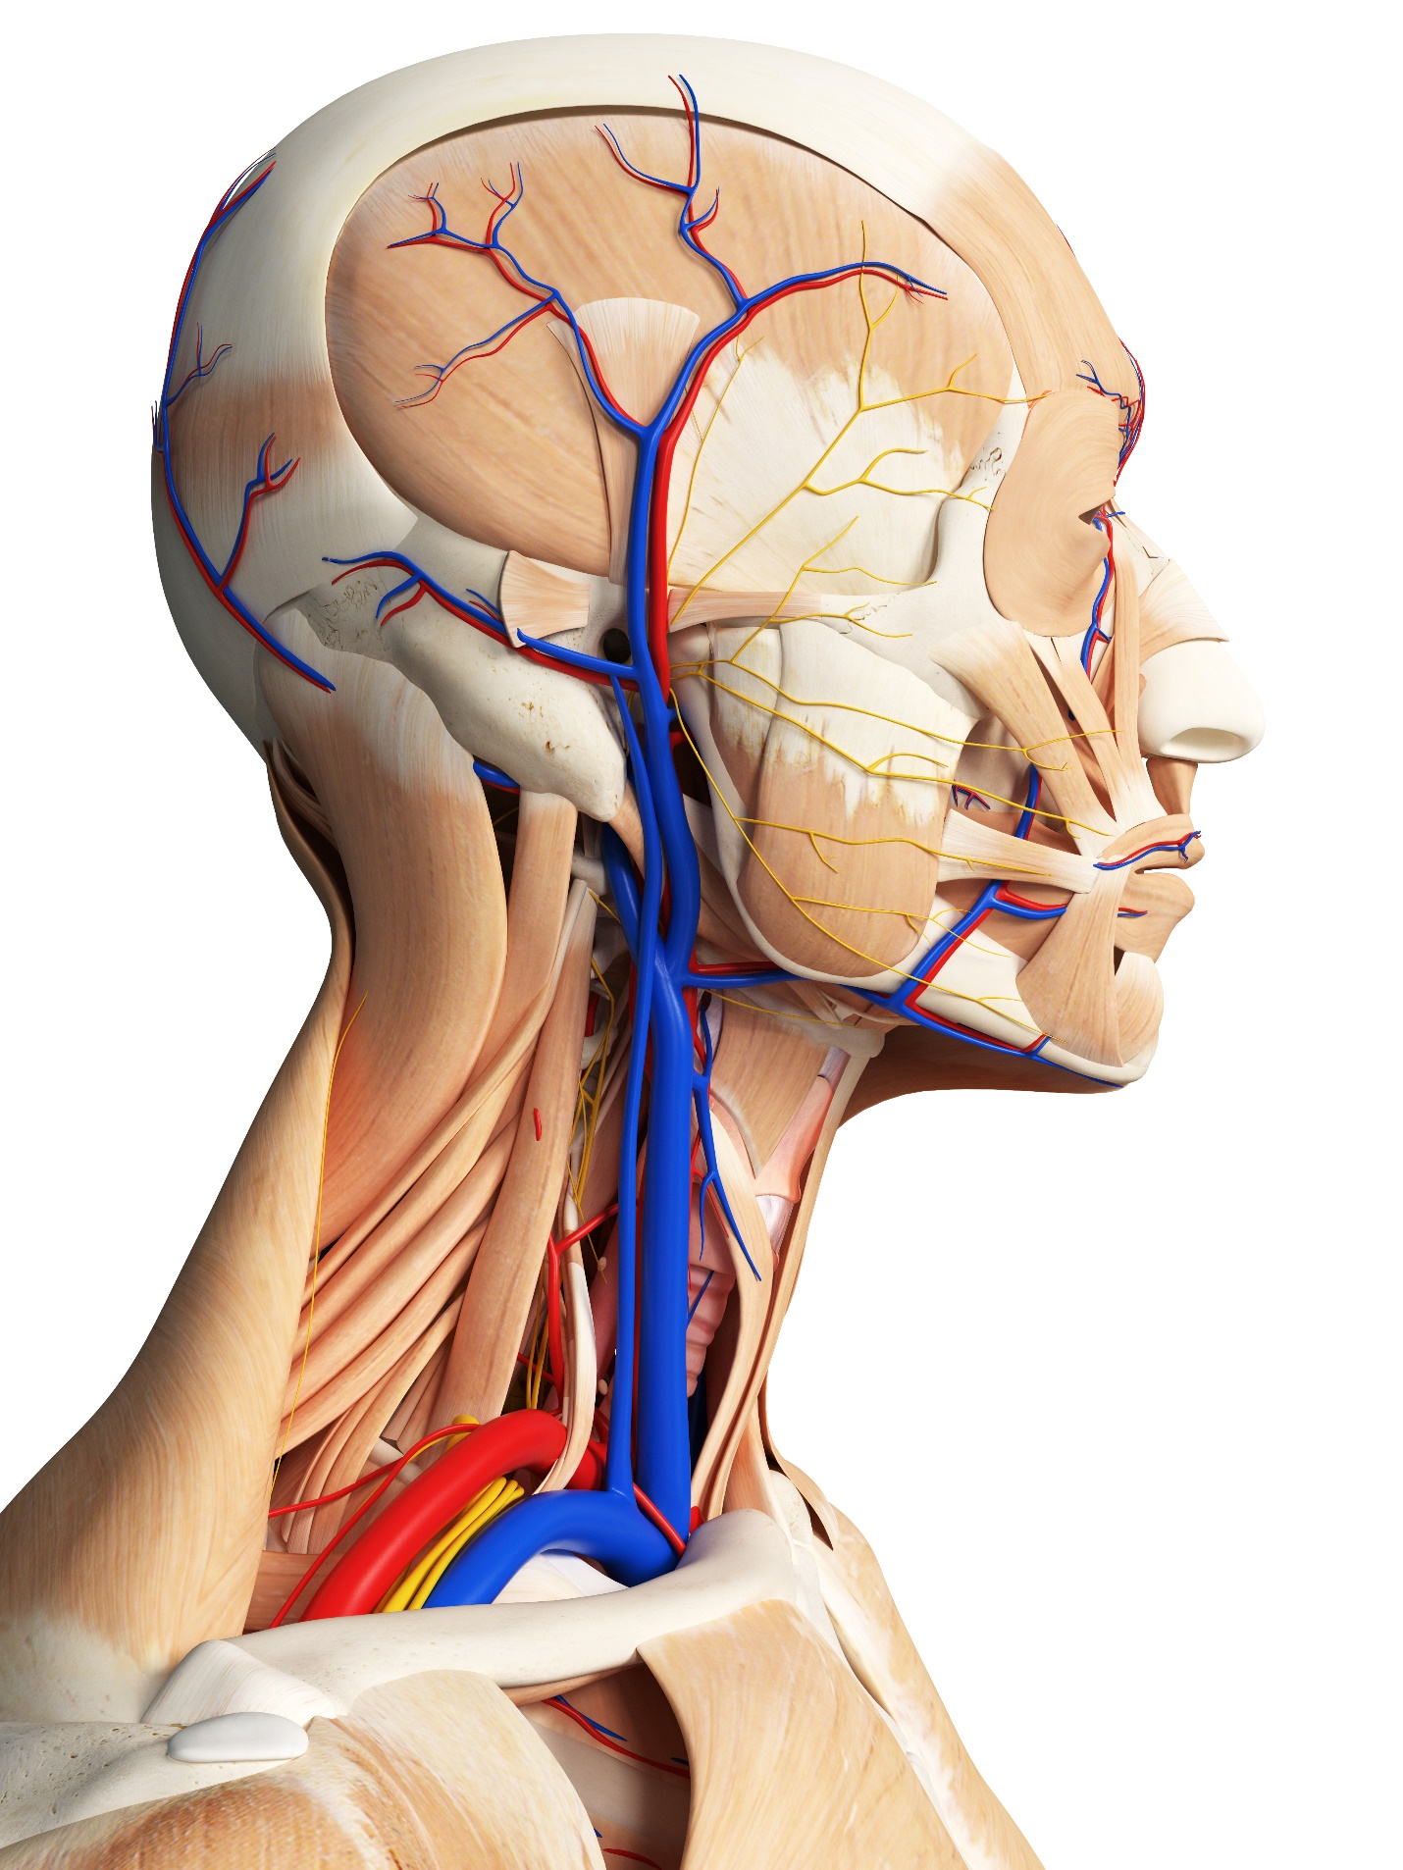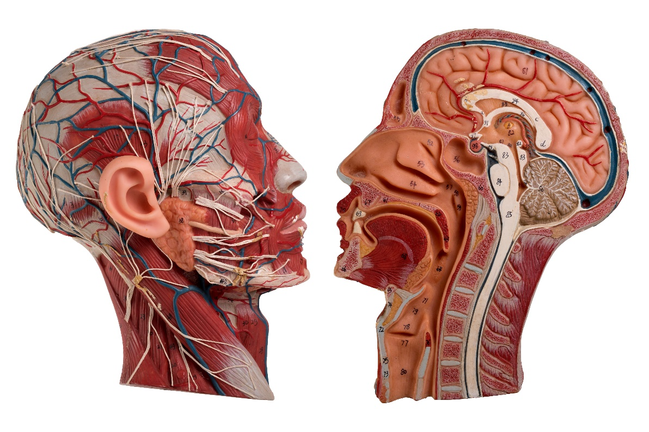
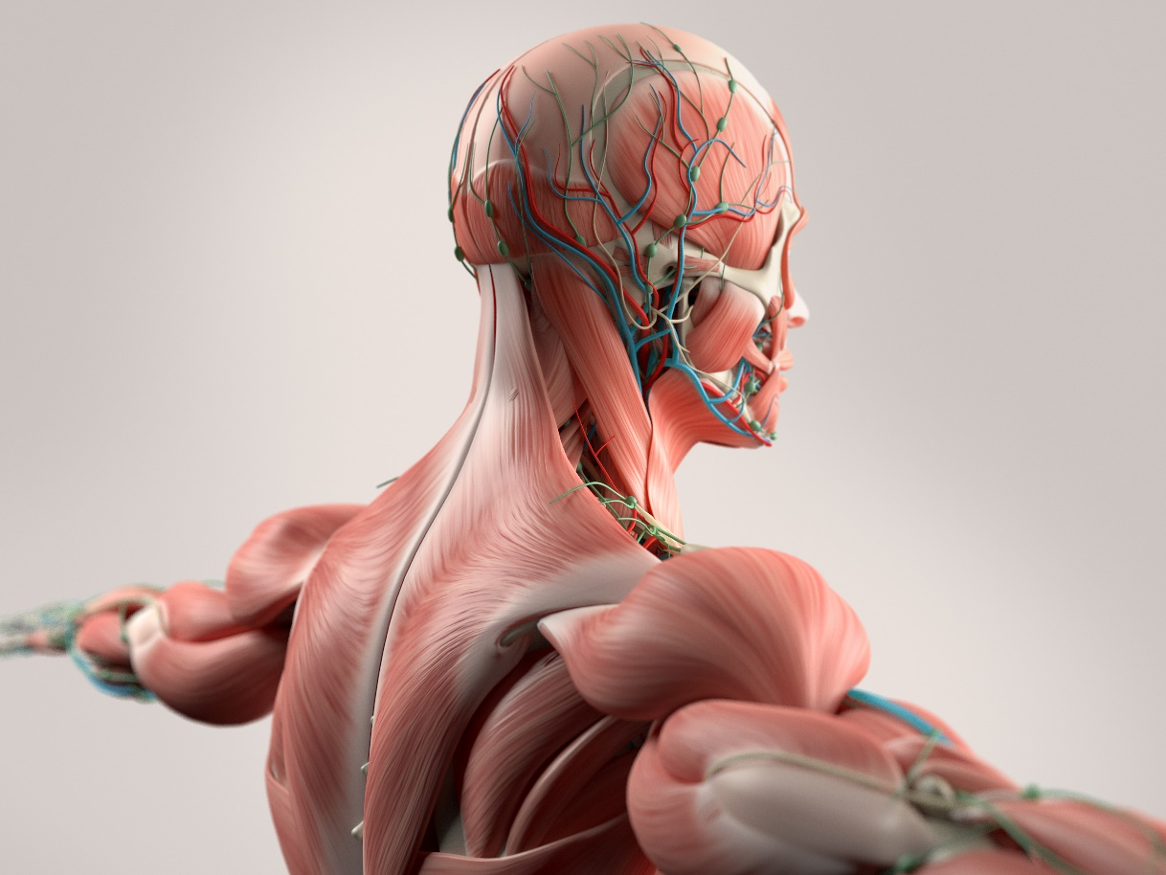

Abdominal Pain and Digestion:
Healer Logic: Things you are ingesting. The abdomen is full of organs in fascia sacks. Fluid build up and pressure causes most of the problems in the abdomen. Fascia fibers create the structure of our organs, so use the same logic as the superficial fascia layer for each organ.
Starting Protocol:

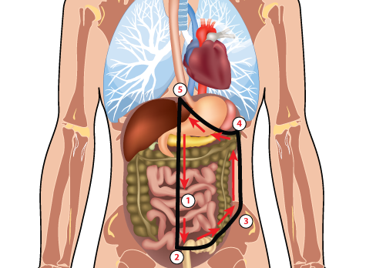
- Start pressing down with your hand right above the pubis bone near the belly button and work your way down to identify the edge of the pubis bone.

- Start working at the bottom of the abdomen by palpating for pain, stiff, and hard spots from the center line of the abdomen and working to the right iliac crest (hip bone). This area focuses on the bladder and lower part of the intestines where the colon can be impacted for constipation conditions. Work on areas you identify with palpation. Use appropriate pressure depending on the amount of fluid build-up in the abdomen.

- Continue palpating upwards along the right side (client’s left) between the hip bone to the bottom of the rib cage.

- Palpate along the edge of the rib cage up to the sternum. This area will focus on the intestines, stomach, liver, and other organs of the abdomen. At a minimum, focus several placements in the stomach area. Stay a few inches away from the bones if you are pressing deep in the abdomen.

- Palpate down the centerline of the abdomen from the sternum to the starting point below the belly button at the pubis bone. The repeat the process on the left side (client’s right) of the abdomen stopping at the sternum on the left side.

- Menstrual and menopause conditions (Cramps, bloating, endometriosis, ovarian cysts)

- Bladder conditions (UTI, infection, incontinence)

- Stomach conditions (Acid reflux, indigestion, hiatal hernia, ulcers, gall bladder)

- Intestinal conditions (Constipation, diarrhea, IBS, Crohn’s, Colitis)
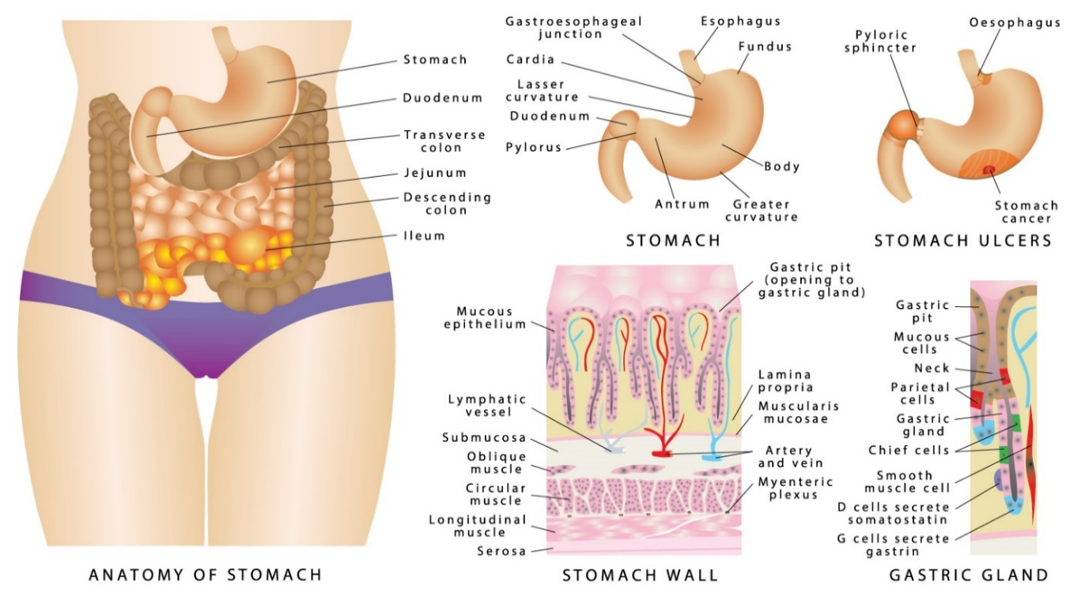

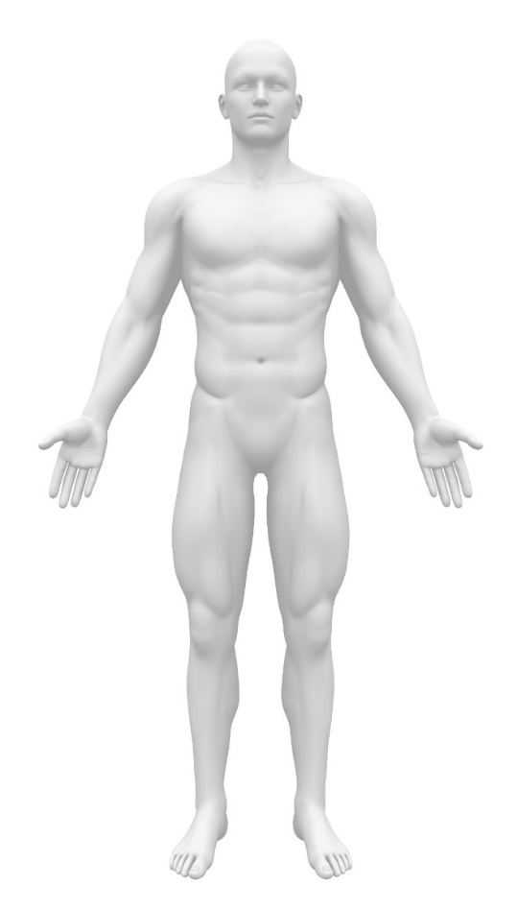 | 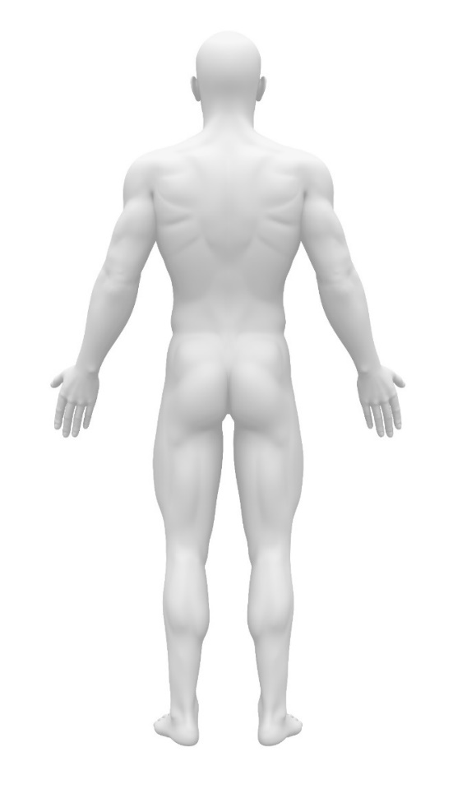

Lower Back and Hip Pain Protocol:
Healer Logic: Results of long-term posture and movement.
Starting Protocol:
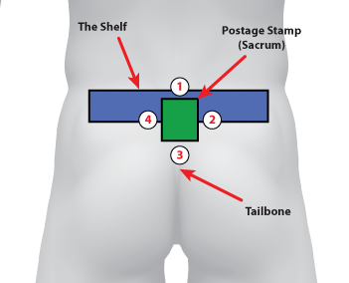
- Start at the top of the postage stamp and press down against the top edge of the postage stamp using a butterfly grip. Hold at an angle over the edge of the hard tissue and into the softer tissue.
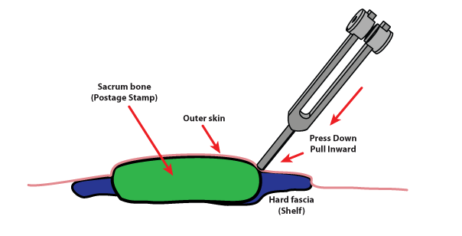

- Work on the shelf of hard fascia radiating from both sides of the postage stamp. Start on the outer edges and work your way inward toward the postage stamp.
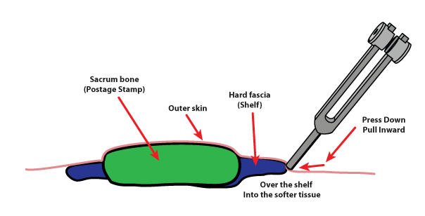

- Work on the tailbone trauma. Find the strip of hardened fascia on both sides of the tailbone. Press down and inward toward the center just like the shelf.

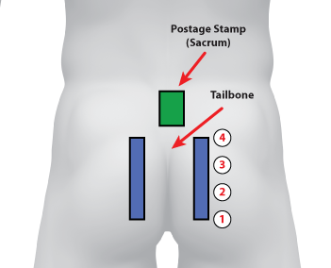

- Follow the bottom of the tailbone fascia tightness down into the sit bone. This area should be tender to the touch for your client. It is the bone that rests against the seat while we are sitting for long periods of time. Skinner people generally have sit bone pain, but we will include it in our starting protocol for all clients. Two or three placements on both sides should reduce any fluid pressure and pain. Put the tuning fork right on top of where you determine the sit bone to be located during palpation.

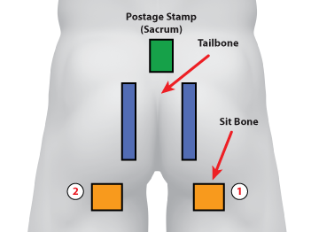

- Work on the Margaret Ball on the hips where the ball joint creates at ball of inflammation in some clients. In certain clients, the lower back pain and tightness cannot be relieved if the Margaret Ball is not resolved. It is more effective to work on the Margaret Ball while the client lays on the side. Sometimes you cannot properly palpate and locate the ball unless the client on laying on the side. Work your way around the outside of the inflammation ball and work toward the center until all of the inflammation is gone.

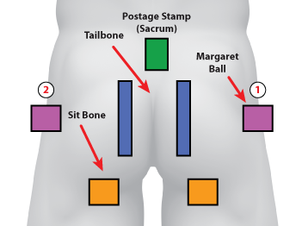

- Finally, Work on the hip bone (Iliac Crest). Feel for the top of the hip where the bone comes closest to the surface of the skin. This hip bone flexes with the entire pelvic girdle and the bones create inflammation near the surface where the fascia slides across this “joint”. Focus on two placements near the front the back locations of the bone where you feel the most inflammation.

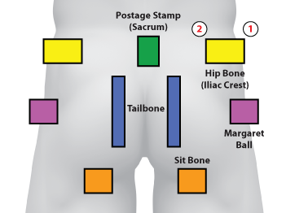

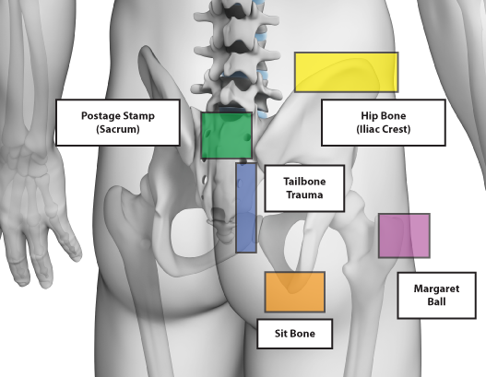

- Disc or spine conditions

- Sciatic pain

- Hip pain (Margaret Ball, Iliac crest)

- Slipped Disc

- Tailbone trauma

- Sit bone
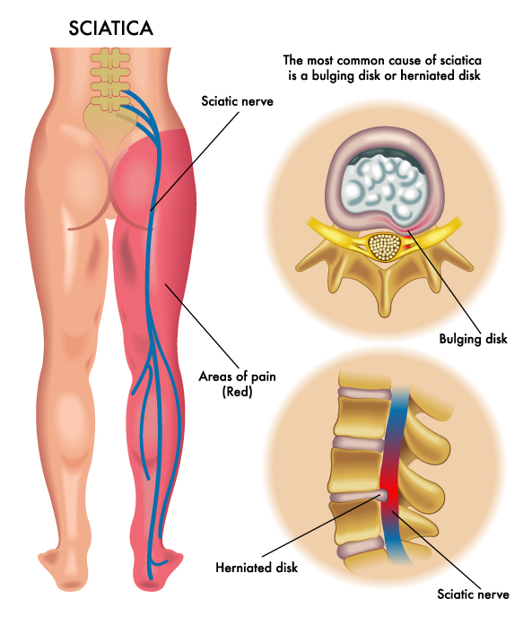
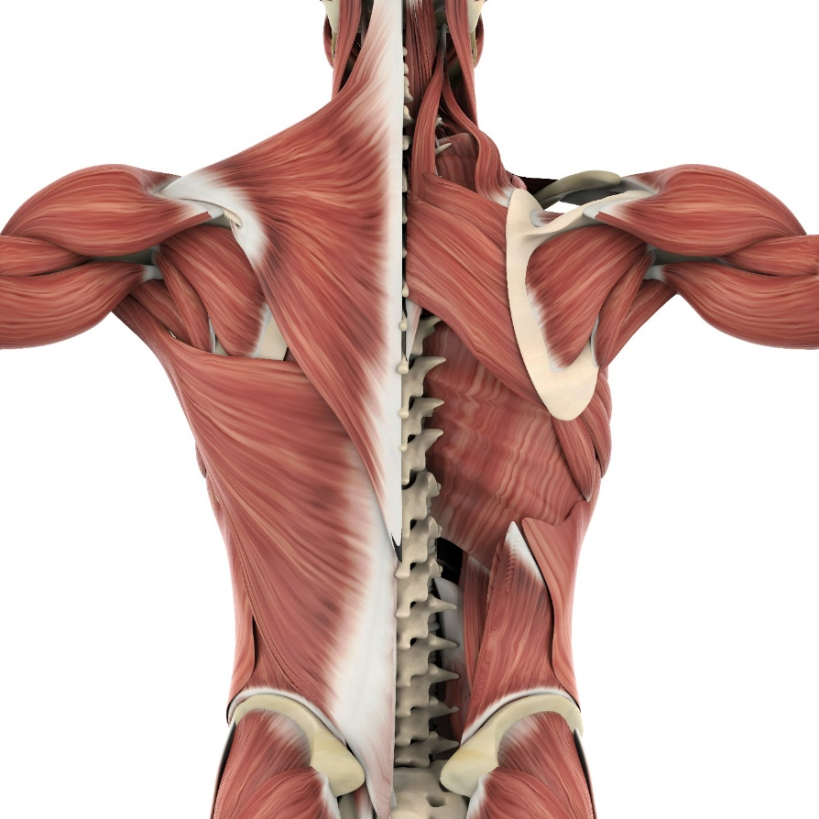

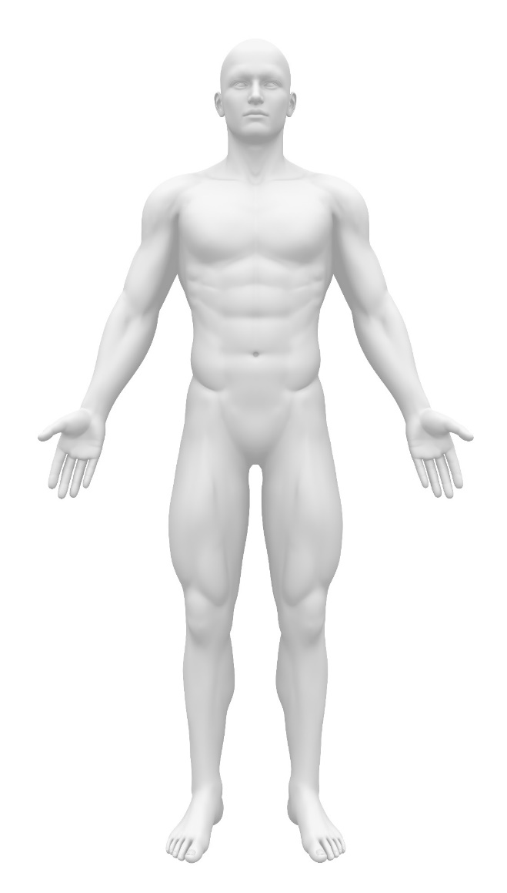 | 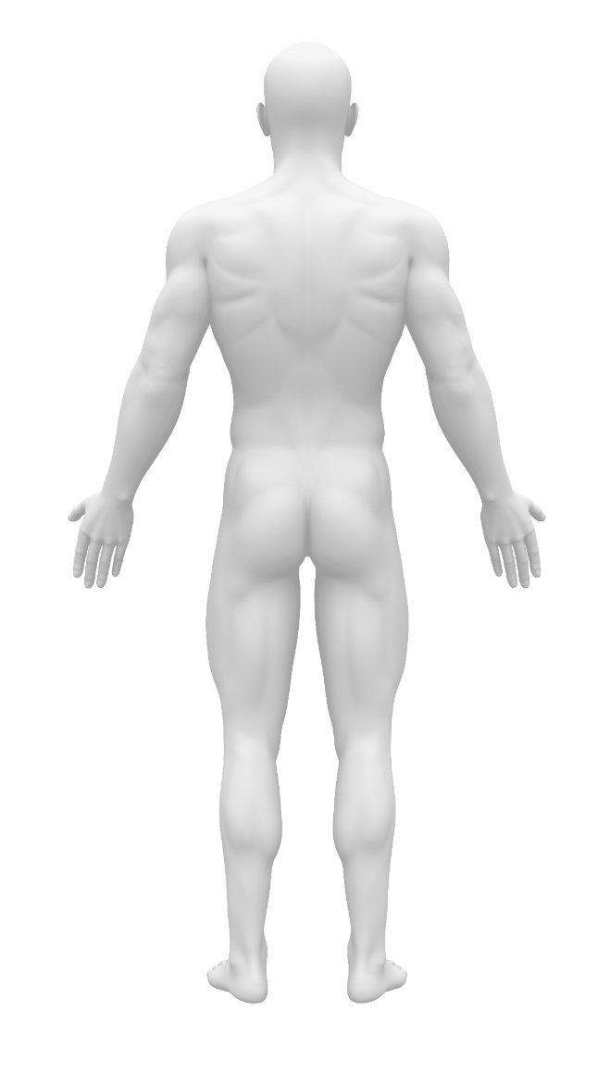

Joint Pain and Range of Motion:
Healer Logic: Results of repetitive movement. Don’t blame the bones. Focus on fluids and fascia as the cause.

- Medical modifications and alterations

- Arthritis, gout, bursitis

- Trauma and injury (with or without surgery)

- Carpel Tunnel

- Dupuytren’s contraction, trigger finger

- Frozen shoulder

- Tennis/Golfer’s Elbow

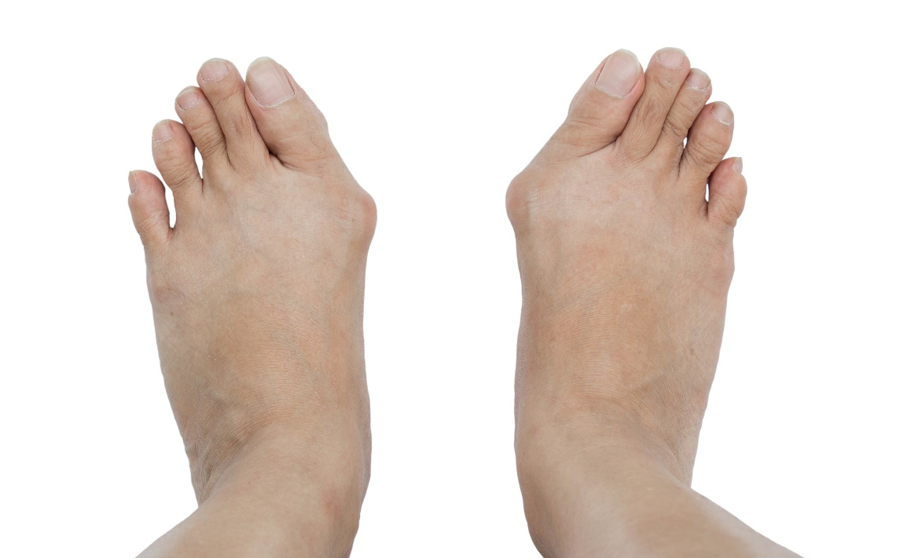

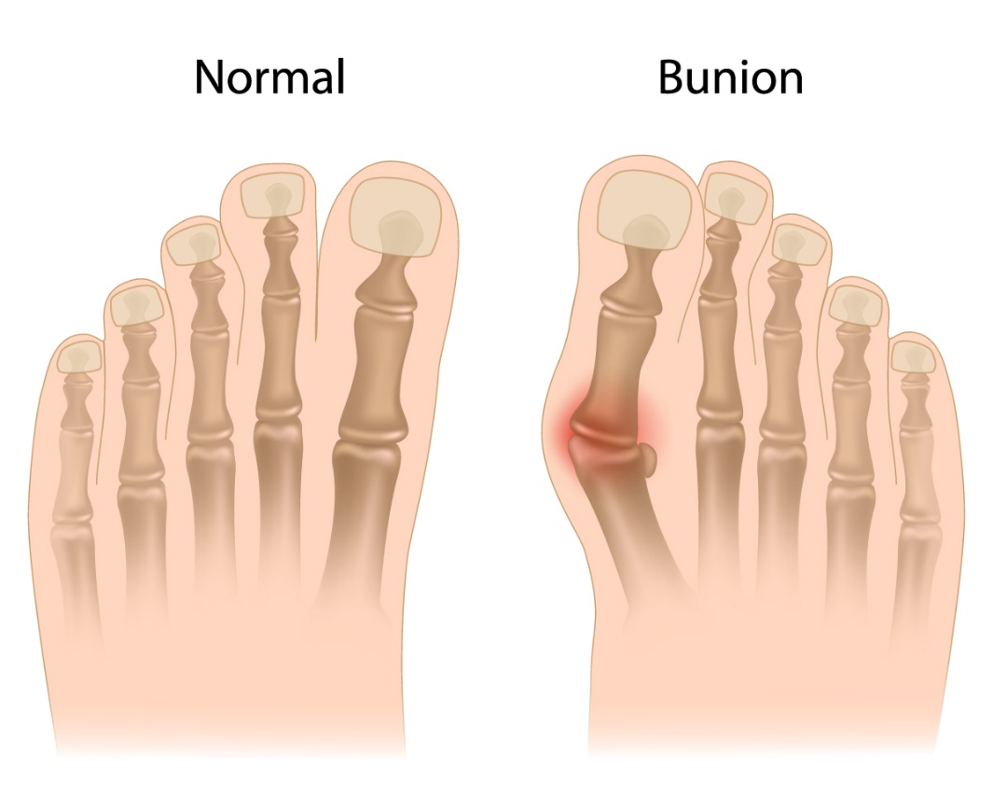
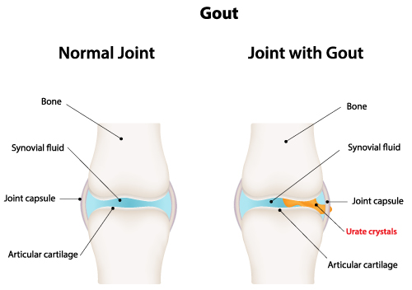

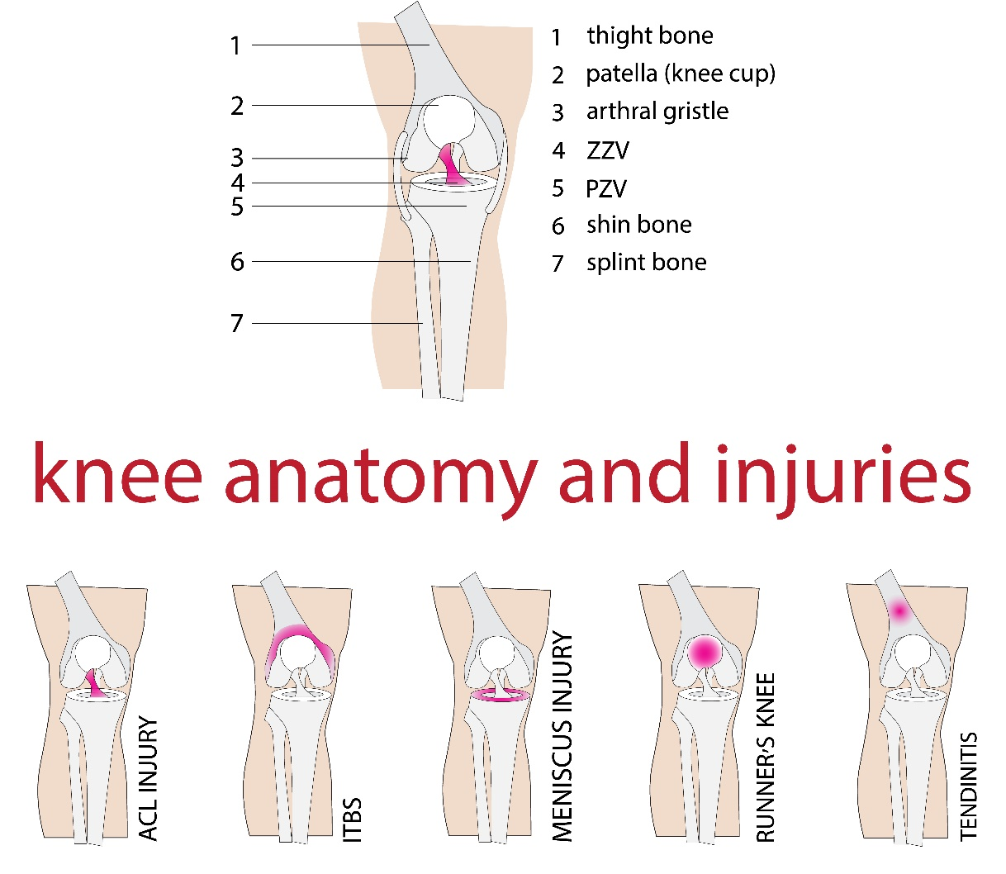
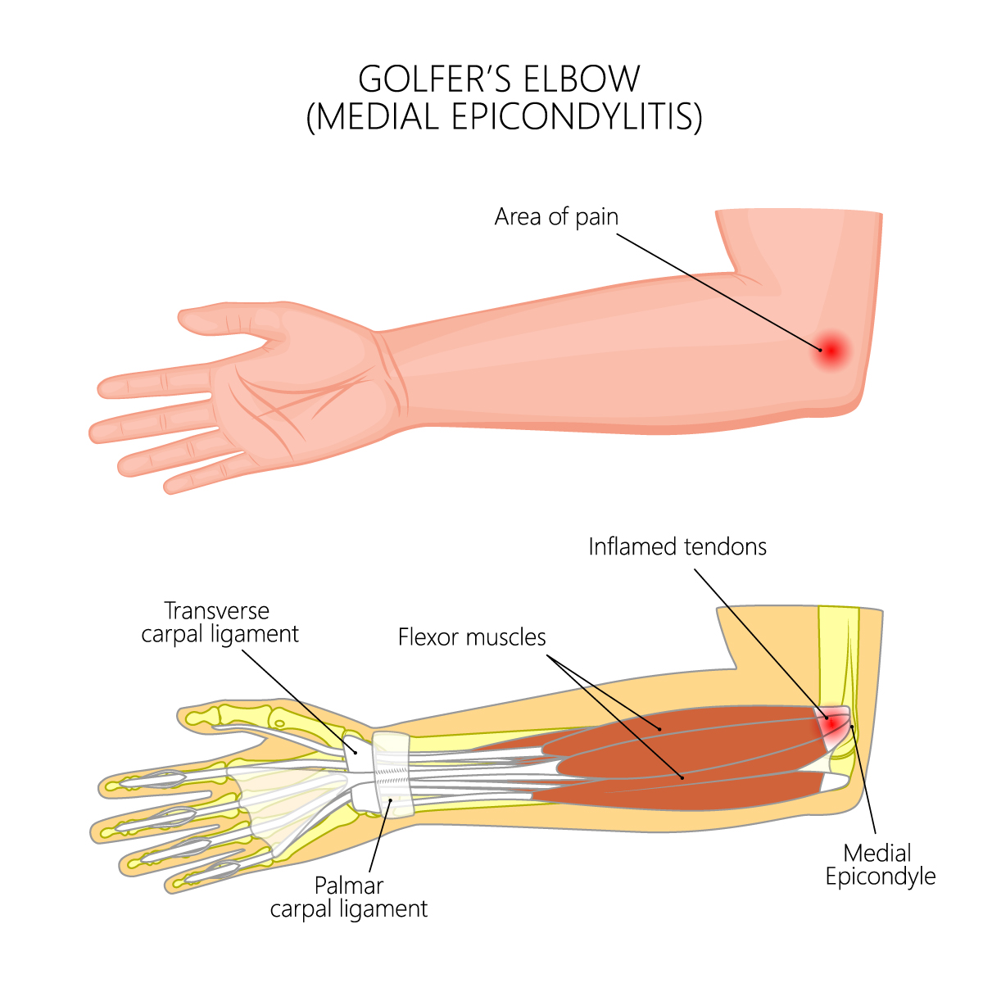
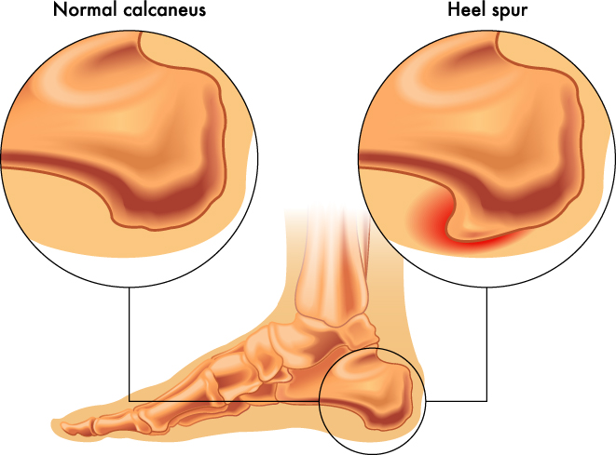

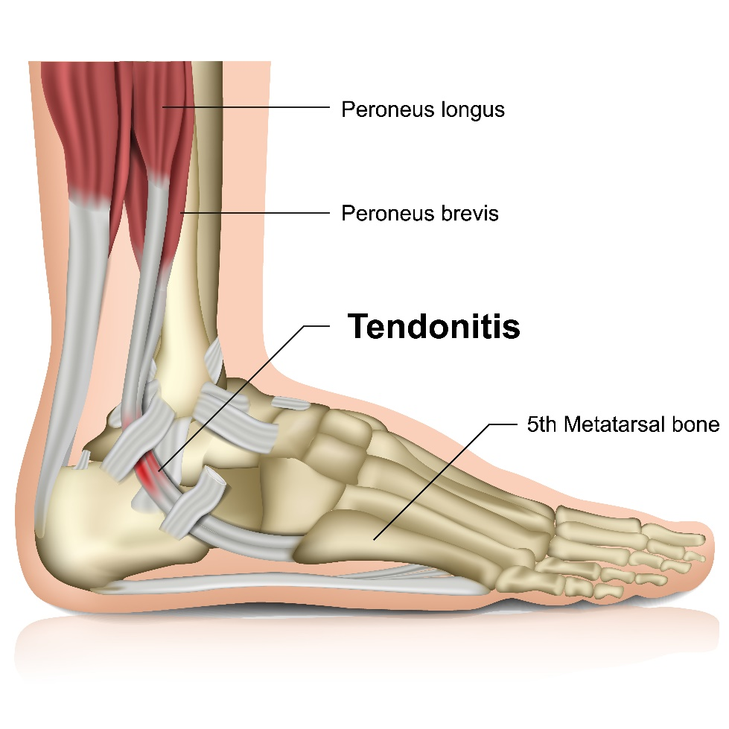
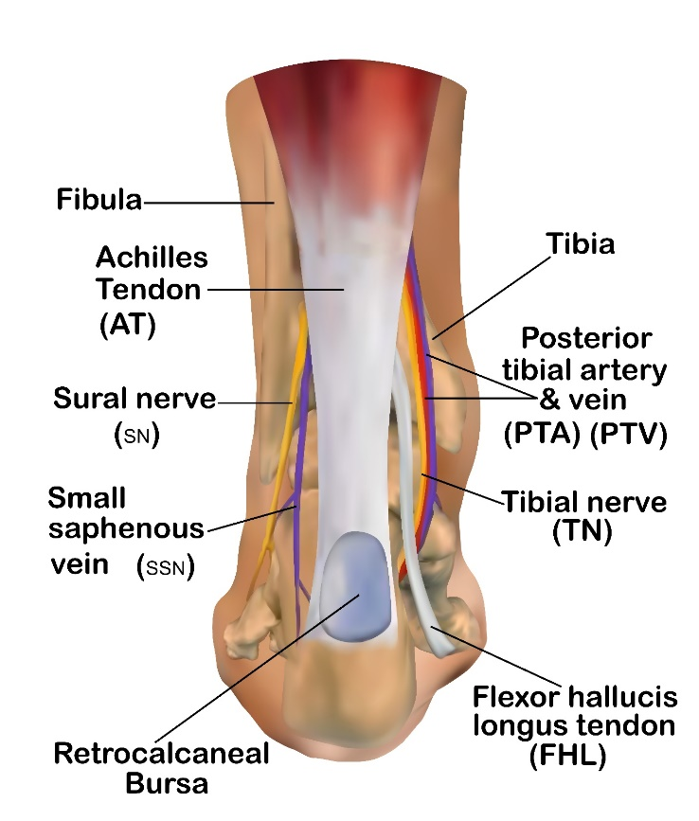

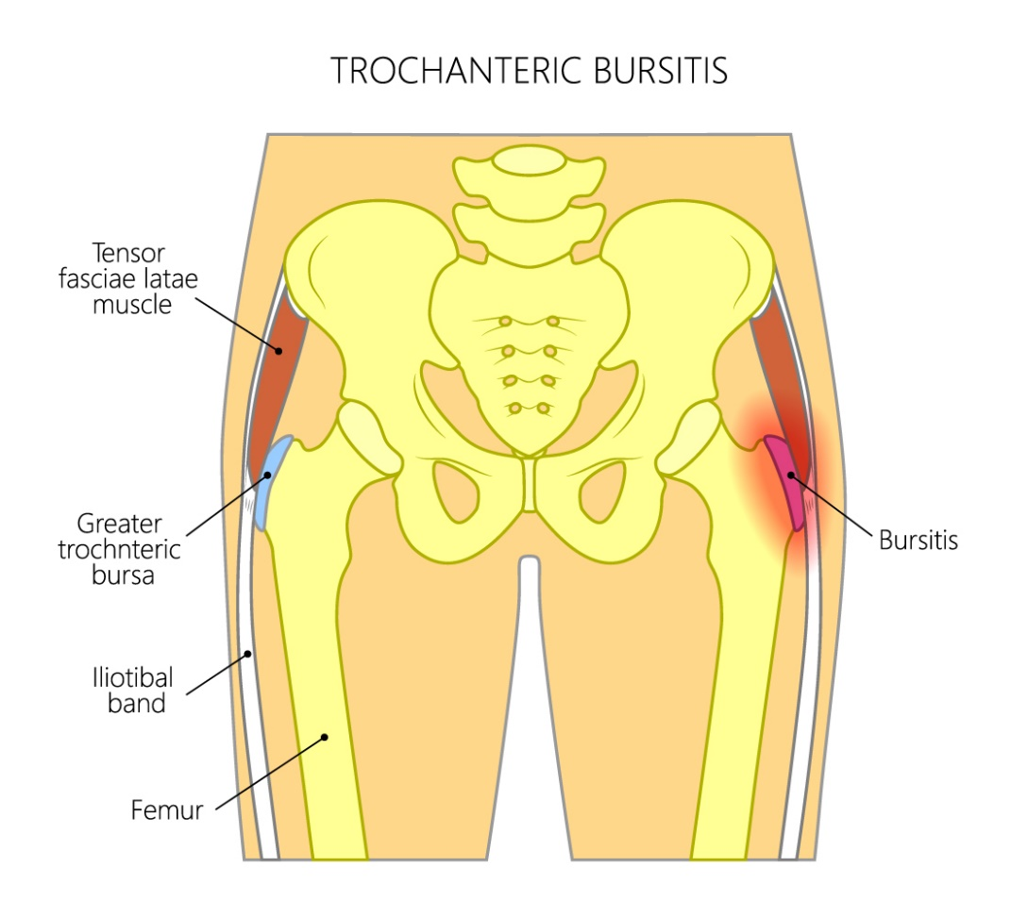
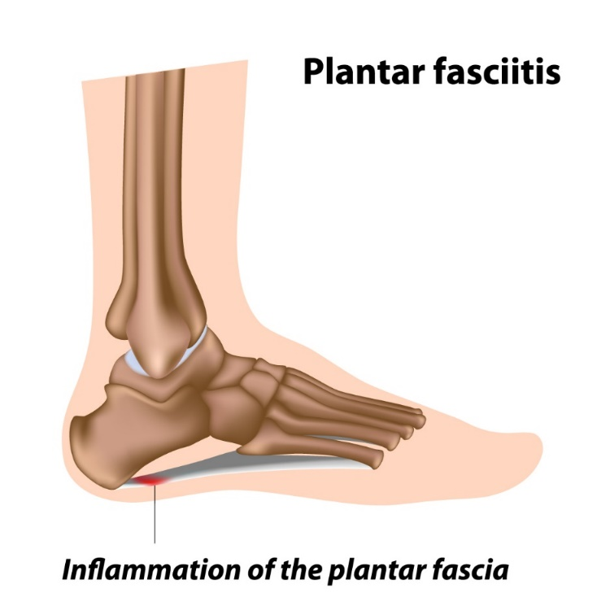

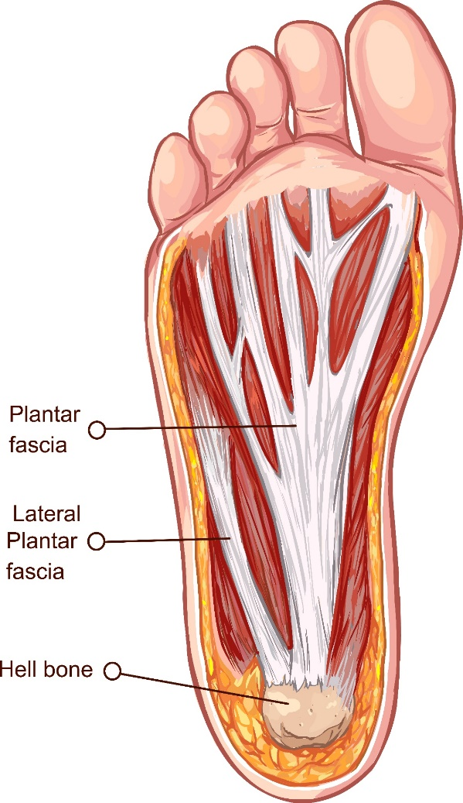
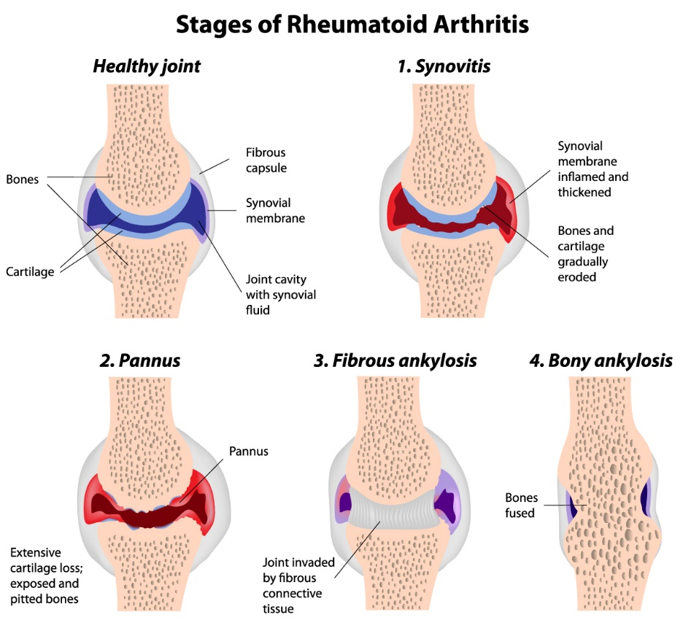

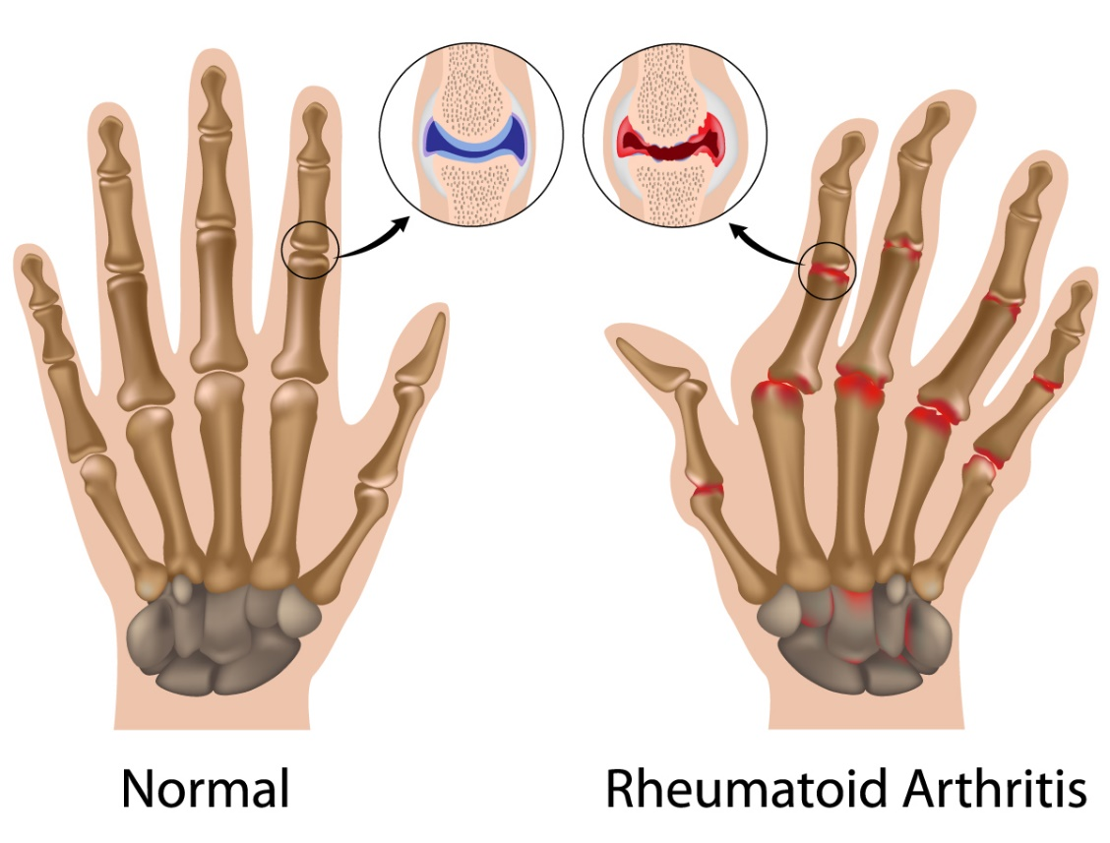

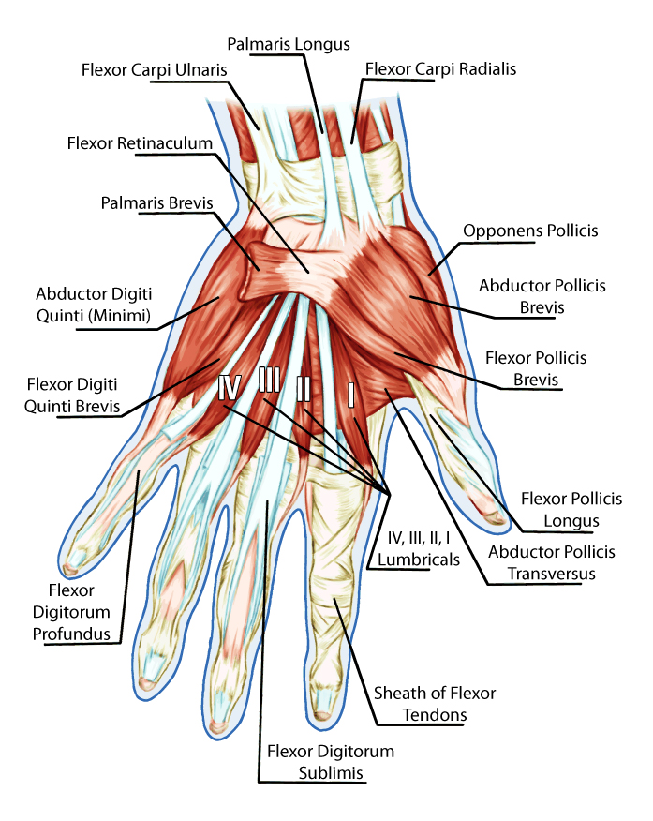

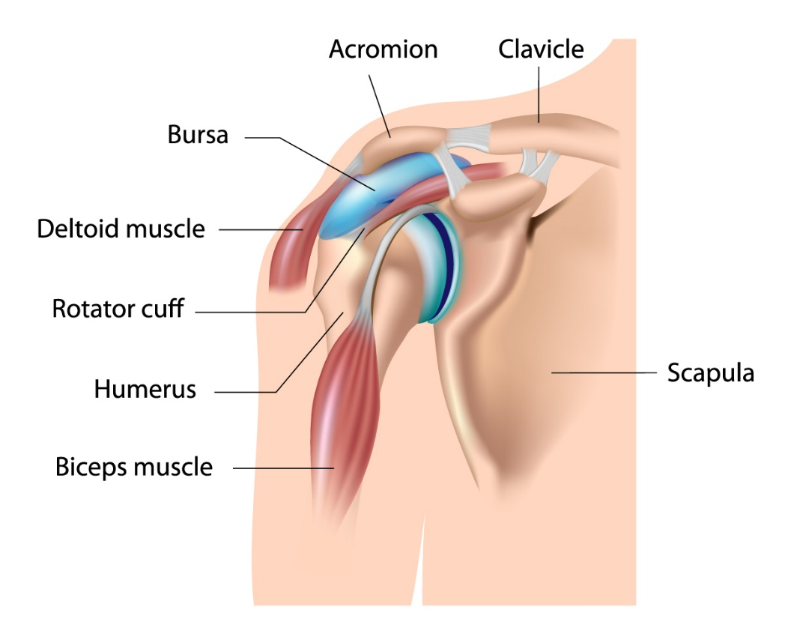
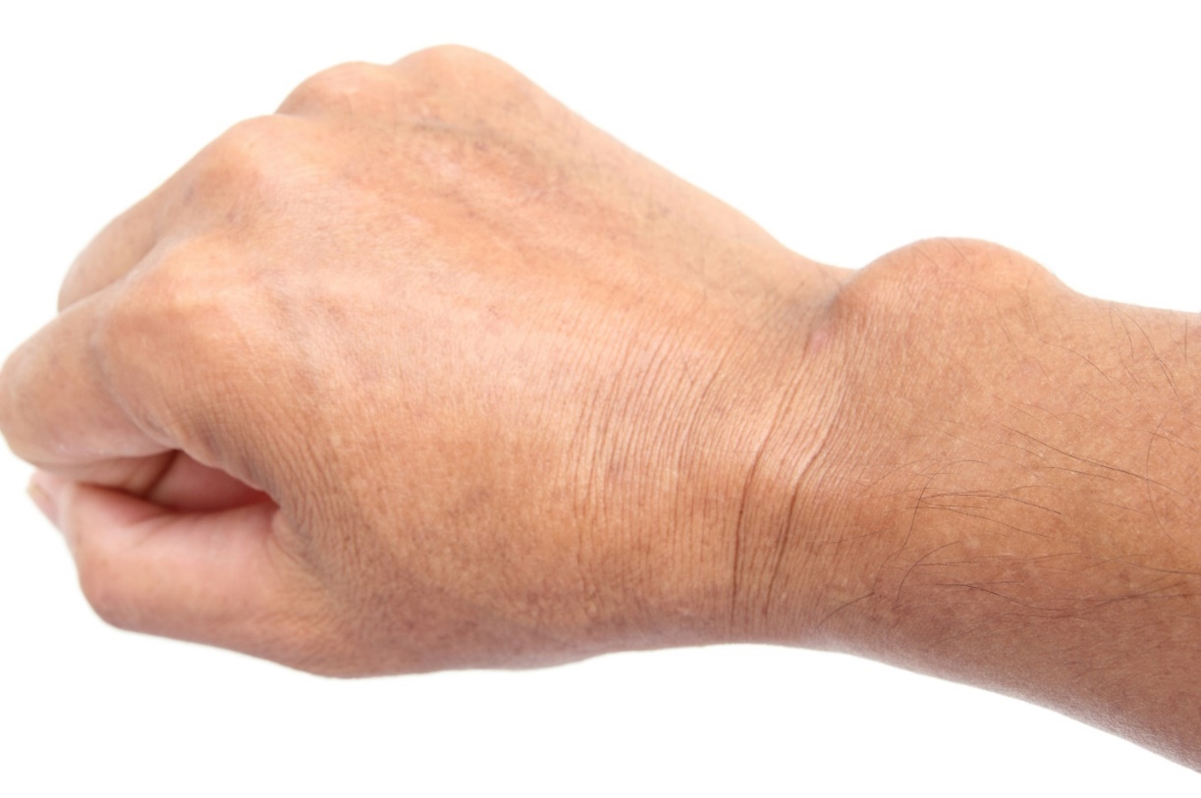

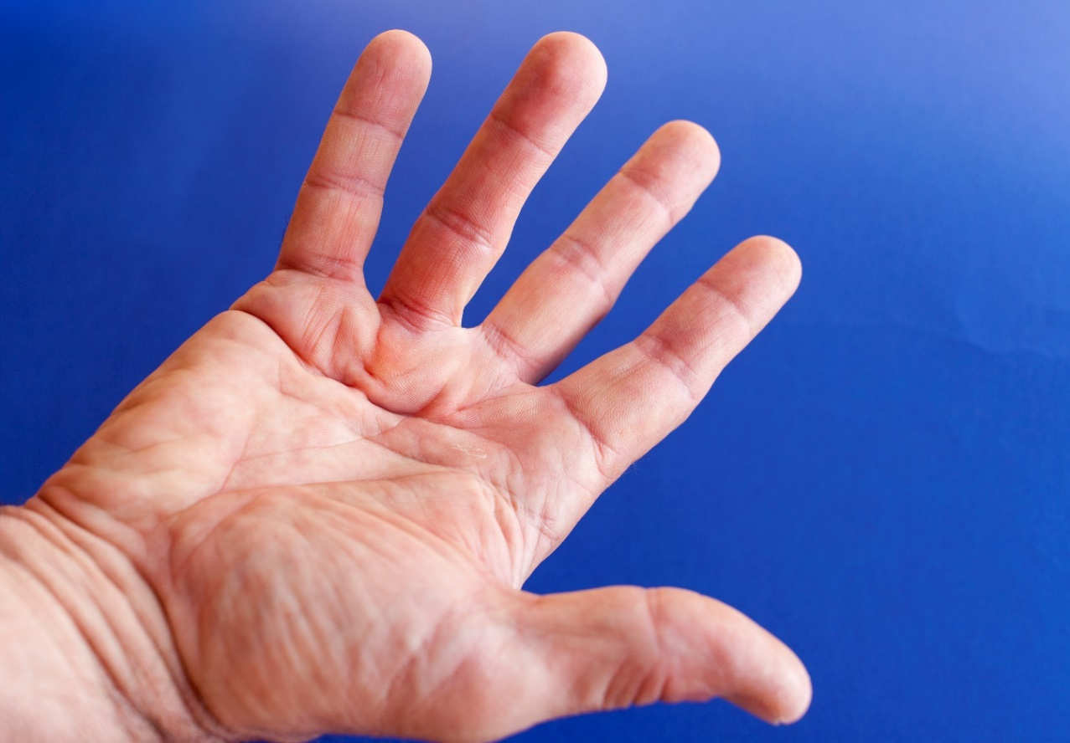

Foot and Leg Pain:
Healer Logic: Results of lifestyle decisions. Foot and leg pain is usually caused from fluid pressure in the extremities or a localized fascial restriction.
Starting Protocol:
- Begin at the back of the upper thigh and palpate down the leg to feel for fluid, lumps, hard spots, and things that feel abnormal.

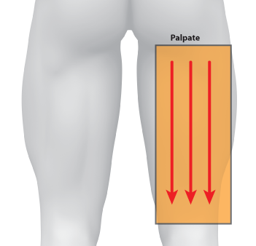

- Use the barefoot tuning fork on areas identified during palpation.

- Use the Press and Push or gem foot for any areas of high fluid pressure. Move the fluid up toward the heart.

- Focus on the lymph nodes behind the knee. The area behind the knee should be concave. If lymph nodes are swollen or the interstitial fluids are compressing the nodes, the tuning fork or a press and push can drain the pressure. Sometimes the knee pain on the front side of the knee is caused by too much fluid pressure behind the knee. The area behind the knee is very tender especially when it is under pressure. Use less pressure compared to other parts of the soft tissue. Acclimate the client to the tuning fork pressure by starting out with less pressure at the beginning of a strike and press with more pressure over time. After a few placements in the same area, you should be able to use more pressure.

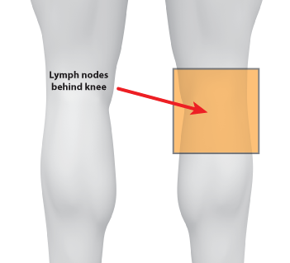

- Feel for a hard spot on the side of the inside of the knee. This area might need to be loosened in order to relieve the pressure behind the knee. This location is referenced as the “Jackpot” because of the first client where we found this particular drain spot. It is also extremely pain and sensitive to most clients for touch and pressure from the tuning fork. Work your way up the inside of the knee for a few strikes (between spots 1&2).
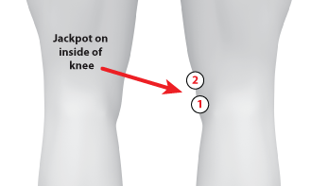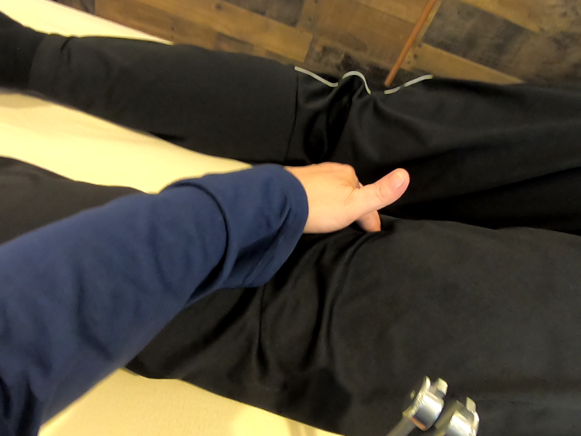

- As a reminder, you are using a lot more pressure on the tuning fork when you angle the tuning fork towards you. Extra pressure or a butterfly grip would be too much pressure in this situation.
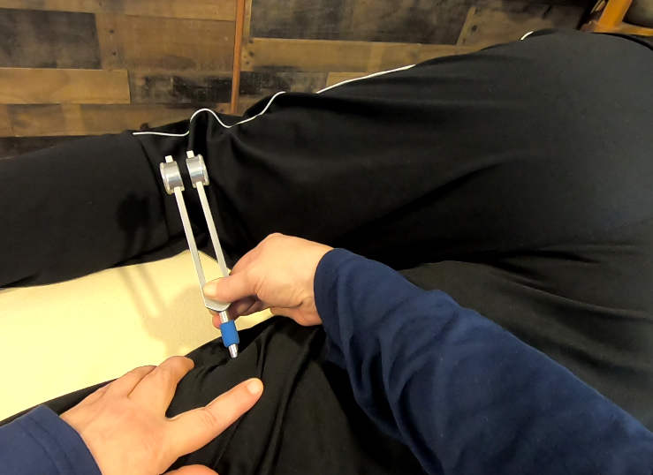

- Feel for fluid areas below the knee in the calf area. Perform a Press and Push to get the fluids above the knee. Get rid of the fluids in the lower leg so you can properly assess for fascial restrictions and smaller fluid pockets.

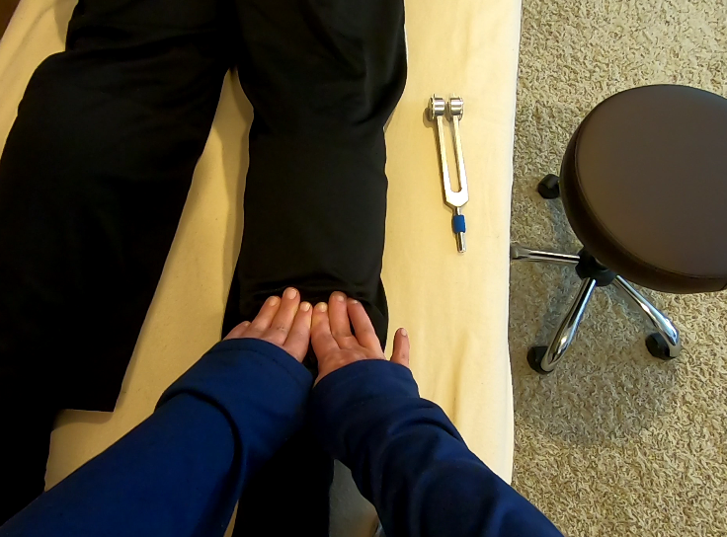

- If there is a lot of fluid in the calf area, use the Press and Push several times getting deeper each time with more pressure. Start out with much less pressure at the beginning and work deeper as you go. Make sure you push the fluids all the way past the knee. You do not want the fluids sitting in the cavity behind the knee. You should be able to feel fluid collecting in front of your fingers as you push. Fluid pressure in the calf is the biggest cause of restless leg syndrome, cramps, and Charlie horses.
- After the fluid push, come back and palpate again for the small areas that need work in the calf area.
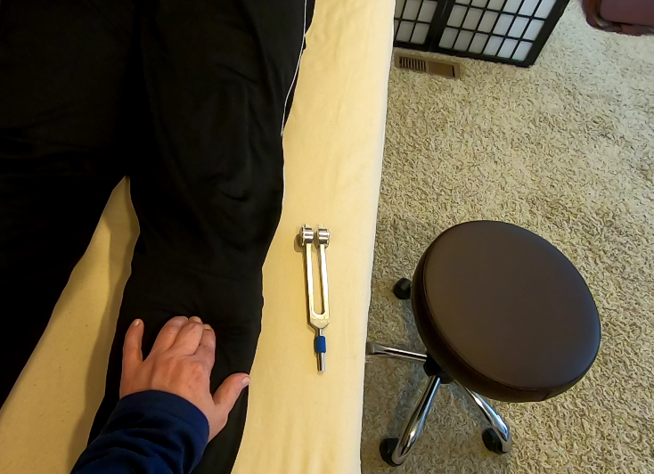

- Palpate and work on the soft part of the ankle. Angle the tuning fork downward to get behind the ankle bone.

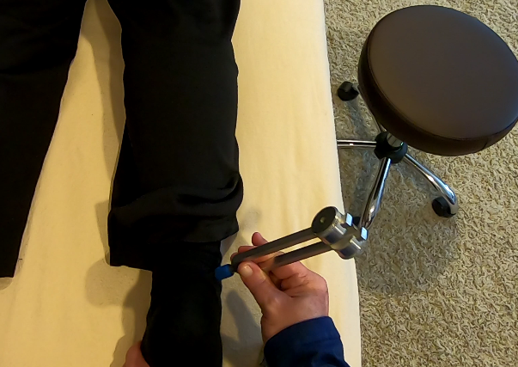

- Work behind and underneath the Achilles tendon. Never work right on top of the tendon. Put a supporting hand on the other side of the foot. Continue working around the ankle bone in the soft tissue. This will dramatically increase range of motion.

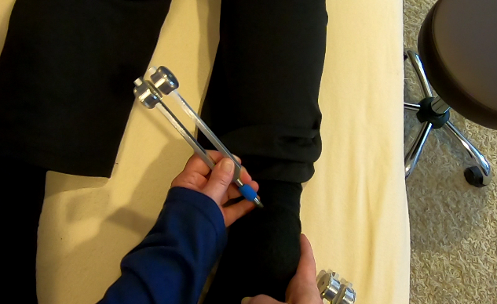

- Palpate the bottom of the foot to check for adhesions.

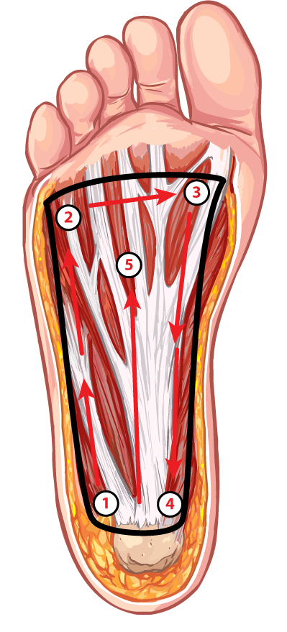

- Feel for something that feels like a pencil underneath the skin. Fluid can get inside of the tendons making them roll back and forth during palpation. Once located, work on it with the barefoot tuning fork by positioning it between your fingers for stability.

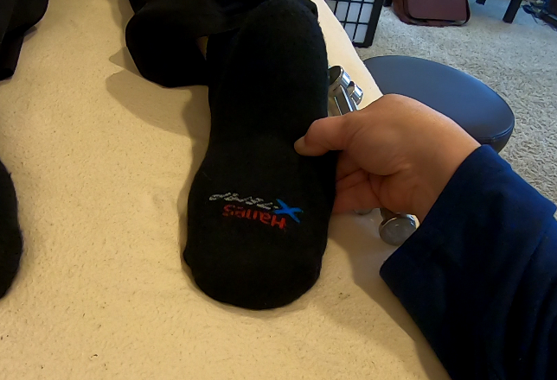

- Leg pain (Restless leg, cramps, Charlie horse)

- Plantar’s warts

- Fallen arches/flat feet

- Plantar fasciitis

- Bunions, hammer toe, in-grown toenails (trauma)

- Bone spurs

Anti-aging Protocols:
Healer Logic: Consider the logic and protocols of the Head and Neck group for this area.
- Age symptoms (Wrinkles, scars, stretch marks, smoker’s lines)

- Double-chin

- Hair loss and gray hair

- Spider and varicose veins

- Eye bags

- Skin conditions (Acne, rashes, rosacea)

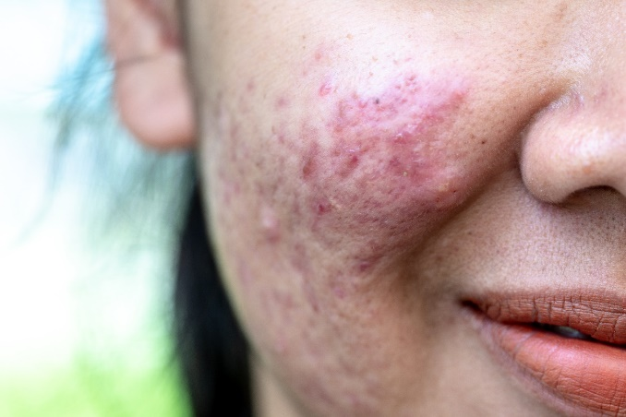 | 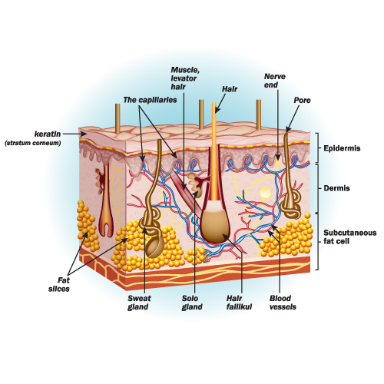
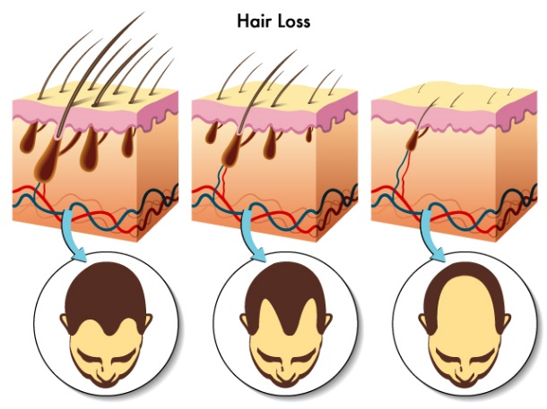 | 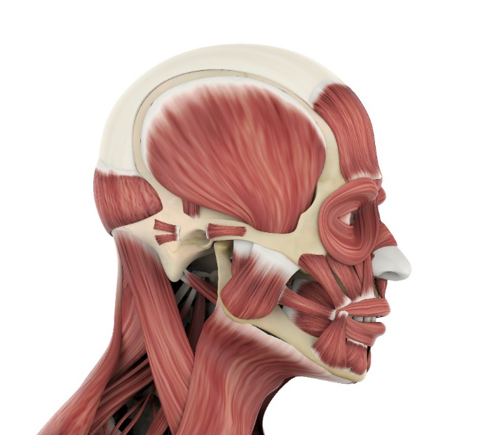

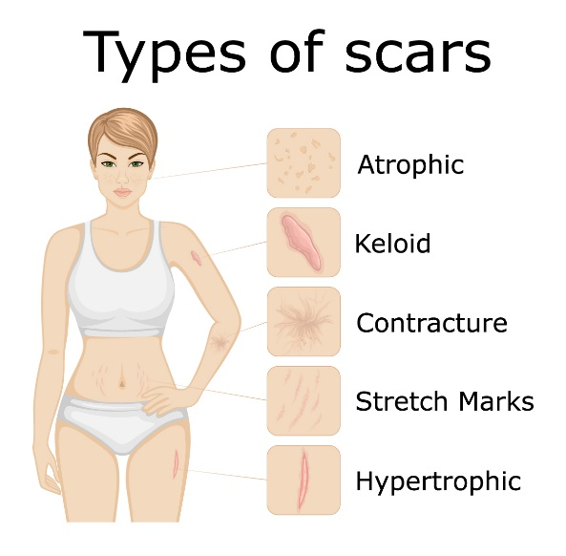 | 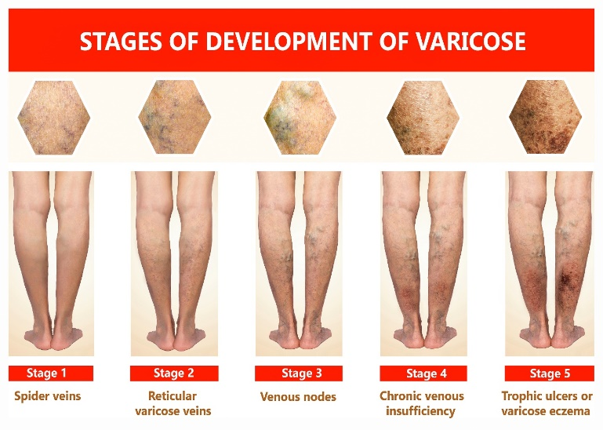

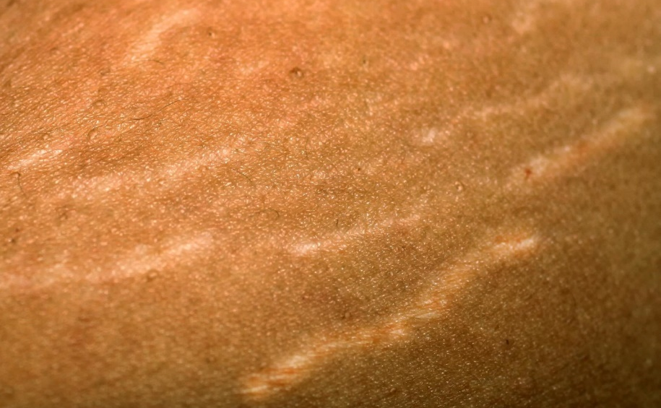

Fat Burning Protocol:
Healer Logic: Consider the logic and protocols of the Abdomen and Digestion group.
- Stomach (upper abdomen)

- Lower abdomen

- Thighs

- Buttocks

- Side boob

- Boob lift

- Double chin

- Sagging arms

- Back fat

- Body shaping and contouring

- Body Wrapping and mud/clay

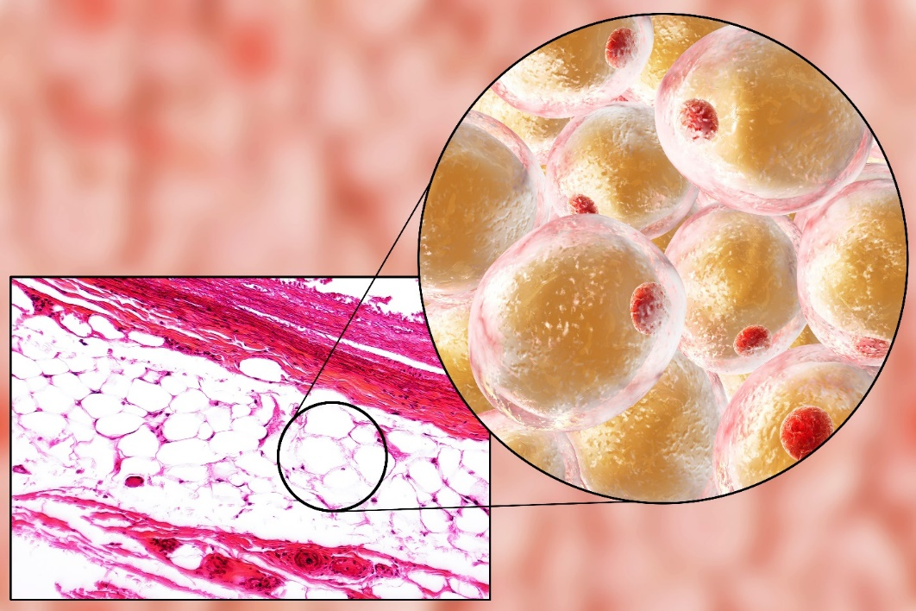
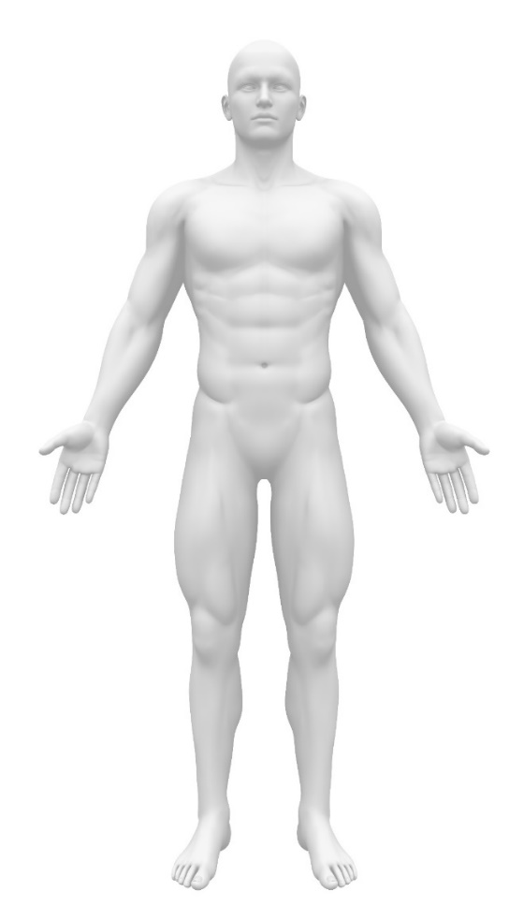 | 